Year Group: Nursery Term: Spring 2 Teachers: Nadia Gresko and Kay Barron
Half term planning : Autumn 2
Enquiry Question: What is your favourite story? Focus books – The Gingerbread Man (x2) The Billy Goats Gruff (x 2) Spring/Easter (x1)
Week | Learning Objectives | Key vocabulary | Teaching input (carpet time) | Guided/ Adult Led Activities  Enhancements to Continuous Provision  (or Independent Activities) | Links to RRSA  (Rights RespectingSchool)
1 | C&L- N1- Listen to other people’s talk with interest but can easily be distracted by other things.  N2- Listen to simple stories and understand what is happening, with the help of the pictures. | Traditional, story, fairy tale, character, puppet, cottage, gingerbread, old man, old woman, cutter, fox  Pattern, repeating | Recap nursery rules and routines for current pupils, focusing on N1.  Share holiday news  Introduce topic – Traditional Tales- what is your favourite story?  Tally of what is your favourite familiar book- Five Minutes Peace, Kipper’s Birthday or Supertato.  Examine The Gingerbread Man front cover. Locate book features – title, pictures, author, illustrator, pages, text. Use the front cover to predict who the characters might be.  Recap on book features and key characters. Read the book for the first time to the children using the puppets.  Children to join in with repeated refrains.  Revisit: action rhymes – clap, pat or clap, stamp etc.  Subitising using a dice | Focus:  LO: Lit Draw and mark make holiday news, teacher to scribe  LO-EAD- adult to support role playing in the bakery. Model phrases and encourage chn to use – I would like a bread roll/cake/croissant etc.  LO-C&L- in small groups read the book and encourage the children to listen to the story and join in with repeated refrains and actions.  LO-EAD- paint characters from the Gingerbread Man for the reading and I wonder display.  LO-N- Subitise dots are on the Gingerbread Men. Maths display  N1 chn to join in with actions patterns- clap, pat etc. Take photos for LJ.  Enhancements  Small world – farm animals and supporting books  DT- design a gingerbread man  Reading area – key phrases from the book displayed and puppets  Playdough – ginger scented  Home corner- Gingerbread themed-bakery.  N-Gingerbread subitising | 
2  World Book Day  (Thurs) | Literacy- N1- Repeat words and phrases from familiar stories.  N2- print has meaning -print can have different purposes | Cooking, Gingerbread, baking, ingredients, equipment, recipe, method | Display the ingredients and equipment to make Gingerbread biscuits.  Share and orally rehearse the instructions to make a Gingerbread Man  Create a recipe book to make Gingerbread biscuits.  Model matching numeral to quantity using the loose parts.  World Book Day – dress up | Focus:  L -Children create a pictorial list of ingredients and equipment needed to make Gingerbread.  C&L -Look at the recipe to make Gingerbread- orally rehearse with actions together.  EAD-Design a Gingerbread Man  UW- Bake and decorate Gingerbread  L- create a story map.  N- match numeral to quantity- loose parts to add buttons.  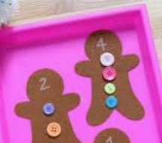  C&L- World Book Day activities.  Enhancements  L- Recipes in the writing area  L– list of ingredients  N- gingerbread match numeral to quantity loose parts  Playdough- loose parts to design gingerbread | 
3  Science Week | PSED-N1 - Feel strong enough to express a range of emotions.  N2- Safely explore emotions beyond their normal range through play and stories.  N2 -Explore collections of materials with similar and/or different properties. | Billy Goats Gruff, bridge, test, feelings, emotions, angry, cross, calming, breathing, regulation, relax | Read The Three Billy Goats Gruff. Recall features of a book. Introduce the characters using puppets - stem sentence – This is the first Billy Goat Gruff etc. Encourage children to repeat key phrases. Use emotion cards to help generate what the troll is like- happy, sad, angry.  Recap book features key characters. Read the book for the first time to the children.  Children to join in with repeated refrains.  Look at emotion cards and naming each. Focus on angry, relate to Billy Goats Gruff. Give scenarios in nursery when we feel angry- taking toys, drawing on other children’s pictures, hurting others  Teach children breathing techniques and calming activities to help with regulation.  Science Week - Look at famous bridges from around the world. Model creating our own bridges using different materials for the Billy Goats to cross. Wood, tin foil etc. | Focus:  LO- PSED- Look at the scene where the troll is angry because the goats are crossing his bridge. Introduce and encourage chn to join in with breathing techniques and calming activities to help with regulation.  UW- children learning about different bridges- cut and stick photos of real bridges from around the world.  EAD- Small world- adult modelling how to retell the story through small world.  UW -Blocks & duplo – create bridges for the Billy Goats Gruff to walk over. Have photos of duplo bridges as a stimulus. Children test their bridges and record on a tick sheet- is the bridge strong/steady?  Enhancements:  Reading area- emotion cards  EAD- create goat puppets  PSED- Thinking space – velcro some of the simple calming and breathing techniques.
4 | Number- N1 - Compare sizes, weights etc. using gesture and language - ‘bigger/little/smaller’, ‘tall’, ‘heavy’.  N2- Make comparisons between objects relating to size, length, weight and capacity. | Billy Goats Gruff, Size, ordering, big, bigger, biggest, little, small, smaller, smallest | Read the Billy Goats Gruff book- focus on book features.  Green meadow background- Order Billy Goat Gruff’s by size.  Create a story map - Ordering pictures from the story  Writing an alternative ending to the Billy Goats Gruff story. | Focus:  LO- N-Order the Billy Goats Gruff by size.  N- set up a scene from the Billy Goats Gruff- encourage children to make observations using the stem sentence relating to size – I can see a little Billy Goat Gruff.  L- Make own story map for the Billy Goats Gruff  EAD- build bridges of various heights in the construction area.  L- mark make an alternative ending to the story the Billy Goats Gruff story.  Enhancements  M- ordering farm animal pictures by size on strips of paper.  L- Make own storyboard.  EAD- Outside – create own bridges using crates and planks.
5 | N1- Explore and respond to different natural phenomena in their setting and on trips.  N2-Talk about what they see, using a wide vocabulary. | Celebration, Easter, Spring, grow, change, weather, chicks, egg, blossom, bonnet, parade, hunt. | Read non fiction books about ‘Spring’- look at changes.  Make blossom pictures  Easter celebration – talk to the children about why we celebrate Easter.  Read We’re Going on an Easter Egg Hunt.  Easter cards- lamb design/writing inserts  Easter songs  Look at clues for going on an Easter Egg hunt around school. | Focus:  LO-UW- Spring walk around the local area – take photos  EAD- create blossom pictures using scrunched up tissue paper  C&L- following instructions to create sponge print sheep.  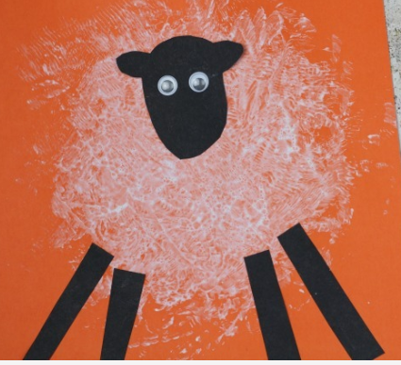  L- mark make and write the inserts  N2- ‘To mum and dad’  N- create an Easter egg wreath  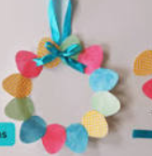  N – match the numeral eggs with the chicks  C&L- follow the clues to locate the Easter Eggs  Enhancements  DT area- Pictures to create own Easter cards cut and stick.  Creative – egg templates for creating own easter eggs using DT materials  Writing area- Easter card templates | 

