
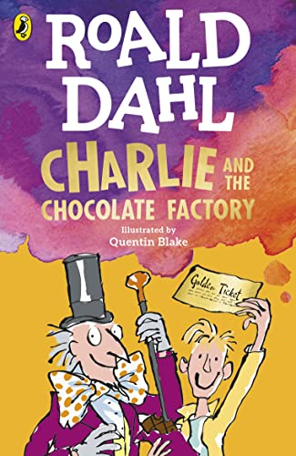


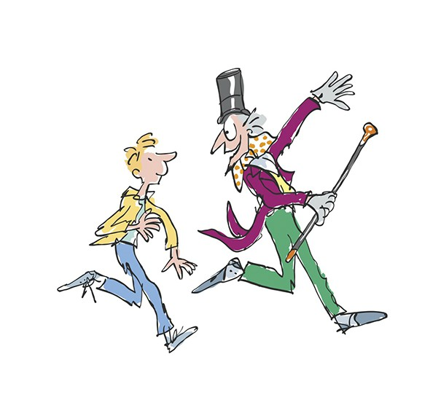
Make a Golden Ticket, just like the one in the book.
Make your own chocolate packaging
Develop and create a new chocolate product
Create a 3D model of a chocolate factory or land of sweets and treats.

- Diary entry from Charlie the day he found his Golden Ticket
- Write a fact file all about Cadbury’s
- Write a leaflet about how chocolate is made
- Create a new story with Charlie and the other children from our book

Have a go at something you find difficult to improve your resilience
Aspirations – create a mood board of jobs you could do when you are older.
Create an idea for a new charity
Practice your times tables.
Can you get a high score on timetables rock stars?
Practice your 3,4, 8 and 6 times tables.

Art & DT

- FORCES!
- Set up Dominoes.
- Race Cars down a Ramp.
- Make a Mousetrap Car.
- Do an Egg Drop Activity.
- Make a Catapult.
- Develop a new game using force
Spring Term
Imagination

Science

English

PSHE

Maths

Homework Menu

