Year Group: F1 Nursery
Term | Autumn 1 | Autumn 2 | Spring 1 | Spring 2 | Summer 1 | Summer 2
Topic | Our Families | Celebrations | Superheroes | Traditional Tales  Billy Goats Gruff/Enormous Turnip | Builder’s Yard | Growing
Enquiry Question | Who is in your family? | What is a celebration? | What is your super power? | What is your favourite story? | What happens on a building site? | What does a plant need to grow?
Class text | 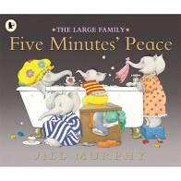 | 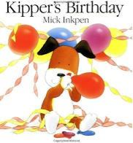 | 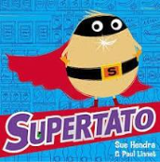 | 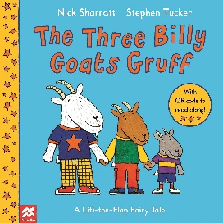  =  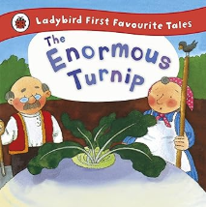 | =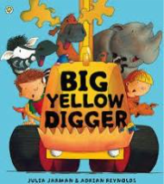 | 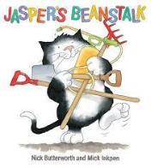
Supporting Texts | Non fiction from ELS  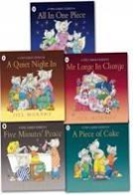  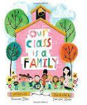  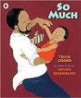 | Non fiction from ELS  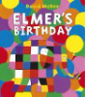  Christmas stories  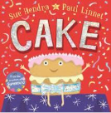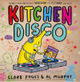 | Non fiction from ELS  =  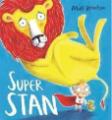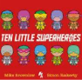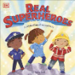 | 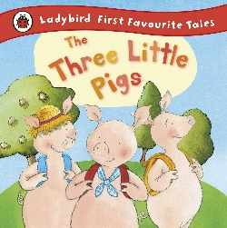  Non fiction from ELS  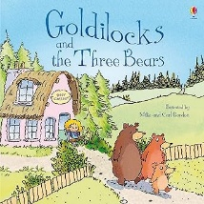  =  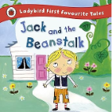 | Non fiction from ELS  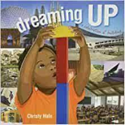  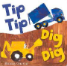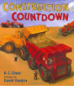 | 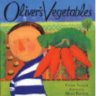  Non fiction from ELS  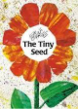  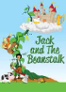
Enrichment/Experiences | Talking Family photo album  Teeth cleaning challenge  Well Being Day - Emotions | Organise a birthday party for Kipper  Anti- Bullying Week- Odd Socks Day  Children in Need  Christmas celebrations  Whitepost Farm Nativity Visit | Superhero dressing up day  Well Being Day – (Aspiration)  Children’s mental Health Week  Safer Internet | World Book Day  Science Week  Easter crafts | Make sandwiches and biscuits  Earth Day  Eid  EAL afternoon | Caterpillars  Class picnic  Well Being Day- (Health)  Sports Day  RSE Day  Reading Celebration Day
Maths Topic | Money | Weight | Patterns | Shape | Sizes, length and height | Ordering and sequencing
Physical Development | Small games equipment  Scooters | Streamers and pompoms | Small games equipment  Superhero obstacles | Crates and planks | Using wheeled vehicles | Heathy eating  Bats and balls
Topic Songs and Rhymes | Family and body songs | Christmas songs | Superhero songs | Nursery rhymes and Easter songs | Vehicle songs | Minibeast songs
Planned Continuous Provision/Enhancements
Term | Autumn 1 | Autumn 2 | Spring 1 | Spring 2 | Summer 1 | Summer 2
Domestic Role Play | Homecorner Shopping | Birthday Party | Homecorner Cooking | Homecorner Spring Cleaning | Little Red Riding Hood’s House | Homecorner Shopping
Imaginative Role Play | Shop | Party Shop | Superhero Hideout | Billy Goats Gruff scene | Builder’s Yard | Garden Centre
Mark making/Writing | Shopping lists  my family booklet | Invitations  Birthday cards | Recipes  Evil Pea ‘Wanted’ posters | Labelling  Easter cards | Letters, materials list, receipts | Shopping lists, minibeasts mark making patterns, mini beast labelling
Maths | Number Rhymes  Counting to 5  Balance, things to weigh |  | Counting to 10  Shape and patterns |  | Counting larger amounts  Numeral recognition to 10  Size, length, height, ordering
Art/Creative | Hand and footprints  Self portraits | Autumn colours  Leaf prints  Collage with autumnal objects | Fruit and veg prints | Painting Houses | Collage  Vehicle track printing | Transient art – natural materials
Making/DT | Paper doll families  House scene using lollipop sticks – square and triangles. Children draw family picture to frame. | Continuous provision  Enhancements – materials for party hats | Big boxes to superhero dens  Continuous provision  Enhancements – Superhero puppets | Create a bridge for the Billy Goats Gruff  Easter crafts | Split pin vehicles | Create ladybird characters using paper plates  Make minibeasts using loose parts
Wet/Dry Sand |  | Cup cake tins, candles, spoons and bowls | Plastic fruit and veg | Diggers | Characters from story, blocks/trees - story maps | Minibeasts in the sand
Water | Bubbles, washing the babies | Coloured water and glitter | People in the water | Watering cans |  | Building materials- floating and sinking
Small World | Dolls house | Farm | Hospital | Dinosaurs | Fairy garden  Peppa pig | Pirate ship
Vehicles | Cars and garage | Trains | Diggers | Fire/police station | Cars and garage | Train
Block Play | People | Dinosaurs | Superhero figures | Zoo animals | People | Farm animals
Book Corner | Family books, people puppets | Autumn books and natural resources  Celebrations books | superhero puppets | Builder/construction books | Traditional Tales books and puppets | Non fiction books growing, planting, vegetables, fruit, healthy eating
Play Dough | People cutters  People outline mats – create facial features | Candles, cake cases, sequins, glitter | Superhero playdough mats | Vehicle cutters, pattern rollers to create tracks | Animal cutters  Fairytale mats | Natural materials, leaves, sticks, flowers
Puzzles/Games | People/homes puzzles | Shape puzzles | Number puzzles | Vehicle puzzles | Animal puzzles | Alphabet puzzles

