Southglade Primary and Nursery School
Telephone : 0115 915 5763
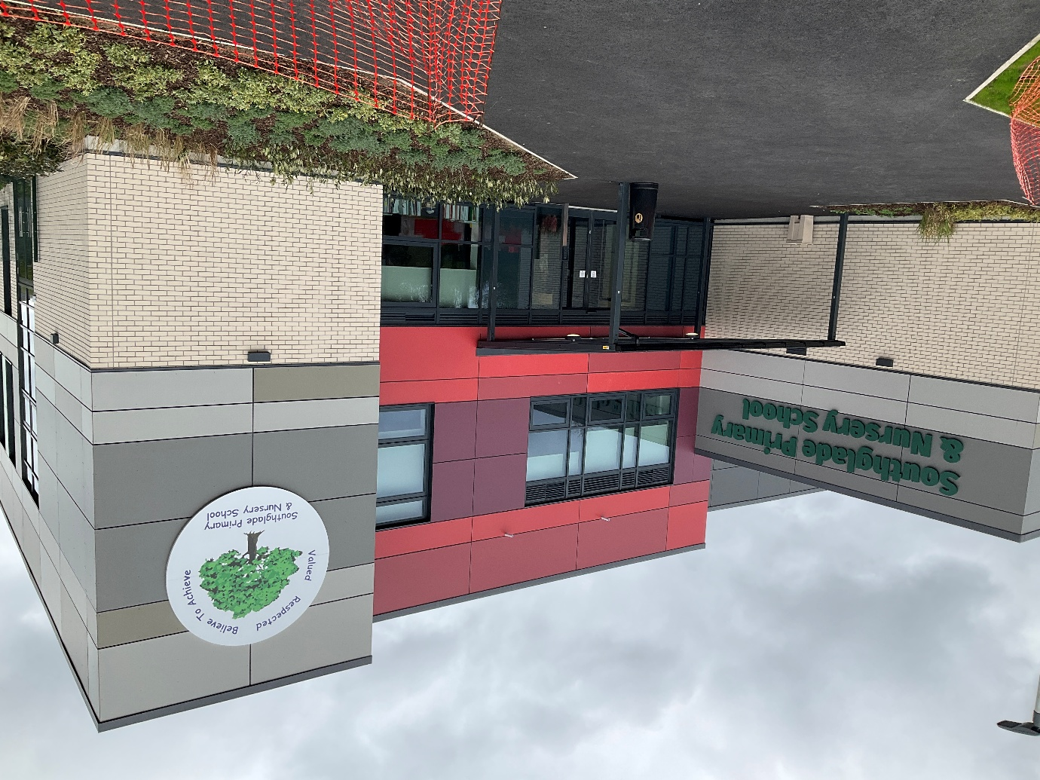
Nursery Brochure
Welcome to Southglade Nursery
2026-2027

Southglade Primary and Nursery School
A Message from the Headteacher

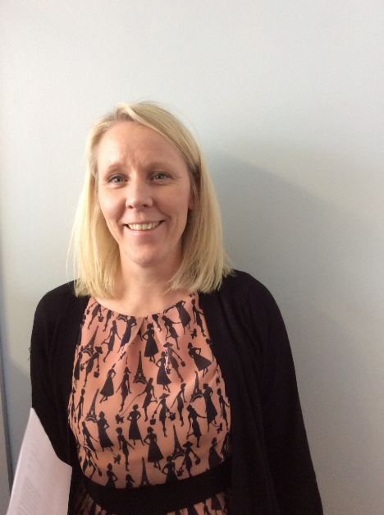

Welcome to Southglade Primary and Nursery School. We look forward to your child joining our Nursery class and to welcoming your family into our school community. We will be working hard together to help your child grow and develop, and to achieve their full potential.
It is an exciting year for us here at Southglade as we have now moved into our brand new school building! Our Nursery and Reception units are next door to each other and share a wonderful outdoor area which the children are loving!
We know that a child’s first day at Nursery can be both exciting and a little daunting for children and their parents, so we have put this brochure together to try and give you as much information about our nursery as possible to help make this significant day go smoothly! We hope it will answer all of your questions.
Mrs. Alison Thomas

Welcome to Southglade Nursery.
At Southglade Nursery, children learn through play in a happy, secure and stimulating environment. By working in partnership with parents, outside agencies and the local community, we support children to become confident, independent learners who enjoy exploring and discovering the world around them.
We hope this booklet answers many of your questions about Southglade Nursery. If you require any further information, please do not hesitate to speak to a member of staff.

The Nursery
Southglade Nursery provides places for children aged 3 to 4 years.
We offer:
- Part-time morning places
- Part-time afternoon places
- Full-time places for children eligible for 30 hours funded childcare
We are based in our purpose-built nursery within the new school building. The nursery has direct access to a dedicated outdoor learning area, which is shared with the Reception children located next door.

Current Nursery Staff
Mrs Smith - Early Years Lead and Nursery Class Teacher
Miss Gresko - Nursery Class Teacher (Wednesday to Friday)
Mrs Bettridge - Teaching Assistant
Mrs Bilan - Teaching Assistant

Nursery session times
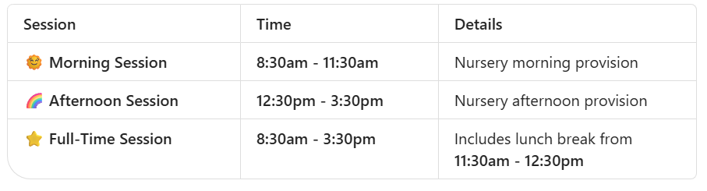
30 Hours Funding
If you are eligible for 30 hours funded childcare and are interested in a full-time Nursery place for your child, please speak to Mrs Smith as soon as possible. Full-time places are limited and early discussions help us to plan and allocate places effectively.
Further information about eligibility for 30 hours childcare funding can be found at: Best Start in Life – Childcare Checker
https://childcare.beststartinlife.gov.uk/
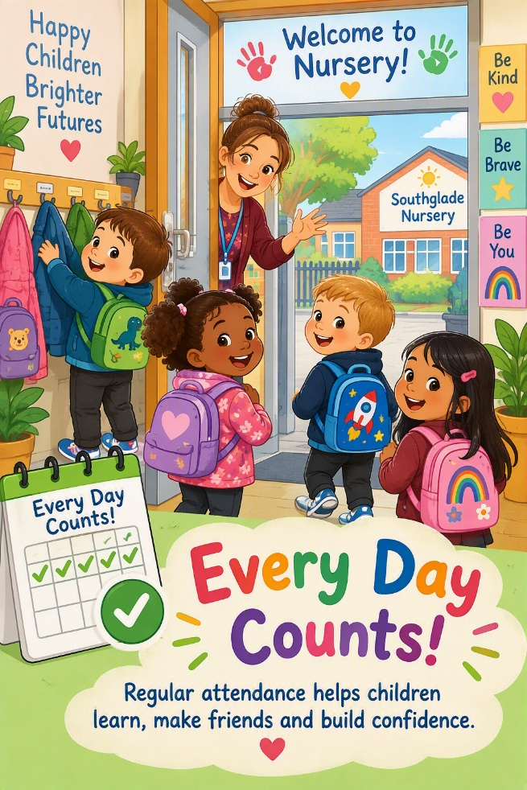
Attendance Matters
Regular attendance is very important in Nursery. Coming to Nursery every day helps children to settle into routines, build friendships, develop confidence and make the most of their learning opportunities. Establishing good attendance habits from an early age supports children as they move through school and helps them develop positive attitudes towards learning.
We understand that young children will sometimes be unwell and need to stay at home. If your child is unable to attend Nursery due to illness, please telephone the school office as soon as possible to let us know the reason for their absence.

What to Bring to Nursery
Water Bottle
Children are provided with milk and fruit during each session. Please send your child with a clearly labelled water bottle containing plain water only. Please do not send juice or additional snacks.

School Lunches
Children attending full-time may either bring a packed lunch or purchase a school meal.
Our school meals are healthy, balanced and freshly prepared. Weekly menus are available for parents to view.
- Current cost: £2.95 per day
- Payment via the Arbor App
Packed lunches should support our Healthy Eating Policy and must not contain:
- Nuts or nut products
- Fizzy drinks

Spare Clothes
Please provide a named bag containing:
- A complete change of clothes
- Spare underwear
- Socks
If your child wears nappies or pull-ups, please also provide:
- Nappies or pull-ups
- Baby wipes
If your child is toilet training, we recommend sending several pairs of underwear (including socks) and spare trousers or leggings.

Keeping in Touch
Communication between home and school is very important to us.
You can keep up to date with school news, events and curriculum information by visiting our website:
www.southgladeprimary.co.uk
We also recommend visiting the Nursery Class page, where you will find:
- Class photographs
- Our class blog
- Curriculum information
- Planning overviews
- Activities to enjoy at home
Regular newsletters are sent to parents throughout the year to keep you informed about upcoming topics, events and learning experiences.

School Communication Apps
We use two online systems to communicate with families. We ask all parents and carers to sign up to both systems when their child starts nursery.
Comms Hub by Juniper Education

Comms Hub is our whole-school communication platform. Through the app you will receive:
- School letters
- Important updates
- Event information
- News and announcements
Evidence Me (2Simple)

Evidence Me allows staff to share photographs and observations of your child's learning and development throughout the year.
Parent Consultations and Reports
Parent consultations take place during the Autumn and Spring Terms, giving you the opportunity to discuss your child's progress with their class teacher.
At the end of your child's final term in Nursery, you will receive a written report outlining their achievements and development.

What to Wear
School uniform is not compulsory in Nursery, although many children choose to wear Southglade Primary School uniform.

Our school colour is burgundy.
Logo uniform can be purchased from:
Just Schoolwear - www.just-schoolwear.co.uk
Burgundy jumpers, cardigans and other suitable items are also available from many local supermarkets.

Children should wear clothes that are:
- Comfortable
- Easy to manage independently
- Suitable for active play
- Appropriate for the weather
As many nursery activities can be messy, children may come home with paint, glue or mud on their clothes. Please avoid sending children in expensive or special outfits.
We enjoy outdoor learning in all seasons, so suitable coats and footwear are essential.
Please Name Everything!
Please write your child's name clearly on all belongings, especially coats, jumpers, cardigans, water bottles and lunch boxes.
This helps us return lost items quickly.
How Can I Help My Child Learn?
Young children learn best through play, everyday experiences and meaningful interactions with the people around them.
Talk Together

- Chat with your child throughout the day.
- Encourage them to share ideas and ask questions.
- Introduce new vocabulary through conversations and experiences.
Read Every Day

- Enjoy books, stories and rhymes together.
- Talk about pictures and characters.
- Ask simple questions and make predictions about what might happen next.
- Visit your local library regularly.
Encourage Independence

- Practise putting on coats and shoes.
- Encourage handwashing.
- Support tidying up after play.
- Praise effort and celebrate achievements.

Explore Numbers and Shapes
- Count objects during everyday activities.
- Look for shapes, numbers & patterns in the environment.
- Compare sizes, lengths and quantities.

Support Physical Development
- Encourage climbing, balancing, running and active outdoor play.
- Use pencils, crayons, playdough and scissors to develop fine motor skills.
School Places
Please note that a Nursery place does not automatically guarantee a place at Southglade Primary School.
Parents must apply for a school place through Nottingham City Council admissions procedures. School admissions is usually open from the end of October to January.
Children who are offered a place at Southglade Primary School will have opportunities to:
- Visit their new classroom
- Meet their teacher
- Take part in transition activities

Additional Needs
At Southglade Nursery, we are committed to ensuring every child can access all areas of learning.
Staff carefully observe children's development and work closely with families to identify and support any additional needs at an early stage.
We regularly work with professionals including:
- Speech and Language Therapists
- Educational Psychologists
- Other specialist support services
Parents are kept fully informed and involved throughout the process. Further information can be found in the school's SEND Policy, available on the school website.

Behaviour Management
We believe everyone in our nursery and school has the right to feel valued, respected and safe.
Positive behaviour is recognised and celebrated so that children understand what they have done well and why it is important.
When difficulties occur, adults support children by teaching positive strategies such as:
- Sharing and taking turns
- Listening to others
- Tidying away resources
If necessary, children may spend a short period in our designated thinking space to help them reflect and prepare to rejoin activities successfully.
Further information can be found in the school's Behaviour Policy.

Equal Opportunities
At Southglade Primary and Nursery School, we are committed to ensuring equality of opportunity and access to learning for all children.
We value and celebrate diversity and strive to create an inclusive environment where every child feels welcomed, respected and able to succeed.

And Finally...
We hope you have found this booklet useful and informative.
Please do not hesitate to contact us if you have any further questions. We look forward to welcoming you and your child to Southglade Nursery and beginning this exciting learning journey together.
Mrs Sophie Smith
Early Years Lead
Southglade Nursery and Primary School

