Year Group: Nursery Term : Autumn 2 Teachers: Miss. Gresko & Mrs Bragg
Half term planning : Autumn 2
Enquiry Question: I wonder… What is a Celebration? Focus Book : Kipper’s Birthday
Week | Learning Objectives | Key vocabulary | Teaching input | Guided/Adult led activities  Enhancements to CP | Links to RRSA  (Rights Respecting School)
1  Diwali/  Bonfire night | To continue developing positive attitudes about the differences between people | Celebration, festival, Diwali, light, dark, fireworks, bonfire, sound words – crackle, pop, bang | Introduce question - What is a Celebration?  Diwali- non fiction book and cbeebies clips, read Rama and Sita story  Ask parents to send in photos of family celebrations  Bonfire Night- share own experiences, non fiction book, you tube Bonfire/fireworks video | Rama and Sita puppets  Rangoli patterns  Paper lanterns  Make diva lamps from clay/dough- decorate with sequins  Tissue paper bonfire and cotton bud firework pictures  Mark making on firework templates – fizz, bang, pop | 
2  Autumnal changes  Parents evening tue/  thur | Use all their senses in hands on exploration of natural materials. | Celebration, Autumn, changes, | Autumn – non fiction book, talk about Autumn changes and celebrations, share photos from our Autumn walk  Share Autumn changes powerpoint. Autumn tree cutting skills activity.  Autumn fingerprint art activity.  Acorn counting game. Match numeral to dots.  Remembrance Sunday  Anti-bullying week – Odd socks Day  Children in Need poweroint | Autumn walk around the local area to collect leaves and take photos  Tuft spot with autumnal leaves, conkers, acorns etc.  Leaf printing with Autumn colour paints and by pressing into play dough  Poppy Day activities- make a wreath  Children in Need colouring | 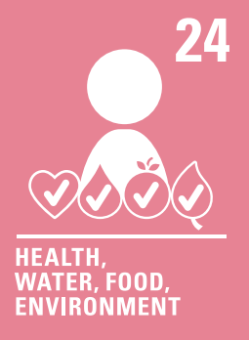
3  Birthdays | Begin to make sense of their own life story and family history | Celebration, Birthday, party, cake, candles | Birthdays- read Kipper’s Birthday  Relate to children’s own birthdays, discuss - how do you celebrate your birthday?  Read Birthday non fiction book  Share photos sent in by parents of family celebrations | Decorate Home corner for a birthday celebration  Matching candles to cakes (quantity to numerals)  Writing invitations for Kipper’s birthday  Making cakes in the playdough area- add candles etc. | 
4  Birthdays | Begin to Understand the 5 key concepts about print | Celebration, invitation, paper chain, decoration, card, recipe, list | Birthdays- Kipper's Birthday  Cake Making, Model Recipe Writing  Model Shopping lists Writing | Writing Recipes/shopping lists  Making paper chains  Making birthday cards | 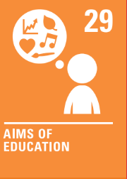
5  Xmas | Begin to Understand the 5 key concepts about print | Celebration, Christmas, Nativity, stable, Mary, Joseph, Jesus, decoration | Introduce Christmas, read Nativity story  Christmas non fiction books  Read Nativity story | Making calendars  Write a list for Santa
6  WPF trip | To continue developing positive attitudes about the differences between people | Celebration, farm, coach, journey, speech bubble, Christmas, trip | Christmas non fiction books  Read Nativity story  Whitepost Farm Trip - look at pictures on website  Share our photos and experience  Writing about photos from trip | Look at photos from the trip and teacher scribes speech bubbles – for class book  Making Christmas cards  Coloured water with glitter in  Christmas playdough cutters | 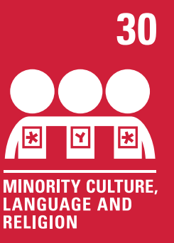
7  Party  Day | To continue developing positive attitudes about the differences between people | Celebration, Christmas, Nativity, stable, Mary, Joseph, Jesus, decoration | Christmas celebration day  Christmas Party | Making party hats  Making Christmas decoration  Make split pin Christmas activity | 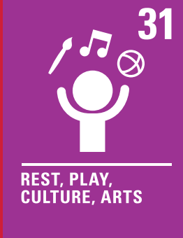
Half Term Planner

