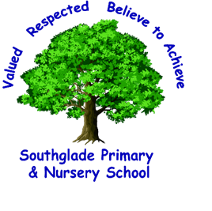
Starting School at Southglade Primary

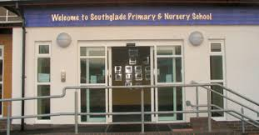
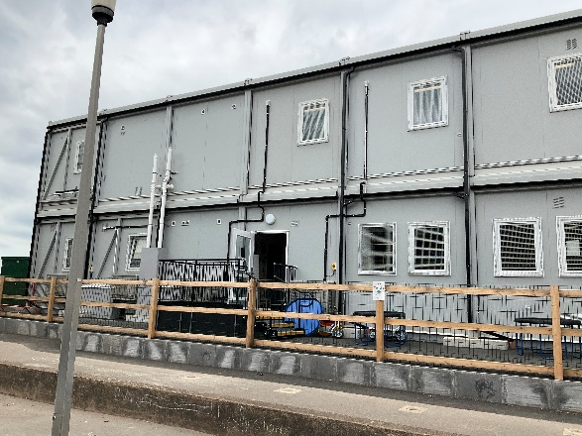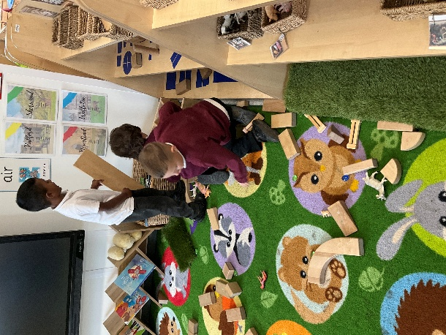

Welcome to Foundation Stage 2 (Reception Class) September 2025

Southglade Primary and Nursery School
A Message from the Headteacher

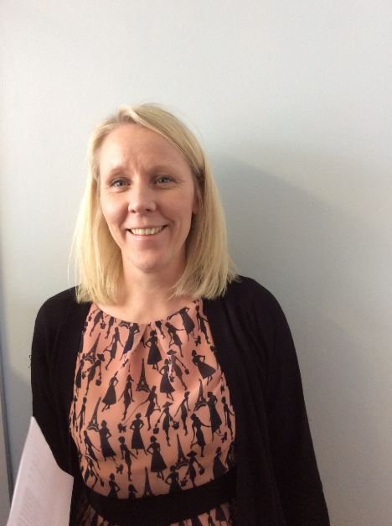

Welcome to Southglade Primary School and Nursery. We look forward to your child joining our Reception class in September and to welcoming new families into our school community. It will be wonderful to see our Nursery children moving up into school and to meet the younger siblings of some of our older children too. We will be working hard together to help your child grow and develop as a learner and young person over the coming years.
It is an exciting year for us here at Southglade as we are expecting to move into our new school building during 2026. Currently the Early Years classes - Nursery and Reception, are based in a temporary building located behind the main school building.
We know that a child’s first day of school can be both exciting and a little worrying for children and their parents, so we have put this brochure together to try and give you as much information about our school as possible to help make this significant day go smoothly! We hope it will answer all of your questions.
Mrs. Alison Thomas
September 2025
What is it like at school? and What class will I be in?
At Southglade Primary and Nursery School we have two F2 classes- Penguins and Polar Bears, which, together with the nursery, form our Foundation Stage (Early Years). The two F2 classes are in our temporary building while our new school is being built. Both classes are in one open plan room, separated by a partial wall, giving us a large, flexible learning area. We also have a small part of the playground outside the classrooms for outdoor learning activities and free play. Toilets and coat pegs are inside the classroom area.
Children will be in either Penguins or Polar Bear class and you will receive a separate letter with this information on.

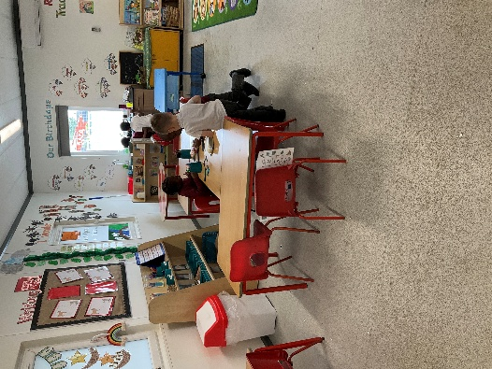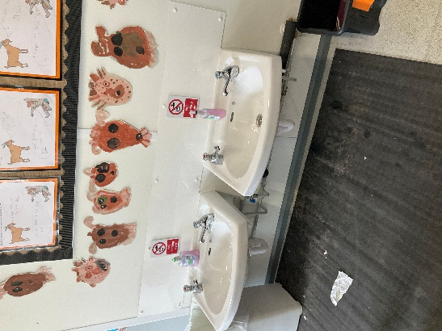
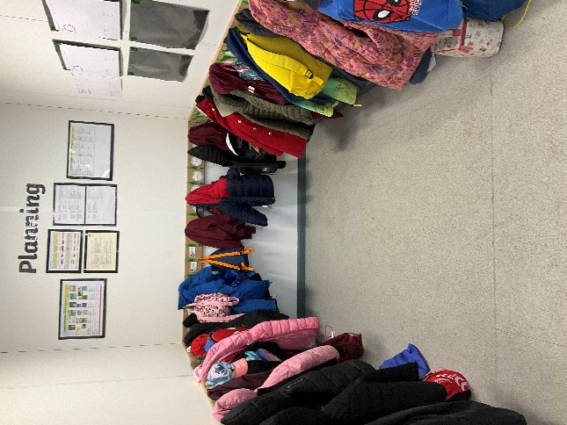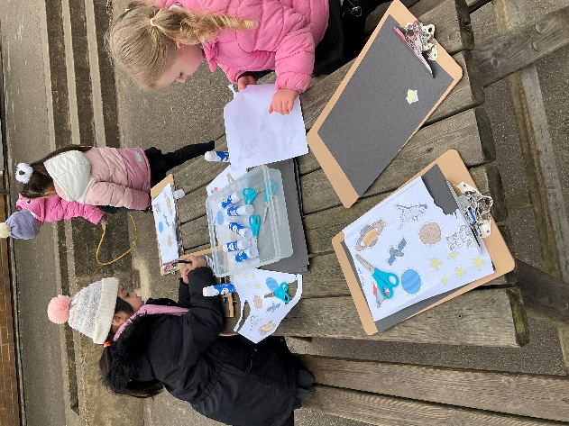

What do I wear at school?
Uniform PE kit
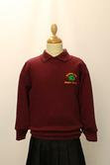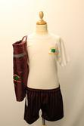
School uniform is an essential part of school life as it creates a unified community and enables pupils to feel a sense of belonging. It is school policy that all children wear the correct uniform to school every day. If your child does not come to school wearing the correct uniform then we will provide them with a school jumper or cardigan to wear. Our school colour is burgundy.
Just School Wear are suppliers of logo uniform. Find them online:
http://www.just-schoolwear.co.uk/
Local supermarkets stock Burgundy jumpers and cardigans, and all other uniform items.
It is vital that all items of clothing are clearly labelled with your child’s name so that any lost items can be returned. Please use sew/iron on labels or an indelible marker, not biro as this washes off after a while.

Uniform:

Burgundy sweatshirt or cardigan
Grey or black trousers, leggings or school skirt/pinafore
White school shirt or blouse /burgundy or white polo shirt
Grey, black or white socks or tights
Black school shoes (open toe or strappy sandals are not acceptable)
On warm days - red and white checked Summer school dress or grey/black school shorts

Additional Items
School fleeces, reversible jackets, burgundy book bags and rucksacks are also available.
PE Kit:
Children also need an appropriate PE kit: black shorts, leggings or tracksuit bottoms; plain white T-shirt or one with the Southglade logo; plimsolls or trainers are not needed initially as we will have bare feet in the hall
Jewellery should not be worn in school.

Will I do PE?
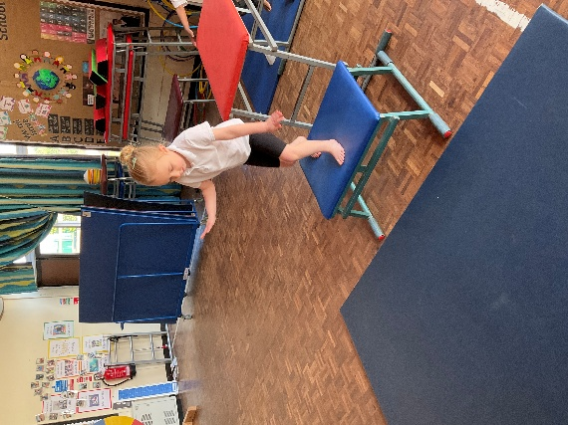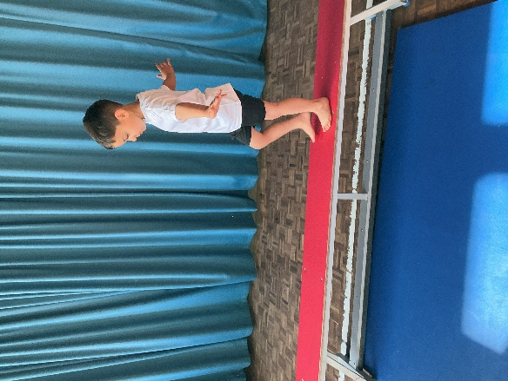

The children have daily access to outdoor play, including lots of physical development opportunities. In addition we also have regular PE lessons in the hall or on the field. Your child will need to bring their PE kit in a named bag, which can be left on their peg. We will send PE kits home every few weeks to be washed. PE drawstring bags can be purchased from the school office. Again all items should be clearly labelled with your child’s name.

Can I play outside?

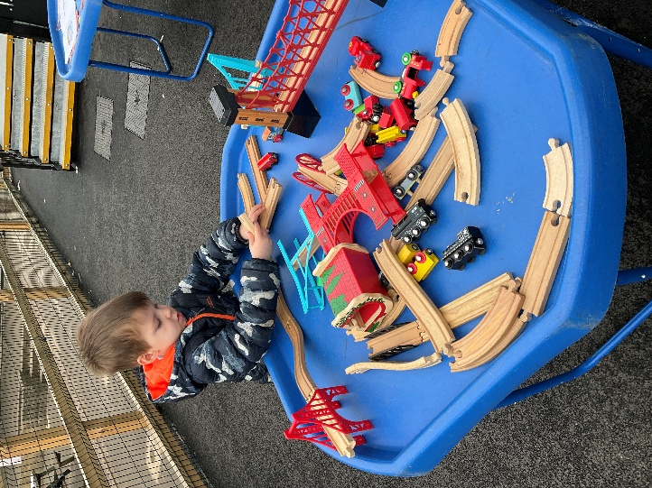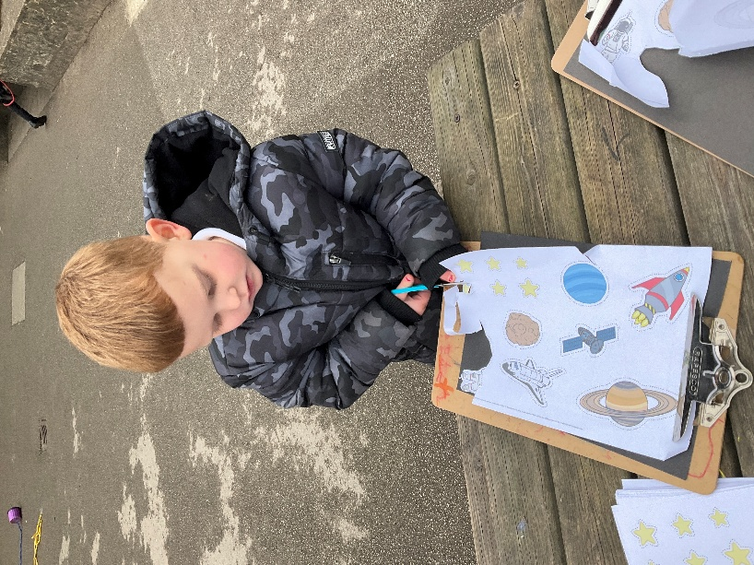

The children have access to outdoor play every day and all children are encouraged to spend some time outside. This is true whatever the weather, so it is important that your child has suitable outdoor clothing with them every day. This means waterproof coats and wellies if it’s wet; warm clothes in winter and sun hat or cap on sunny days. Sun cream should be applied in the morning before you bring your child to school.

What time does school start?
School starts at 8.45 am and home time is 3.15pm. Lunch time is from 11.30 until 12.30. Children in F2 go into their classrooms via the steps around the side of the temporary building. Doors will be open from 8.35am for drop off and we ask that parents please say goodbye outside and allow children to come inside independently.

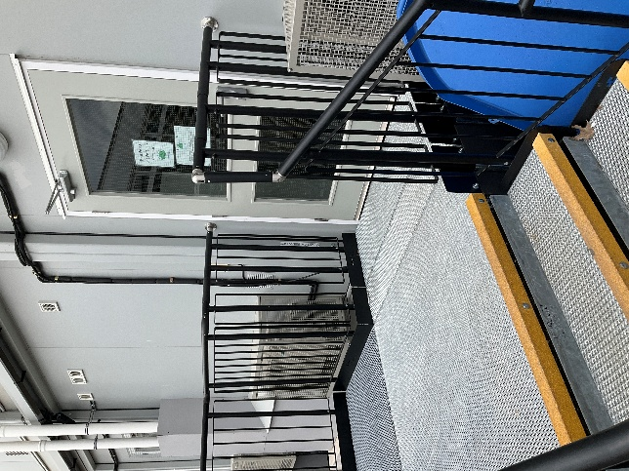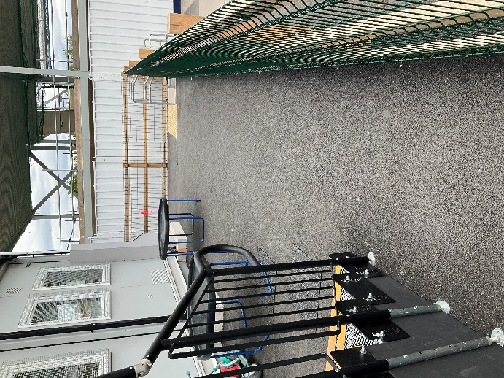

At the end of the day the children will be let out through the same door, please stand and wait away from the steps to allow children safe access. Staff will not let a child out until they have seen the collecting adult. This is to ensure the children’s safety, but it can take a little while until staff become familiar with new faces so please bear with us for the first few weeks! At the beginning of the year you will be asked to fill in a form telling us who has permission to collect your child from school.
If someone different will be collecting your child from school please let staff know in the morning, we will not release children to an unknown adult without their parents’ permission. If it is a last minute arrangement please phone the school office to let them know who will be collecting your child. Children can only be collected by a nominated person who is over 16 years old.

What happens if my child needs an inhaler or medicine at school?
On entry to school you will be asked to fill in a form letting us know about any dietary or medical needs and/or any allergies. Please ensure we are kept up to date with any changes. If your child needs an inhaler for asthma, this should be clearly labelled with your child’s name and an asthma form filled in at the reception desk.
If your child has been prescribed medicine which needs to be taken four times a day, then it is possible for a member of staff to administer a dose during the school day. Medicine should be handed in at the reception desk where you will be asked to fill in and sign a form specifying the medicine and dose required.
If your child is too ill to attend school or has a medical appointment please let the school office know as soon as possible.

When are the School Holidays?
We follow the Nottingham City Council School holidays pattern, which you will be given a copy of in September and which is also available online. In addition the school will set 5 INSET days for teaching training across the year, which you will be given the dates for in September, via the school website .
At Southglade Primary we also follow Nottingham City policy which states that children should not be withdrawn from school for family holidays. Holiday request forms may be obtained from the office but it is unlikely the Head Teacher will authorise an absence unless there are exceptional circumstances. Nottingham City Council may impose fines for unauthorised holiday absence.

When can parents speak to the teacher?
Urgent messages can be passed on when you drop your child at school in the morning.
If you have a query or concern class teachers are always available for a quick chat after school.
For a longer discussion teachers may ask you to arrange an appointment so they have more time to talk.
How will my parents know what I do in school?
Communication is very important to our school and we have many different ways to stay in touch.
Lots of information about school, special events and curriculum can be found on the schools website: www.southgladeprimary.co.uk where you can also navigate to our year group class page:
Reception | Southglade Primary School
This has lots of photos, our class blog, planning and activities to do at home, and is well worth a visit.
Regular newsletters are sent out to let you know what will be happening each term and let you know which book and topic we will be learning about.



The school also subscribes to Marvellous Me and Evidence Me (2simple) – both of which you will be asked to sign up to at the beginning of the year. Marvellous Me is our whole school communications system. You will receive lots of important letters and updates through the Marvellous Me app as well as “badges” rewarding your child’s great work at school and “activities” showing you what they have been up to during the day. 2simple is an email based system which allows F2 staff to send you photos and observations of your child playing and learning each half term.
In the Autumn and Spring terms you will be invited into school by your child’s class teacher for a parent consultation. At the end of the Summer term a written report is sent out detailing your child’s achievements.

Do I need to bring any food with me?
All F2 children are currently entitled to a free school meal everyday. There is a three week rolling menu of hot dinners, and a sandwich or snack type lunch is also an option.

School meals are eaten in the Key Stage 1 (small) hall.
Different dietary needs can be catered for, including vegetarian and gluten free.
Water is always available to all children in the dining hall.
If you would prefer, you can bring a healthy packed lunch to school.

Will I get a snack during the day?
All the children are provided with a piece of fruit each day. Children up to the age of five are also entitled to a free carton of milk each day. When your child is five you will have the option to continue with daily milk but there will be a small charge. On starting school you will receive details of how to register online for the school milk scheme. Children who do not like, or are allergic to, milk can have water to drink instead. Other snacks or drinks should not be sent into school.
Water is available for the children to drink throughout the day. Children are asked to bring in their own water bottle, clearly labelled with their name. Water bottles will go home each day to be washed and brought back the next day. Children who do not bring a bottle will be provided with a cup to use.

Can I bring in treats on my birthday?
We will always celebrate every child’s birthday at school by singing Happy Birthday with the whole class. If you wish to send in a treat for your child to share with the other children, such as mini chocolate bars, small cakes or fruit this is fine but not compulsory! Please do not send in anything containing nuts.

What will I learn at school?
Across the Foundation Stage (Nursery and F2), we follow the Early Years Foundation Stage (EYFS) Curriculum as required by the Government for all under 5s education. The work in F2 is a continuation of the learning journey the children have begun either in Nursery or other pre-school settings. The emphasis is very much on learning through play and the teachers aim to provide a rich and stimulating environment for the children.
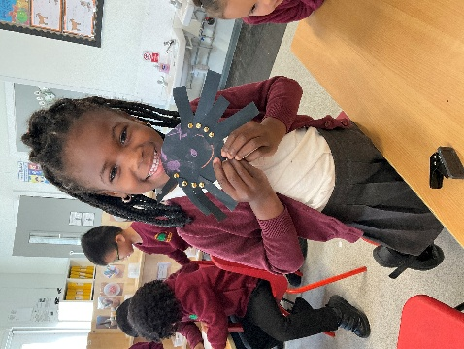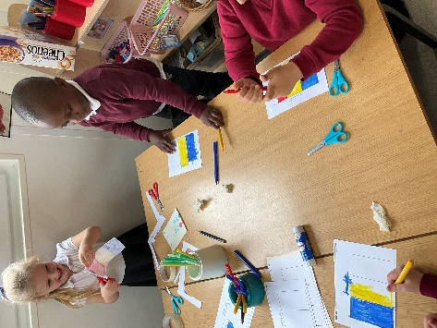
Early Learning Goals
Within the Early Years Framework there are 3 prime areas of learning and 4 specific areas. This framework provides the basis of how we structure the learning environment, the activities and opportunities we provide, and how we assess your child’s development. For each of the areas of Learning there are specific ‘Early Learning Goals’ to work towards:

Prime Areas

Personal, Social and Emotional Development : Self Regulation, Managing Self, Building Relationships
Physical Development : Gross Motor Skills, Fine Motor Skills
Communication and Language : Listening, Attention and Understanding, Speaking

Specific areas

Literacy: Word Reading, Comprehension, Writing
Mathematics: Numbers, Numerical Patterns
Understanding the World :Past and Present; People, Culture and Communities; The Natural World
Expressive Arts and Design : Creating with Materials, Being imaginative and expressive

Phonics and Maths

Phonics and maths are taught daily, often in smaller groups, for a 15-20 minute session.
Phonics is key to the development early of Reading and Writing and is given our highest priority. Children begin to learn, using the Little Wandle Phonics Scheme, from their very first day in school. They are taught to say and read every sound, and how to blend them together to read a word eg m-a-t says mat (blending); hat is spelt h-a-t (segmenting). More information can be found in our phonics policy, available on the school website.
Maths is taught using a mastery approach – children gain a deep understanding of each number to 10, including the number facts which go with it. For example how to count to 3, how to write the numeral 3, to recognise a group of 3 without counting, to show 3 fingers, to know 2+1 is 3, 4-1 is 3 etc. This underlying knowledge of number then supports their learning in maths as they move on to more complicated problems and calculations.

Will I get a reading book?
In F2 the most important homework we expect the children to do is READING. It is vital that you spend a few minutes each day to read with your child to reinforce the learning they do at school.
Once your child has settled into school, they will bring home a reading book and a reading diary. They will already have read their book in a small group at school, and it is essential that they also read it at home to develop fluency and confidence. The reading book your child is given will contain mostly words which are “decodable”. This means your child can sound out the word using phonics that they know eg c-a-t says cat. Your child will also bring home Tricky Words to learn. Learning to read these words on sight will help your child to be more fluent when reading and also support their writing too.
In September we will give you much more guidance on how to support your child with learning to read.
From time to time we may also send home other small homework tasks which will support the work we are doing in school. These will always be fun activities for you and your child to enjoy doing together.

What are the school rules?
In order to keep the children safe while they are playing, and to help them to learn how to behave in larger social groups, we have some very simple class Rules which the children are expected to follow.
- We walk inside and run outside.
- We talk inside and shout outside.
- We never hurt our friends.
- We always tidy up.
All children in school also learn about our school Code of Conduct which is based around RESPECT, and is followed by the whole school community, including visitors. For more information please see our Behaviour Policy, which is available on the school website.

How can I be ready to start school?
At school we will expect your child to be as independent as possible. It will really help if you support us with this at home.
Some useful things for your child to practise are:
- Putting on their own coat and doing up the zip/buttons
- Putting on their own shoes and socks, including fastening laces and Velcro
- Using a knife and fork to eat
- Writing and recognising the letters of their own first name
- Counting to 10
- Washing and drying their hands
- Getting dressed in the morning
- All school aged children should be walking to school and carrying their own book bag.
- We would expect children to be toileting themselves but we can offer support if there are medical or developmental reasons why this is not yet happening.

We are looking forward to meeting and welcoming you into Southglade Primary and Nursery School. If you have any questions of queries please contact school:

admin@southglade.nottingham.sch.uk

0115 915 5763

