Southglade Primary and Nursery School
Telephone : 0115 915 5763

Nursery Brochure

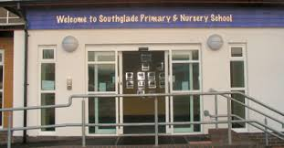
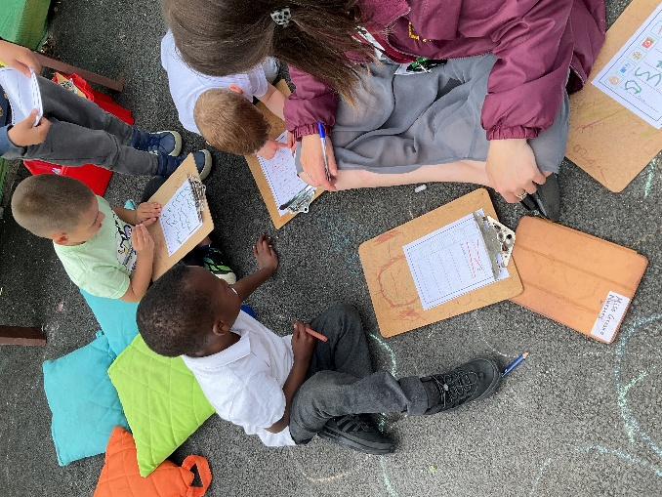 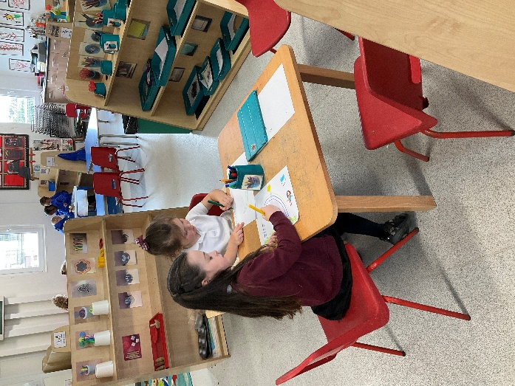
Welcome to Foundation Stage
Southglade Primary and Nursery School

A Message from the Headteacher

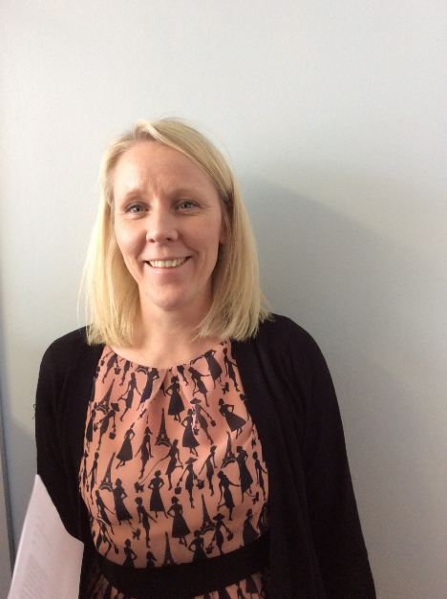

Welcome to Southglade Primary and Nursery School. We look forward to your child joining our Nursery class and to welcoming your family into our school community. We will be working hard together to help your child grow and develop, and to achieve their full potential.
It is an exciting year for us here at Southglade as we are expecting to move into our new school building during 2026. Currently the Early Years classes - Nursery and Reception, are based in a temporary building located behind the main school building.
We know that a child’s first day at Nursery can be both exciting and a little daunting for children and their parents, so we have put this brochure together to try and give you as much information about our nursery as possible to help make this significant day go smoothly! We hope it will answer all of your questions.
Mrs. Alison Thomas

Welcome
At Southglade Nursery the children learn through play in a happy, secure and stimulating environment. By working in partnership with parents, outside agencies and the local community we support the children to become confident and independent learners. We hope this brochure will be helpful and will answer some of your questions about Southglade Nursery. Please feel free to approach staff for any further information.

The Nursery
Southglade Nursery is for children aged 3-4 years. We have part time morning and afternoon places. Full time places are also available for children with 30 hours funding. Our nursery is currently based in the Temporary building behind the main school. We are looking forward to moving into our brand new Nursery classroom next year.

Current Nursery Staff

Mrs. Barron – Early Years Lead
Miss. Gresko - Nursery Class Teacher
Mrs. Bostock – Nursery Class
Mrs. Bettridge -Teaching Assistant
Mrs. Skupin -Teaching Assistant

Nursery session times

Morning session : 8.30-11.30
Afternoon session : 12.30-3.30
Full time : 8.30-3.30 (lunch 11.30-12.30)

What to bring to Nursery
Water bottle
Children are provided with a milk and fruit snack during the session, but will need to bring their own water bottle, clearly labelled with their name. Plain water only please, not juice. Please do not send in any other snacks.
School lunches
If your child attends full time you may choose whether to send your child in with a packed lunch from home or to have school lunches. The school lunches which we provide are healthy, balanced meals and weekly menus are available so that you can see what the children have had. Meals currently cost £2.75 a day.
Any packed lunches sent into school must be healthy and in line with the schools Healthy Eating Policy – no chocolate, crisps or fizzy drinks please.
A change of clothes
Please send your child to nursery with a named bag containing a set of clean clothes in case they need changing while at nursery. If your child is in nappies or pull ups please provide a few of these and baby wipes. If your child is toilet training please send in several pairs of pants and bottoms in case of accidents!

Keeping in touch
Communication is very important to our school and we have many different ways to stay in touch.
Lots of information about school, special events and curriculum can be found on the schools website: www.southgladeprimary.co.uk
Check out the Nursery class page too. This has lots of photos, our class blog, planning and activities to do at home, and is well worth a visit.
Regular newsletters are sent out to let you know what will be happening each term and let you know which book and topic we will be learning about.


The school also subscribes to Marvellous Me and 2simple (Evidence Me) – both of which you will be asked to sign up to when your child starts Nursery. Marvellous Me is our whole school communications system. You will receive lots of important letters and updates through the Marvellous Me app as well as “badges” rewarding your child’s great work at school and “activities” showing you what they have been up to during the day. Evidence Me is an email based system which allows nursery staff to send you photos and observations of your child playing and learning each half term.
In the Spring and Autumn term you will be invited into school by your child’s class teacher for a parent consultation. At the end of their final term a written report is sent out detailing your child’s achievements.

What to Wear
Uniforms are not compulsory in nursery but many children do choose to wear Southglade Primary School uniform. Our school colour is burgundy.
Just School Wear are suppliers of logo uniform in Bulwell or Arnold or online:
http://www.just-schoolwear.co.uk/
Local supermarkets stock Burgundy jumpers and cardigans, and all other uniform items.
Any clothes worn at nursery should be comfortable and easy for the children to manage. They will need to be able to go to the toilet, take off a layer if it’s hot and get their shoes on and off.
Lots of our activities are messy and it is likely the children will come home covered in paint, glue, mud etc. Please do not send them in any expensive or special clothes!
We are outside a lot of the time, in all weather, so children will need appropriate clothing and footwear for the season. Please name everything, especially coats, jumpers and cardigans otherwise it can be really hard to reunite items with their owners!
How can I help my child to learn?
The home is the most important place of learning for young children so there is lots you can do to support their education:
- Talk to your child about what they are doing and listen carefully to what they tell you.
- Encourage your child to ask and answer questions.
- Help them to become independent e.g. going to the toilet on their own, putting on their coat and shoes themselves.
- Read stories, sing songs and say nursery rhymes regularly.
- Watch TV or use the computer together and talk about what is happening.
- Count everyday objects as you go about your normal routines e.g. stairs, cups, fingers.
- Look for and name shapes inside and outside.
- Talk about and involve your child in everyday tasks such as washing up, shopping etc.

School Places
A place in Nursery does not mean your child will automatically get a place in Southglade Primary School. You will need to follow Nottingham City school place application procedures. Please ask at Nursery if you need any more information regarding this. Children who do get a place at Southglade Primary School will have opportunities to visit their new class and meet their new teacher while still at nursery.

Additional Needs
At Nursery, all staff support children to access all Areas of Learning by providing for their individual needs within the group.
We aim for early identification by our staff of children with additional needs, including with Speech and Language, and we then offer support to both children and parents.
Some children may need extra support from a Special Needs Assistant or Speech Therapist which we can provide.
We work with a range of professionals who visit the Nursery regularly including Speech Therapists and Educational Psychologists.
Parents are kept well informed of their child’s progress. Please see the schools Special Educational Needs and Disability Policy for more information. (Available on the school website)

Behaviour Management
We believe that everyone in our nursery, and in our school, has the right to feel valued, respected and safe.
Positive behaviour is always acknowledged and praised so the children understand what they have done well and why it is important.
Adults will intervene when behaviour is unkind or disruptive and give the children positive strategies to try, such as waiting for a turn, sharing or tidying away. If the unacceptable behaviour continues, children may be sent to our thinking space for a short “time out.” Please see the school Behaviour Policy for more information. (Available on the school website)

Equal opportunities
At Southglade Primary and Nursery School we are committed to ensuring equality of learning opportunities and access to all areas of the curriculum for all of our pupils.

And Finally…
We hope that you have found this brochure useful. Please do not hesitate to contact us if you require any further information.
We look forward to welcoming you and your child into our Nursery.
Mrs. Kay Barron
Early Years Lead

