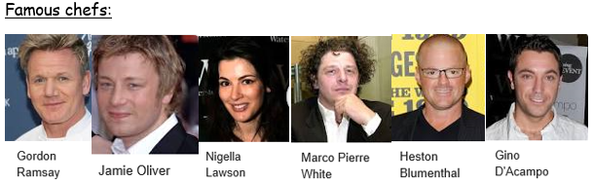
Knowledge Organiser: D&T
I wonder how herbs and spices can affect the taste of food.
Key vocabulary
Combinations | Joining or merging of different parts or qualities
Tasting | Sample, compare, and evaluate different foods.
Chopping / cutting | Claw and bridge grip are different types of cutting
Weighing | Measuring something out to get the specific weight intended, using scales.
Sieving | Put a food into a sieve to remove unwanted items e.g., to remove lumps.
Rolling | Using a cylinder-shaped utensil to flatten or shape
Utensil | a tool, container, or other article, especially for household use.


