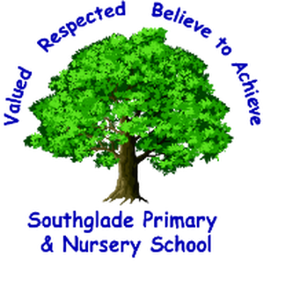

Anti-bullying booklet
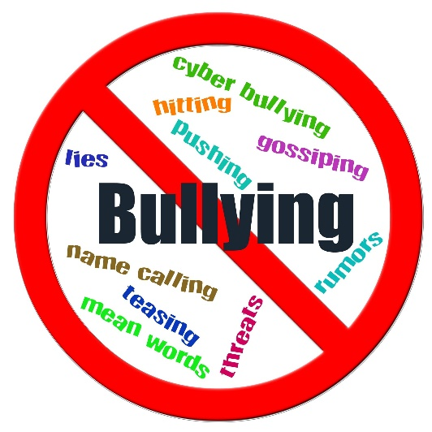

Autumn 2020
A booklet designed for the children by the children
What is bullying?
- Bullying means several times on purpose (STOP)
- Bullying is hurting someone on purpose.
- Being mean every day
- Hurting someone’s feelings
- Bullying is hurting someone physically or through their words.
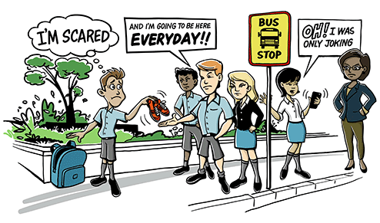

What might bullies do?
- Bullies might call you names and tease you.
- Bullies might push you or hurt you.
- Bullies might laugh at you and make you feel worried.
- Bullies might be unkind to you online through social media
- Bullying can make you feel 6 metres tall but being bullied makes you feel really small.
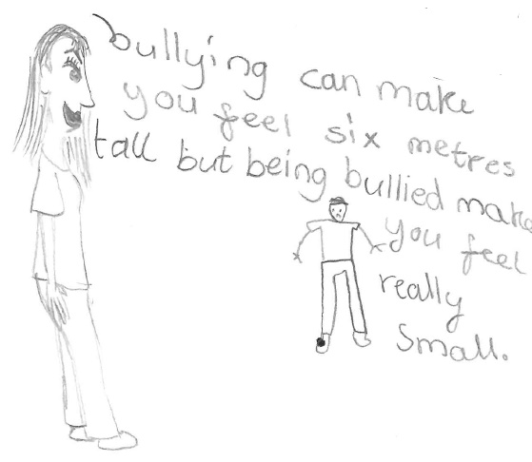

Why might bullies bully people?
- People might be bullies if they have been bullied themselves
- Bullies might think that they are better than everyone else
- Someone might be a bully because they want to be noticed
- Bullies could be jealous of you
- Bullies might pick on people that they don’t like.
- A bully might be having problems at home and decide to take it out at people at school
- If somebody is new to a school they might be scared and be bullies.
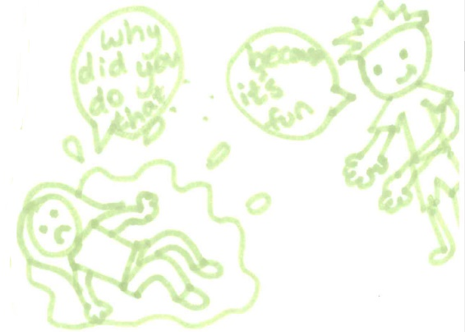

Where might bullying happen?
- Bullying could happen everywhere
- Bullying might happen on your way to or from school
- Bullying might happen on the playground or at the Ridge
- Bullying can also take place online through apps like Snapchat or Instagram.
- If a bully has your phone number they could send you mean messages
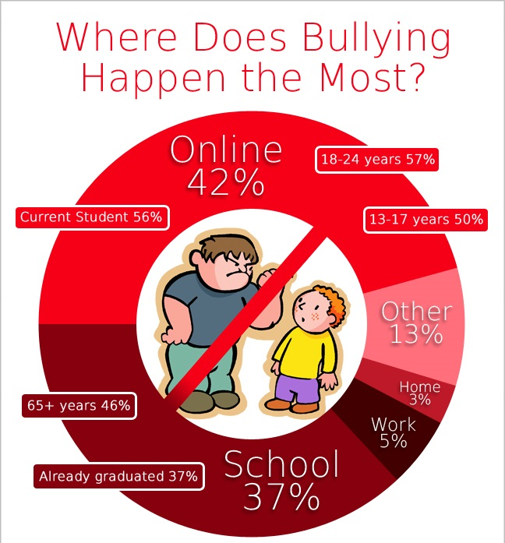

What can I do if I am being bullied?
- Tell your teacher/parents
- Stand up for yourself and ask the bullies to stop
- Tell the learning mentors
- Write it in the worry box
- You could get your friend to help you
- Be the bigger person and walk away. Make sure you tell an adult that you trust.

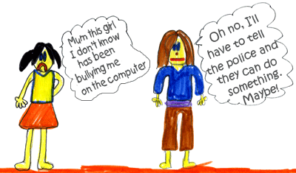

What can I do if my friend is being bullied?
- Tell a school councillor
- Help your friend to tell an adult
- I could stand up to the bullies and confront them for my friend if I am feeling confident
- Tell my parents and ask them for their advice
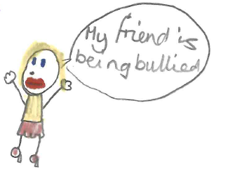

What can I do if I think that I am a bully?
- Talk to a learning mentor. They will not shout at you but they will try to help you to stop.
- Speak to my teacher privately
- Say sorry to the person I have bullied and be kind to them
- Make a present to apologise to the person you have been unkind to.

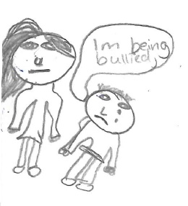

How can my teacher help?
- Teachers will talk to the bully and encourage them to stop
- Teachers will talk to the bully’s parents
- If the bullying doesn’t stop after the teacher has spoken to the bully then they will speak to Mrs Thomas, Mr Pegram, Mrs Hyland and Mrs Rowlett about it.
- Teachers can send the bully to isolation
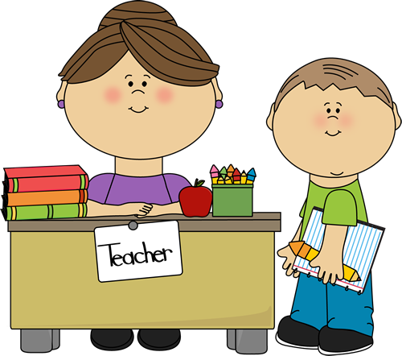

How can my friends help?
- Your friends can stick up for you and protect you.
- They can ask you if you are ok
- Your friends can help you to tell an adult
- They can stay with you so you are not alone with the bully
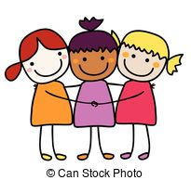

How can my parents help?
- They will give you a hug and make sure you are okay.
- If you tell your parents you will feel better
- Your parents can talk to your teacher for you
- If your parents know the bully’s parents then they can speak to them
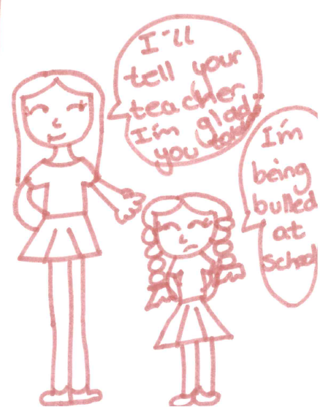

Parent views
Parents were invited to a whole school assembly where the anti-bullying booklet was presented to the school.
- “The booklet is really useful and accessible for parents.”
- “It was really good and there’s nothing that I’d change.”

Pupil views
- “I found all of the information interesting.”
- “It taught me that if someone is being mean to me it’s ok to tell someone about it.”
- “It taught me to stick up for myself and tell an adult if I’m being bullied.”
- “I like it because children made it.”
- “I know how to get some help.”
- “If I am feeling worried then I will talk to my teacher.”
- “I think children will use it because it was written by other children.”

