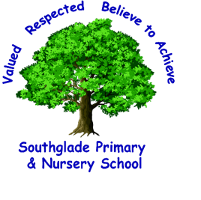
Southglade Primary and Nursery School
Beckhampton Road
Bestwood
Nottingham
NG5 5NE
Telephone: 0115 9155763
E-mail: admin@southglade.nottingham.sch.uk
Headteacher: Mrs A Thomas (B.Ed. Hons)

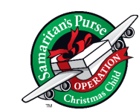

RE: Operation Christmas Child
Dear Parents/Carers,
We are delighted to share that Southglade Primary and Nursery School will be supporting Operation Christmas Child, an inspiring project run by Samaritan’s Purse. This initiative gives our pupils the chance to make a real difference in the lives of children around the world by filling shoeboxes with small gifts, school supplies, and hygiene items.
As a Rights Respecting School, we are committed to upholding the values of the UN Convention on the Rights of the Child. In particular, this project links closely to:
- Article 27: Every child has the right to a standard of living adequate for their health and well-being.
- Article 28: Every child has the right to an education.
- Article 31: Every child has the right to play and enjoy their childhood.
Through Operation Christmas Child, our students are learning about empathy, global citizenship, and how they can take action to support the rights of other children across the world.
How You Can Help
- Pack a shoebox at home: Families are invited to fill a standard-sized shoebox (or plastic box) with small gifts such as toys, school supplies, and personal care items. Please choose items that are suitable for either a boy or a girl, and keep in mind the appropriate age category: 2–4 years, 5–9 years, or 10–14 years. You may also wish to include a short note or card to make your box extra special.
Please remember to avoid food, liquids, or items related to war or conflict
- Return Completed Boxes: Please bring your filled shoebox to school by Monday 10th November. Please do not seal the lid of the shoebox.
- Donation: A £5 donation helps cover shipping and project costs. Donations can be made online or included in the shoebox in a clearly marked envelope.
If you would like a pre-printed shoebox label, please contact your child’s teacher—these are available on request. Thank you for supporting this project and helping us continue our journey as a Rights Respecting School. Together, we can encourage our children to be compassionate, active global citizens who understand and respect the rights of others.
Mrs Morton

