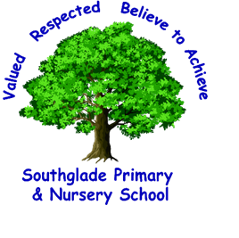

Coronavirus Update
Dear parents / Carers
Firstly can I reassure you that currently there are no confirmed cases of coronavirus at Southglade Primary and Nursery School. I have been made aware that there are some conversations taking place on social media stating that there are. I can confirm that this is not true.
I would like to reassure you that we continue to follow the guidelines as set out by the DFE and school will continue to operate as normal.
Any updates that we receive that may change these arrangements we will immediately pass on to parents.
In the meantime the DFE have announced the following helpline.

Department for Education coronavirus helpline
The Department for Education coronavirus helpline is now available to answer questions about COVID-19 relating to education and children’s social care. Staff, parents and young people can contact this helpline as follows:
Phone: 0800 046 8687
Email: DfE.coronavirushelpline@education.gov.uk
Opening hours: 8am to 6pm (Monday to Friday)

Can I ask that all parents are signed up to the Marvellous Me app and continue to regularly access the school website (https://www.southgladeprimary.co.uk/) and school Twitter account (@southglagePri) as we will post any updates we receive firstly on there.
We have also finalised our remote learning strategy and this will be relayed to pupils and parents via Marvellous Me, the school website and Twitter if needed.
But at the moment, school continues to run as normal
Kind Regards
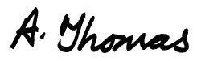
Alison Thomas
Head Teacher

