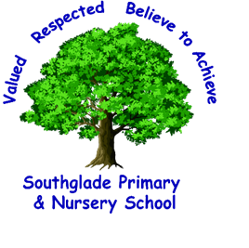

Coronavirus Update
Dear Parents/carers
At the end of last week, the Government’s COBRA committee decided to move to a new phase in its fight against coronavirus, with updated information about how to delay the spread of the disease. The new advice does not require schools to shut and Southglade remains open for all healthy pupils and staff.
The key message from the government is that anyone with symptoms of coronavirus – specifically a new, continuous dry cough or fever (temperature over 37.8 degrees) should stay at home in self-isolation for seven days.
You do not need to call NHS 111 to self-isolate but we would of course ask that you notify school in the usual way with any absences.
If symptoms worsen during the stay at home period or you feel that your child cannot cope with their symptoms at home or are no better after 7 days contact NHS 111 online at 111.nhs.uk. If you have no internet access, you should call NHS 111. For a medical emergency, dial 999.
Current advice remains in place: no education or children’s social care setting should close in response to a suspected or confirmed COVID-19 case unless advised to do so by Public Health England.
What this means at Southglade
At Southglade we continue to follow government advice closely, and will update you with information as the situation develops. (Please ensure that you are regularly checking Marvellous Me and the school website for updates.)
We will continue to reiterate to our pupils about good hygiene practice, in particular regular and thorough handwashing. Please support us by encouraging your child to follow this advice at all times. We are also taking additional cleaning measures within school in line with national advice.
Over the coming days and weeks, the new advice means that there may be some children and staff who need to stay at home for this period, because the symptoms described are similar to those of the usual coughs and colds we have around at this time of year. Therefore, we will not be informing parents/carers every time someone is staying at home to self-isolate for 7 days. If at any time, we have a confirmed case, pupil or staff, in school we will follow advice from the local Public Health Protection Team who will advise school further about the next steps to take. Currently there are no confirmed cases with our pupils, staff, parents or carers.
Parents Evenings postponed
After a lot of thought we have decided to postpone this week’s planned Parents Evenings to reduce the amount of outside contact entering school. In recent weeks we have increased our cleaning measures across school in line with national advice and feel that the high volume of people attending could counteract this and make it difficult for a thorough clean to take place when the building is busy with parents, children and staff.
If you feel there are urgent issues you need to talk to your child’s teacher about this week, please phone and arrange a telephone appointment for a suitable time. Likewise, if your child’s teacher thinks there is something pressing they need to talk to you about, they will ring to talk or arrange an alternative apppointment. At this point we cannot advise on when parents’ evenings will take place as the situation, as you are aware, is changing rapidly.
I understand that these are uncertain times and there may be further disruption ahead, but we will continue to keep you updated on developments as soon as we hear.
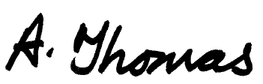
Kind Regards

Alison Thomas
Head Teacher
Useful Advice Lines
NHS Health Information and Advice
https://www.nhs.uk/conditions/coronavirus-covid-19/
Department for Education Coronavirus Helpline
Phone: 0800 046 8687
Email: DfE.coronavirushelpline@education.gov.uk
Opening hours: 8am to 6pm (Monday to Friday)
Department for Education Guidance for Schools
https://www.gov.uk/government/publications/guidance-to-educational-settings-about-covid-19
Advice on Staying at Home
https://www.gov.uk/government/publications/covid-19-stay-at-home-guidance

