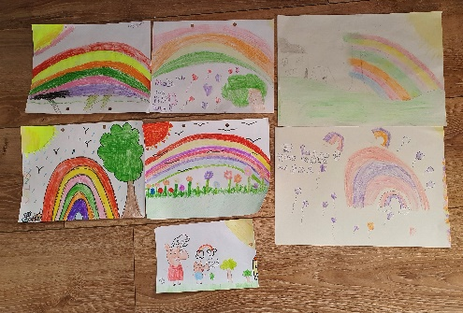

Week 2
Hello Southgladers
How are you all? I hope you all had a good first week at home and managed to enjoy some of that lovely sunshine.
Thank you so much for all your wonderful emails and Tweets. It was so nice to hear from so many of you and to see the photographs of all the fantastic work and activities you have been doing from diary writing to cake baking, seed planting to rainbow drawings. It seems like you have all been super busy with your learning. Remember if you would like to show me anything you have done ask your grown up to help you email me at: headteacher@southglade.nottingham.sch.uk
Your teachers will continue to upload your remote learning for this week on the school website and via a Marvellous Me to your parents. Remember you can use the online resources and links that your teachers have provided too like Times Table Rock Stars, Purple Mash and BBC Bitesize. And don’t forget to do your reading – I’d love to hear about some of the wonderful books you have been enjoying.
I know things may still feel a little strange (it still does for me too) but hopefully you are getting into a routine at home. Perhaps you have created a daily timetable to help you with your learning just like we do at school. Remember when your parents / carers tell you it is time for school work you should listen to them because they are saying exactly the same things as your teacher would. It is important to keep practising those skills you have learnt even though you are at home.
Don’t forget the importance of daily exercise as well and getting out in your garden when you can. In school we have been doing daily ‘PE with Joe’ each morning at 9:00am to get us ready for our learning. Have any of you been joining in at home?
Remember it is okay to still be feeling a little bit anxious about what is going on. (Mrs McCarthy has put a video on our website that you might want to watch – follow the link to the video resource page on the ‘Children’ tab on our website https://southglade.primarysite.media/). In time things will go back to normal but in the meantime we must focus on keeping busy and being kind to one another.
Your teachers and I are missing you so much and we are thinking about you all the time. We look forward to seeing you all back at school soon.
Take care of yourselves and I’ll be thinking of you
Mrs Thomas

