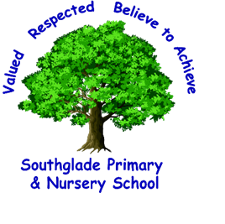

Dear Southgladers
How are you? I am missing you so much at school and I am really looking forward to school reopening (when it is safe to do so) and we can all be together again.
I hope that you have settled back in to your home learning routine after the Easter holidays. This week your teachers have uploaded a weekly timetable to your year group page on the website so that you know what you are going to be doing each day. Your teachers will also make sure your work is uploaded to your year group page each morning ready for you and don’t forget to include some form of daily exercise into your routine too. Most important of all to remember though is you must listen to what your grown-ups tell you and ask you to do just like you would your teachers in school. They are there to look after you and help you and want you to try your very best.
Thank you again to those of you who have emailed me and your teachers and sent photos and videos of the things you have been doing. I’ve been very impressed with all the variety of brilliant things you have done. Have a look on our website or our Twitter page where you might see some of your work being showcased.
Don’t forget you can contact me at any time by emailing:
headteacher@southglade.nottingham.sch.uk

I love receiving your emails and finding out about what you have been doing.


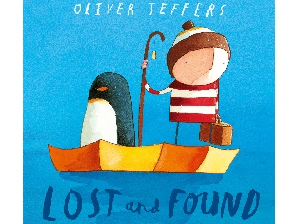
I also need your help with something… on our website we have created a story page on the video resource link. We thought it would be lovely for you to be able to see and hear some of your teachers and teaching assistants read you a story. Could I ask you to let me (or your teacher) know if you have a favourite story you would like us to read and then we can add it to our story page.

The children who were in school last week have created a fantastic rainbow display on our fence at the front of school to say thank you to all our amazing key workers and to hopefully bring a bit of cheer to everyone who passes by school.
I think it looks fantastic.
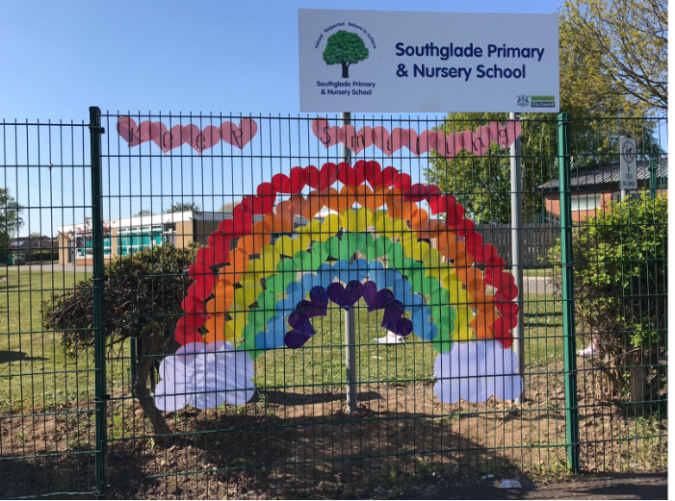

Please try to keep working hard (don’t forget the importance of a daily routine – get up; get dressed and start your learning) and behaving well for your grown-ups. Remember we are all trying to do our bit and we must keep looking after each other.
Remember just how amazing you all are.
Take care of yourselves and I’ll be thinking of you all
Best Wishes

Mrs Thomas

