his is still conditional, and the reopening of
schools will only happen if the five key tests set out by the government have been met.
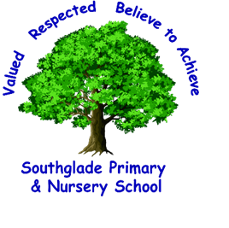
Southglade Primary and Nursery School
Beckhampton Road
Bestwood
Nottingham
NG5 5NE
Telephone: 0115 9155763
E-mail: admin@southglade.nottingham.sch.uk
Headteacher: Mrs A Thomas (B.Ed. Hons)

Dear Parents & Carers,
This letter will detail specifics for the planned re-opening to Year 6 pupils.
The following information I hope will help give you a better understanding of what school will look like and will help you – as a parent – come to an informed decision about whether you will be sending your child into school when we have agreed a return date. Sending your child to school is entirely your decision and as a school we will continue to support you whatever decision you come to. There will be no penalties for parents if they choose not to send their child into school at this time.
However, our first priority is the safety and well-being of the
children and staff, and in order to re-open safely we will need to make huge changes to
the school day and normal routines.
As I have previously stated, our first priority is the safety and well-being of our children and staff, and in order to re-open safely we will need to make significant changes to the school day and ‘normal’ routines. These are some guidelines which will need to be in place when we reopen.
School Routines when your child returns:
Part Time Provision  - School will be open Monday to Thursday only  - School will be closed to pupils in year 6 on a Friday to allow for extra cleaning  - The school day will run with reduced hours to allow us to stagger drop-offs, pick-ups, breaktimes and lunchtimes and to allow for additional cleaning, e.g.  - Bubble Times will be:  Eagle Bubble = 9:00am – 1:30pm  Flamingo Bubble = 9:45am – 2:15pm  Puffin bubble = 10:30am – 3:00pm  - Children must be dropped off and collected promptly at these times so that they do not overlap with other year group Bubbles  - There will be NO breakfast club provision or After School Club provision | 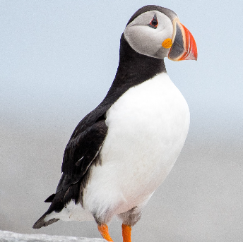  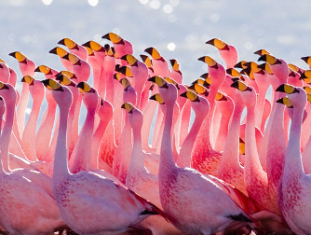  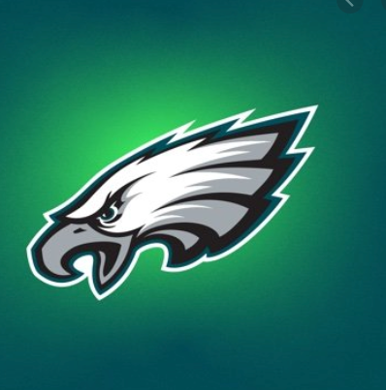
Class ‘Bubbles’  - Children will be in small groups of 10 – 12. We will call these ‘Bubbles’  - Each Bubble will be named after a bird to make it easier for the children to remember  - Children may not be with all of their friends  - Teaching ‘bubbles’ will not be allowed to mix and will be kept separate throughout the day  - Teaching ‘bubbles’ cannot be changed. We will begin with 3 teaching Bubbles and then fill up a fourth if demand increases  - Teaching ‘bubbles’ will always be taught by the same adults. There will be 2 adults in each ‘bubble’ – a teacher and a TA  - Bubbles will be led by Mrs Mpofu / Mrs Morton/ Mr Easton. Children may not be in their usual classroom, and each ‘bubble’ will use the same classroom throughout the day and week  - Children will wash their hands before they enter their classroom.  - We will talk to the children about social distancing and endeavour that activities we plan for support this thinking. However – we are a school. Your children are children and  we make no guarantees about them being 2m apart at all times in their ‘bubble’  - Each ‘bubble’ will have their own toilet and sink. Children will be accompanied to the toilet to ensure proper handwashing takes place. | 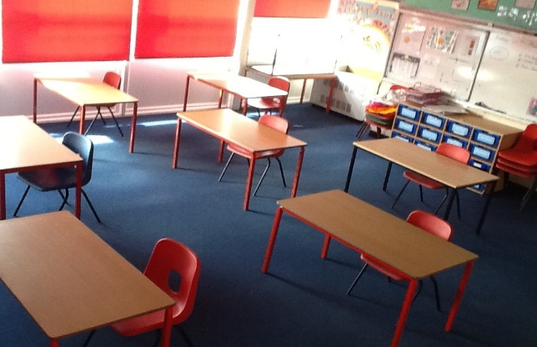  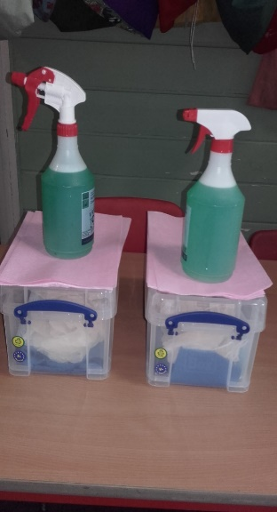  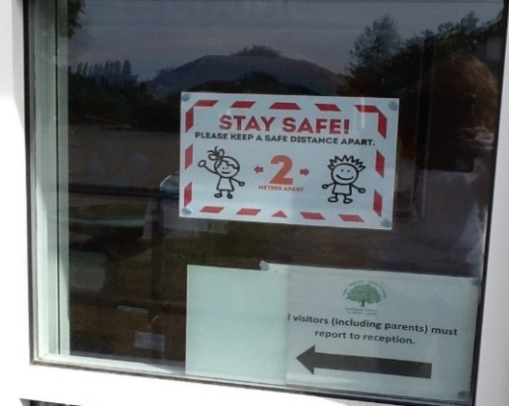  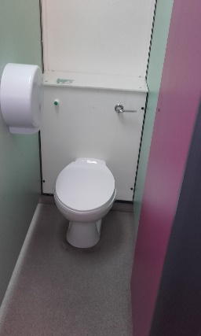  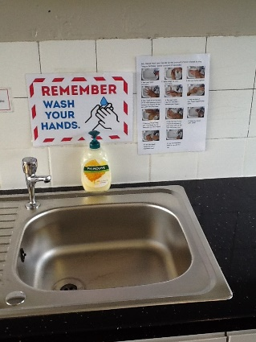  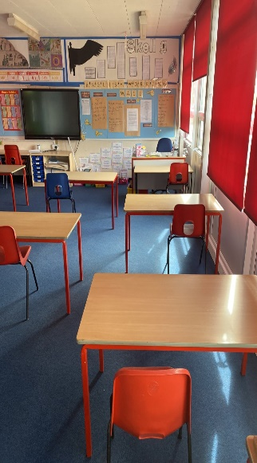
What will school look like?
- Children’s tables will be spaced out and their work station will be independent
- Each child will have a designated space which is labelled to support tracing measures. They will all have a set of personal equipment provided
- Classrooms are arranged with clear surfaces and soft furnishings / toys removed
- Your child will put all their belongings on the backs of their chair. They will not use pegs / coat hooks etc.
- The only items children are permitted to bring from home are a water bottle and a lunchbox which will remain on their table.
- Children are not permitted to bring any bags or equipment to school, including a mobile phone.
- Children are not permitted to come to school on bikes or scooters
- Children will enter school in a systematic way with 2m distancing clear / lining up on the white lines
- Parents are encouraged to walk or cycle to school and avoid public transport
- Cleaning will take place throughout the day

How do I enter school?  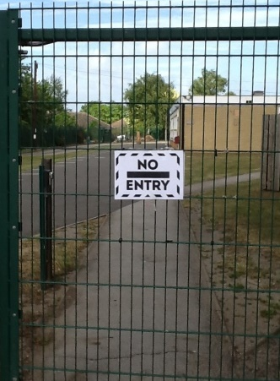  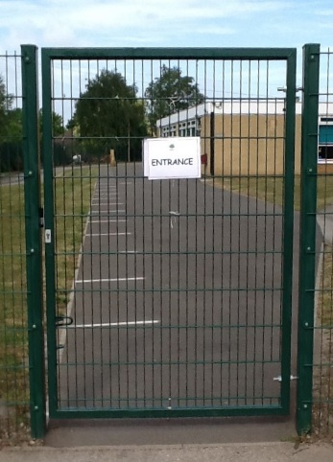  - Year 6 children MUST enter through the entrance gate (this is the non-automatic pedestrian gate). Hand sanitize their hands at the designated area and then line up on the next available white line  - Parents are not permitted to enter the school site at drop off time  - Bubble teachers will call each child into the building – one at a time – to wash their hands and enter the classroom.  - Year 6 pupils will enter the building via the year 5 and 6 doors  - Each Bubble will have a have an agreed start and finish time. It is essential that pupils are punctual. Any pupil who is late may have to wait longer before being able to enter school  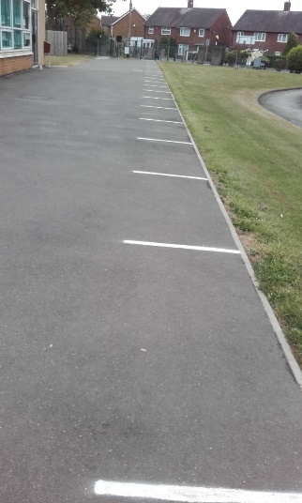  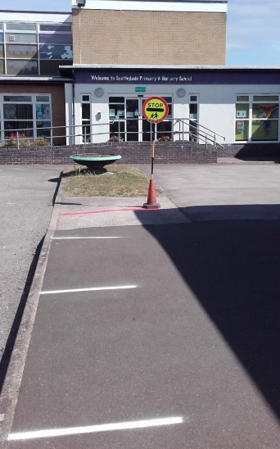 | 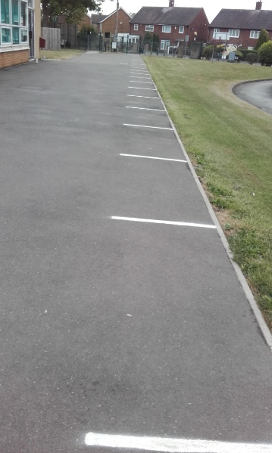  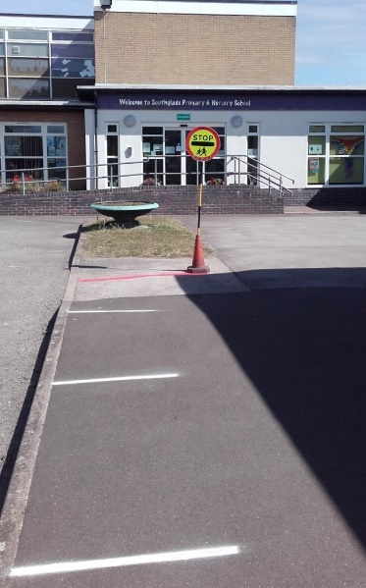
How do I leave school?
- At the end of the day the Bubble staff will walk children 2m apart to the school gate
- Each child will line up on the 2m white markings
- Parents will access the site through the entrance gate, collect their child and proceed straight away to the exit gate.
- There will not be an opportunity for parents to talk with the class teacher. Any discussions or concerns should take place by phone call or email.
- Only one parent will be able to drop off or pick up their child, and parents will not be able to enter the school building unless in an emergency.
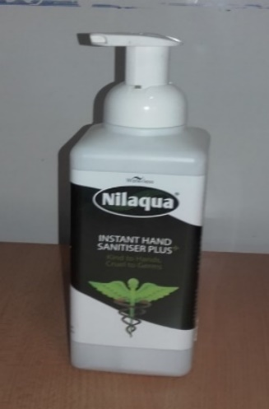
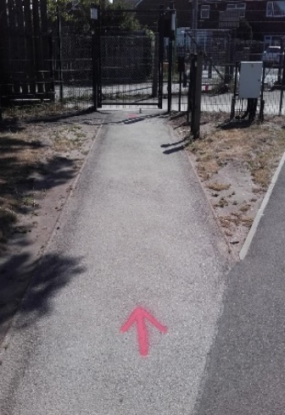
- Parents and children must observe social distancing when coming to and from school
- All communication between the teacher and parent will take place on the phone or via email.
- School uniform is optional.
- Your child will need to wear clean clothes everyday
- Your child should remove all clothes that they have worn to school as soon as they get home and these will need to be washed
- Windows / external doors will be open to increase ventilation. Send your child with a jumper. It could get cold on some days!

Playtimes and Lunchtimes:  - Playtimes and lunchtimes will be staggered  - Each Bubble will be allocated a zone on the playground  - Your child will not be able to play with a child from another Bubble  - Children are permitted to play together within their Bubble; closer than the 2m guidance but no contact games can be played.  - Each child will wear a coloured band at playtimes and lunchtimes  - Children can only use their assigned toilet even during playtimes and lunchtimes  - All the large play equipment will be out of use and taped off.  - Playtime equipment boxes will be provided for each Bubble. | 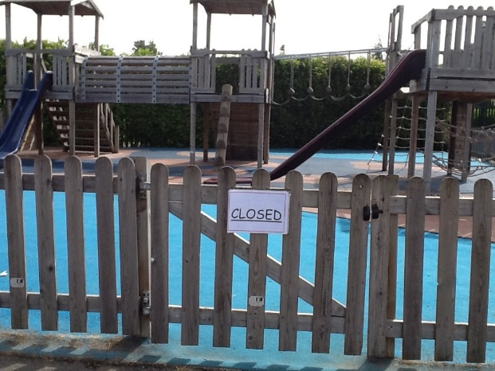
Dinners:  - There will be no hot dinners served  - A grab bag will be provided for pupils who are entitled to a free school meal. All other children will need to bring their own packed lunch (there will be no opportunity to purchase a grab bag).  - Children in receipt of fsm who are attending school will no longer be entitled to the fsm super market voucher  - If parents request, a grab bag will be provided for children in receipt of fsm on a Friday. This can be collected from school at an agreed time | 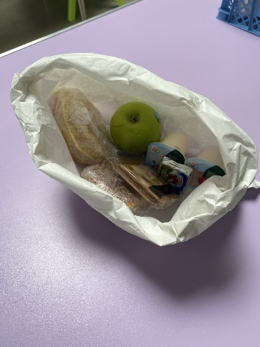  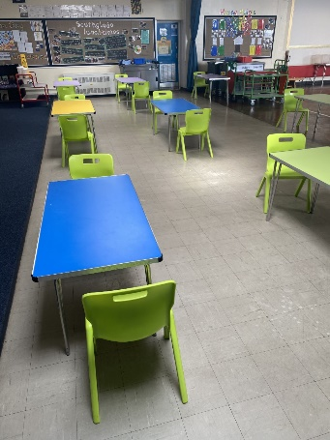
- There will be additional points for children to understand in our behaviour policy, e.g following requests around hygienic measures etc. This will be sent to you if you decide to send your child so you can look through them together  - Children will wash their hands often throughout the day.  - Children will be taken to the toilet and supervised with hand washing  - We will teach and go over certain hygiene routines  - We will have a daily PSHE session to support every child’s emotional wellbeing  - We will encourage children to be doing as much physical exercise as we can. Pupils do not need a PE kit.  - If your child needs sunscreen please apply this before school  - We will only be able to administer long term prescribed medicine, but where possible this should be administered at home.  - We will not administer any pain relief medicines | 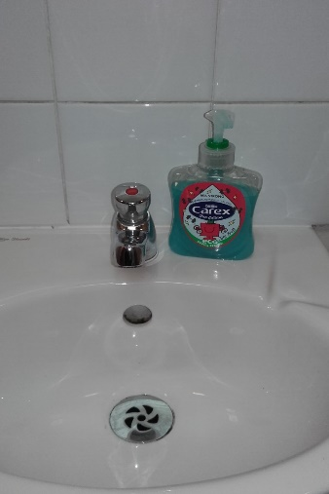  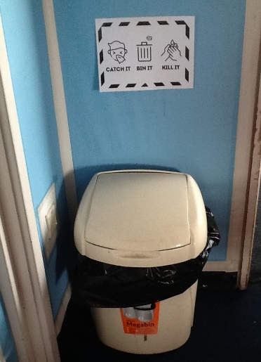
- We will continue to upload daily remote learning activities onto the year 6 class page on the website  - Children who do not attend school will receive a weekly well-being call.  - The year 7 common transfer day has been cancelled | 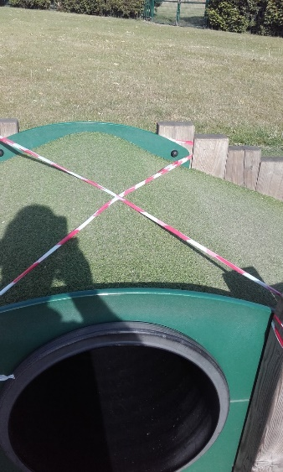  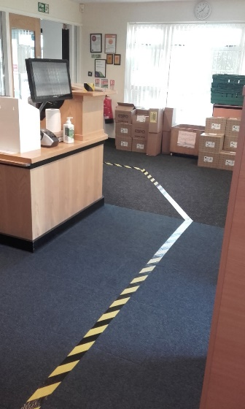
- There will be signage around our school to remind everyone of staying alert to coronavirus spread prevention

- Our plans mean we are taking every possible step to follow government guidelines whilst ensuring we are acting with the safety of our pupils and staff at the heart of every decision we make

School when we do reopen to more pupils will be a different experience from when we broke up on Friday 20th March. The children’s safety and well-being are our top priority, and all of our decisions about how we re-open will be based on the welfare and safety of the children and staff.
If you have further questions, please do get in touch.

What do I need to do next?
Ensure you are aware of the start/ finish times for the bubble your child/children are in,
Kind Regards,
Mrs Alison Thomas
Head Teacher

QUESTIONS YOU MAY ASK:
Q) What if my child already attends key worker school?
School will open to Y6. This means that if your child is in key worker school – they will now be able to access Year 6. They will NOT however be able to go into key worker school any more. We are avoiding groups and bubbles mixing. So your child will have to come during the reduced Year 6 day and would not be able to attend on a Friday. Speak to Mr Pegram if you have any questions on this. You may have other children attending key worker school.

Q) What if I decide not to send my child in when school reopens but after a few weeks, I do want them to come in?
YOU CANNOT “JUST SEND YOUR CHILD INTO SCHOOL” School MUST be aware your child is coming. Depending on staffing – you may have to wait until the start of a week – for your child to start school so we can ensure we have staff ready and classrooms ready. School and home MUST keep in contact about any decisions you make.

Q) What if my child is sick? Do I keep them off school?
Yes – as you usually would. Call school if you are unsure. If you feel your child has any symptoms of coronavirus – follow this advice:
Staff and pupils who report the following symptoms remain at home for 7 days. Their household members must remain at home for 14 days:
- a high temperature – this means you feel hot to touch on your chest or back (you do not need to measure your temperature)
- a new, continuous cough – this means coughing a lot for more than an hour, or 3 or more coughing episodes in 24 hours (if you usually have a cough, it may be worse than usual)
All staff and pupils who are attending a school will have access to a test if they display symptoms of coronavirus, they are encouraged to get tested as soon as possible https://www.gov.uk/guidance/coronavirus-covid-19-getting-tested
Where the pupil or staff member tests negative, they can return to their setting and the fellow household members can end their self-isolation.
Where the pupil tests positive, the rest of their Bubble are sent home and advised to self-isolate for 14 days. The other household members of that wider class or group do not need to self-isolate unless the child, young person or staff member they live with in that group subsequently develops symptoms.
No staff member, pupil, parent or visitor should attend school if they are displaying symptoms of coronavirus.

Q) What if my child or someone else in their bubble shows coronavirus symptoms?
We have a designated “sick bay” in school. This is our BFG room. They will be taken there and you will be asked to collect them, contact the NHS for a test and self-isolate. Our school is also well stocked in PPE for staff. If your child has suspected c oronavirus symptoms – a staff member will wear PPE whilst they administer care.

Q) Does my child need their PE kit in school? Will they be getting changed for PE?
No. Your child will not need PE kit – just trainers.

Q) What if my child does not follow instructions e.g. following one way system / not washing their hands when asked to?
I hope this will not happen. However, if a child is not following instructions, you will be asked to collect them and consequences will apply as usual. If a child compromises a staff member or pupils’ safety by deliberately spitting, coughing, sneezing at them they will receive a fixed term exclusion.

