his is still conditional, and the reopening of
schools will only happen if the five key tests set out by the government have been met.
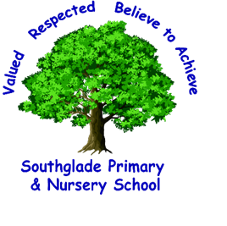
Southglade Primary and Nursery School
Beckhampton Road
Bestwood
Nottingham
NG5 5NE
Telephone: 0115 9155763
E-mail: admin@southglade.nottingham.sch.uk
Headteacher: Mrs A Thomas (B.Ed. Hons)

Dear Parents & Carers,
RE- IMPORTANT Return to School Arrangements
However, our first priority is the safety and well-being of the
children and staff, and in order to re-open safely we will need to make huge changes to
the school day and normal routines.
As you will be aware the government announced on 2nd July 2020 that schools will re-open to all pupils in September and attendance will be mandatory which means failure to send your child may result in a fine and your child losing their school place.
We are very much looking forward to welcoming all our children back to school on Thursday 3rd September and in this letter, I would like to share with you our plans and preparations for this.
Our first priority has to be the safety and well-being of our children, staff and parents, and in order to ensure this, we have had to make some changes to the school day and ‘normal’ routines. Having reviewed and updated our Risk assessment and following the government guidance, below are a list of the measures which we will have in place to allow us to welcome all our pupils back into the school.
School Routines when your child returns in September:
Teams and Bubbles
School will be divided into two Teams:
Team Achieve and Team Believe
Within each team there will then be 6 class ‘Bubbles’. Children will always remain within their class ‘bubble’ and will not mix with any other bubbles during the school day.
Team Achieve and Team Believe will have separate start and finish times and separate playtimes and lunchtimes. They will have a designated area of school to work and also a designated zone on the playground each week. Each child will be given their own pack of regularly used resources eg pen, pencil, ruler, rubber, whiteboard and general classroom equipment will be shared across the bubble but not with another bubble without being meticulously cleaned.

Team Achieve | 6M – Mrs Morton; 5M – Mrs Mpofu; 4B – Miss Blaxley; 3B – Miss Barker; 2B – Mrs Bragg; 1L – Mr Land
Team Believe | 6PS – Mr Shuttleworth and Mr Pegram, 5H – Mr Hunter; 4P – Miss Pericleous; 3F – Miss Finnie; 2S – Miss Storer; 1S – Miss Smith and Miss Short

Timings
In the latest government guidance document, it proposes that staggered start and finish times should continue in order to avoid large numbers of people on site at any one time.
As we are such a large school we have made the decision to use both the Beckhampton Road gates and the playground gates.
Our EYFS and Key Stage 1 pupils will use the Beckhampton Road Gates and our Key Stage 2 pupils will use the playground gates.
For safeguarding reasons there will be no opportunity for pupils and parents to ‘cut through’ school to get to the correct gates. Please use the path at the side of school.
The table below shows the drop off and pick up times for each class and the designated entrance for each Bubble. I politely ask that you adhere to these times and the correct entrance gate. By doing so it will enable us to avoid any large numbers of people at the school gates at one time.

Bubble /Class | Drop Off | Pick Up | Designated Entrance
Nursery am | 8:30am | 11:30am | Beckhampton Road  (Via the F2 playground)
Nursery pm | 12:30pm | 3:30pm | Beckhampton Road  (Via the F2 playground)
Nursery (30 hours funding) | 8:30am | 3:30pm | Beckhampton Road  (Via the F2 playground)
Polar Bears | 8:40am | 3:10pm | Beckhampton Road  (Via the F2 playground)
Penguins | 8:50am | 3:20pm | Beckhampton Road  (Via the F2 playground)
1L – Mr Land | 8:30am | 3:00pm | Beckhampton Road
1S – Miss Smith / Miss Short | 8:50am | 3:20pm | Beckhampton Road
2B – Mrs Bragg | 8:40am | 3:10pm | Beckhampton Road
2S – Miss Storer | 9:00am | 3:30pm | Beckhampton Road
3B – Miss Barker | 8:30am | 3:00pm | Lower Playground Gate (Nursery Yard Gate)
3F – Miss Finnie | 8:50am | 3:20pm | Lower Playground Gate (Nursery Yard Gate)
4B – Miss Blaxley | 8:40am | 3:10pm | Lower Playground Gate (Nursery Yard Gate)
4P – Miss Pericleous | 9:00am | 3:30pm | Lower Playground Gate (Nursery Yard Gate)
5M – Mrs Mpofu | 8:30am | 3:00pm | Lower Playground Gate (Nursery Yard Gate)
5H – Mr Hunter | 8:50am | 3:20pm | Lower Playground Gate (Nursery Yard Gate)
6M – Mrs Morton | 8:40am | 3:10pm | Lower Playground Gate (Nursery Yard Gate)
6PS – Mr Pegram and Mr Shuttleworth | 9:00am | 3:30pm | Lower Playground Gate (Nursery Yard Gate)

- Children must be dropped off and collected promptly at these times so that they do not overlap with other class bubbles
- No scooters or bikes are allowed
- There will be NO breakfast club provision or After School Club provision at the start of the Autumn term
How do I enter School in the mornings?  If your child is in EYFS or Key Stage 1 then please bring them to the entrance gate on Beckhampton Road at the correct start time for their class. Proceed through the gate following the arrows to your child’s classroom door where you will be met by their teacher or TA.  You will not be allowed into the classroom with your child.  Once your child has entered their classroom please exit the school site by following the arrows to the exit gate. We will be operating a one-way system with an entrance gate and an exit gate to help reduce congestion at this busy time.  If your child is in KS 2 then please bring them to the entrance gate on the playground (it is the gate that leads onto the Nursery yard) at the correct start time for their class. We would ask parents not to enter the playground and to say goodbye to your child before entering the school grounds to avoid over-crowding at the gate. Once on the playground your child will walk to their allocated lining up space ready to be taken into school by their class teacher. | Entrance Gate for Nursery, Polar Bears, Penguins, Years 1 and 2  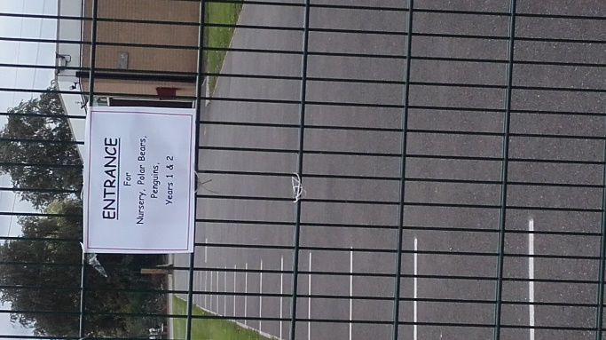 | Entrance Gate for years 3,4,5 and 6  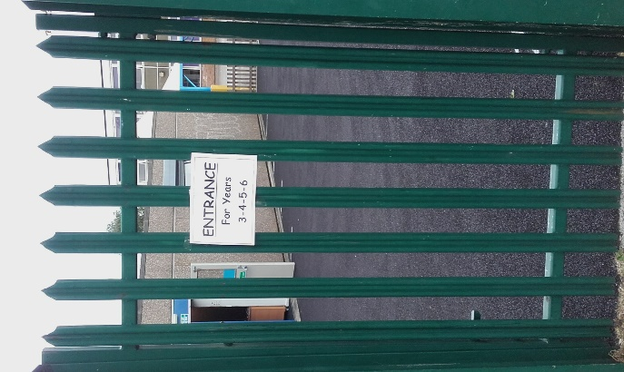
How do I leave school at the end of the day?  If your child is in EYFS or Key Stage 1 then please enter school through the Beckhampton Road gate at the correct time and proceed to your child’s classroom door. Your child’s teacher will then safely dismiss the children one child at a time. You will need to be patient and wait for your child’s turn.  Once you have collected your child please follow the arrows to the exit gate onto Beckhampton Road. (The exit gate is the one on the left-hand side as you are facing Beckhampton Road.)  If your child is in KS 2 then please enter the playground through the entrance gate onto the Nursery playground and then through the smaller gate onto the main playground.  Your child’s teacher will bring their class out onto the playground where they will line up ready to be dismissed. The children will be dismissed one at a time. Please be patient waiting for your child’s turn.  Once you have collected your child please exit the school playground using the exit gate which is the one at the top of the playground.  If your child is in year 4 the class teacher will dismiss them from their classroom door on the lower playground. | Exit Gate onto Beckhampton Road  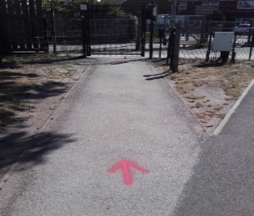  Entrance and Exit Gates onto the Playground  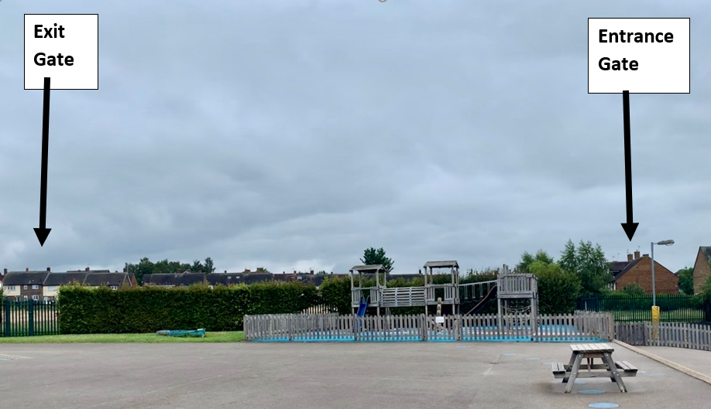
- If you wish to speak to your child’s class teacher at the end of the day then you will need to wait until all the class have been dismissed. We advise that the best means of communication will be by telephone or email. Any face to face discussions that do take place should be outside and with a 2m distance.
- Parents and children must observe social distancing when coming to and from school
- Only one parent will be able to drop off or pick up their child, and parents will not be able to enter the school building unless in an emergency or they have a pre-arranged appointment
- No bikes or scooters will be permitted on the school premises
What will school look like?
- Children will be in class Bubbles.
- Class ‘bubbles’ will not be allowed to mix and will be kept separate throughout the day as much as possible
- Children’s tables will be placed in rows and the children will sit in pairs facing forward.
- They will all have a set of personal equipment provided
- There will be signage around our school and in classrooms to remind everyone of staying alert to help prevent the spread of coronavirus
- We will continue to operate a one-way system around the school building
- Additional cleaning will take place throughout the day
- There will be no assemblies in the hall
- Ipads and laptops will be used in classrooms and will be cleaned after each use
- Children will continue to access a broad and balanced curriculum and we will have a daily PSHE session to support every child’s emotional wellbeing
What can my child bring in from home?
The only items children are permitted to bring from home are:
- a water-bottle
- a lunchbox
- Coat, hat, gloves
- School bag
- Reading book
- Trainers for PE
- Pencil cases or toys from home are NOT allowed
PE:
- All PE lessons will take place outside
- All equipment will be cleaned after each use
- Children will not need a full PE kit to begin with just a pair of trainers

Handwashing:
Regular handwashing will take place:
- On arrival at school
- After breaks and sport activities
- Early Years: after using wheeled bikes, trikes and other large, movable toys
- Before cooking and eating – pupils will hand wash before lunch and then use hand sanitiser when lining up for their dinner sitting
- After sneezing or coughing
- After using the toilet
- Before leaving at home time
We will teach and go over certain hygiene rules with pupils regularly.
School Uniform:
- Full school uniform should be worn
- Windows / external doors will be open to increase ventilation. Please make sure your child has a jumper with them. It could get cold on some days!
Playtimes and Lunchtimes:
- Playtimes and lunchtimes will be staggered
- Each class Bubble will be allocated a zone on the playground
- Your child will not be able to play with a child from another class Bubble
- Children are permitted to play together within their Bubble
- Playtime equipment boxes will be provided for each Bubble.
Dinners:
- Dinners will be served in the KS 1 and KS 2 halls
- We will be serving hot dinners but it will be a limited menu and we will be unable to provide a canteen service. Children will have their dinner brought to them at their table.
- From September we will be a cashless school. There will be no opportunity to buy a school dinner with a cash payment. All payments will need to be made via the Parent Pay app.
Behaviour Policy Update:
There will be additional points for children to understand in our behaviour policy, e.g following requests around hygienic measures which will be shared with them on the first day of term.
Please read the updated behaviour policy in our covid-19 section on our school website.

Our plans mean we are taking every possible step to follow government guidelines whilst ensuring we are acting with the safety of our pupils and staff at the heart of every decision we make. Your children’s safety and well-being remain our top priority and this has informed all of the changes detailed above. If you have any further questions, please do get in touch via email at headteacher@southglade.nottingham.sch.uk
Kind Regards,
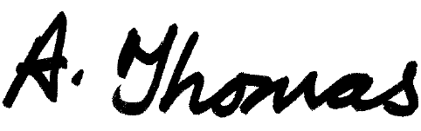
Mrs Alison Thomas
Head Teacher

QUESTIONS YOU MAY ASK:
Q) What if my children have a different start and finish time?
Whilst we would encourage all our families to try and stick to the start and finish times for their child’s class, we understand that for some of our families this may mean a considerable wait between one child starting school and your next child/ren starting. We want to avoid and reduce the number of parents waiting at the gate so a system will be in place to support these families.
If you wish to use this system then you must drop off siblings at the earliest start time your children have and collect at the latest finish time.
Morning Procedures
Please drop off your child with the earliest start time first. If your other child, with the later start time is in KS1 then please bring them to their classroom door where the teacher or TA will meet them.
KS2 siblings can be dropped off on the playground and will wait in a designated area – this will be the canopy on the lower playground. A staff member will be on duty to supervise your child until it is time for them to line up with their class. Children will not be allowed onto the playground early to ‘play’. It will be a waiting zone only.
End of Day procedures
At the end of the day no child will be allowed to leave their class early to go home with siblings.
KS 1 and EYFS children will remain in their classroom until their parent/carer arrives to collect.
KS2 children will leave their classroom at the allocated home time and will wait under the canopy on the lower playground with a member of staff until their adult arrives.
Late Collection Policy
Any child who has not been collected by 3:35pm will be taken to the main reception area to wait. At this time all school gates will be locked and parents will need to use the intercom system on the Beckhampton Road gate to notify staff. Your child will then be brought down to meet you

Q) What if my child is late arriving at school?
If your child is going to be late please phone school to let us know. Once the school gates are closed you will need to walk to the main gate on Beckhampton Road, press the intercom and let the reception team know. A member of staff will walk to the gate to collect your child/ren.

Q) What if my child is sick? Do I keep them off school?
Yes – as you usually would. Call school if you are unsure. If you feel your child has any symptoms of coronavirus – follow this advice:
Staff and pupils who report the following symptoms remain at home for 7 days. Their household members must remain at home for 14 days:
- a high temperature – this means you feel hot to touch on your chest or back (you do not need to measure your temperature)
- a new, continuous cough – this means coughing a lot for more than an hour, or 3 or more coughing episodes in 24 hours (if you usually have a cough, it may be worse than usual)
- loss of taste and/ or smell
All staff and pupils who are attending a school will have access to a test if they display symptoms of coronavirus.
Where the pupil or staff member tests negative, they can return to their setting and the fellow household members can end their self-isolation.
Where the pupil tests positive, the rest of their Class Bubble are sent home and advised to self-isolate for 14 days. The other household members of that wider class or group do not need to self-isolate unless the child, young person or staff member they live with in that group subsequently develops symptoms.
No staff member, pupil, parent or visitor should attend school if they are displaying symptoms of coronavirus.
Q) What if my child does not follow instructions e.g. following one-way system / not washing their hands when asked to?
I hope this will not happen. However, if a child is not following instructions consequences will apply as usual. If a child compromises a staff member or pupils’ safety by deliberately spitting, coughing, sneezing at them they may receive a fixed term exclusion.
Q) Can I enter the school site and building?
Yes, you may enter the school site at drop off and collection times but you will not be able to enter the school building without a prearranged appointment. Communication with school staff, including the reception/admin team, should be via email and telephone.
Q) What happens if my child has an appointment to attend during the school day?
Please inform school via email or telephone of the date and time of the appointment. On the day arrive at school at the Beckhampton gate entrance and press the intercom to let the reception team know you have arrived. A member of staff will then bring your child to you at the gate.
Q) Can my child wear a face mask to school?
Currently the wearing of face masks is not advised in school. If a child wears a face mask to school they will be asked to remove it in a safe way and either dispose of a temporary face covering in a covered bin or put a reusable face covering in a plastic bag so they can take it home with them.

