

Christmas Jumper Day

Dear parents/carers,
I am writing to inform you that we will be supporting Save the Children’s Christmas Jumper Day appeal on Friday 11th December 2020.
Pupils who would like to be involved are able to wear a Christmas jumper or t-shirt and wear the rest of their uniform as they normally would.
On the day please bring in a donation of £1, this will be collected by your child’s class teacher, and the money sent to Save the Children.
Some children may already have a Christmas jumper but if you don’t, we do not expect you to go out and buy one. Why not turn an old jumper into a Christmas jumper, or have a go at designing your own Christmas t-shirt instead. Have fun! We look forward to seeing your Christmas creations.
Kind Regards
Mrs Alison Thomas
(Head Teacher)
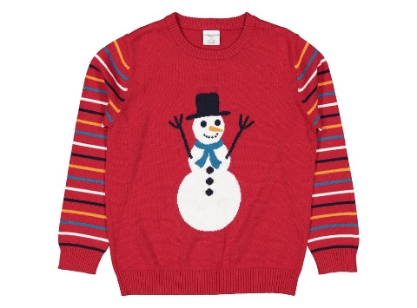


Description

