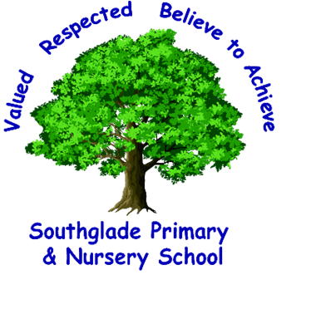

Nursery Admissions Policy Statement
Summer 2025

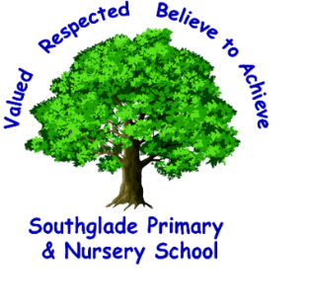
Nursery Admissions Policy Statement
Southglade Nursery is a 52 place nursery – 52 morning sessions and 52 afternoon sessions. These are allocated as a combination of full time (all day) and part time (morning or afternoon) places.

Session Times
Full time: 8.30 am – 3.30 pm (30 hours+5 hours lunchtime)
Part time mornings: 8.30 am – 11.30 am (15 hours)
Part time afternoons: 12.30 pm – 3.30 pm (15 hours)
Lunchtime is from 11.30am – 12.30pm for full time children only. Children who have a part time place stay in Nursery for their full 3 hour session each day and do not have lunch at school.

N2 Places
N2 places will be offered to parents of children who are 3 before August 31st 2025.
All children aged 3-4 are entitled to 15 hours Nursery Provision through the Government Universal Funding. Children of working parents may be eligible for 30 hours per week of funding. We will only offer full time places to parents who have a 30 hour funding code. Details of how to apply for a code can be found at https://www.gov.uk/apply-30-hours-free-childcare

N2 Places will be allocated in the following order of priority:
1. Looked after children, children with an EHCP or Special Educational Needs
2. Children with 30 hours funding in place i.e. code verified by school
3. Children already attending our Nursery as N1s
4. Children with older siblings at our school
5. Other children on our waiting list in date of birth order

N1 Places
N1 places will be offered to parents of children who are 3 before December 31st 2025, to start in January 2026; and to parents of children who are 3 before March 31st 2026 to start in April 2026. Full time places will only be offered to children whose parents receive 30 hour funding from the Government – see above for details.

Places will be allocated in the following order of priority:
1. Looked after children, children with an EHCP or Special Educational Needs
2. Children with 30 hours funding in place i.e. code verified by school
3. Children with siblings at our school
4. Children on our waiting list in date of birth order

