Pupil premium strategy statement

This statement details our school’s use of pupil premium (and recovery premium for the 2023 to 2024 academic year) funding to help improve the attainment of our disadvantaged pupils.

It outlines our pupil premium strategy, how we intend to spend the funding in this academic year and the effect that last year’s spending of pupil premium had within our school.

School overview
Detail | Data
School name | Southglade Primary
Number of pupils in school | 427
Proportion (%) of pupil premium eligible pupils | 53% (F2-Y6)
Academic year/years that our current pupil premium strategy plan covers (3 year plans are recommended) | 2022-23, 2023-24, 2024-25
Date this statement was published | September 2023
Date on which it will be reviewed | September 2024
Statement authorised by | Alison Thomas
Pupil premium lead | Kevin Pegram
Governor / Trustee lead | Mark Taylor
Funding overview
Detail | Amount
Pupil premium funding allocation this academic year | £315,143
Recovery premium funding allocation this academic year | £29,000
Total budget for this academic year  If your school is an academy in a trust that pools this funding, state the amount available to your school this academic year | £344,143

Part A: Pupil premium strategy plan

Statement of intent
Our intention is that all pupils, irrespective of their background or the challenges they face, make good progress and achieve high attainment across all subject areas. The focus of our pupil premium strategy is to support disadvantaged pupils to achieve that goal, including progress for those who are already high attainers.
We will consider the challenges faced by vulnerable pupils, such as those who have a social worker and young carers. The activity we have outlined in this statement is also intended to support their needs, regardless of whether they are disadvantaged or not.
High-quality teaching is at the heart of our approach, with a focus on areas in which disadvantaged pupils require the most support. This is proven to have the greatest impact on closing the disadvantage attainment gap and at the same time will benefit the non-disadvantaged pupils in our school. Implicit in the intended outcomes detailed below, is the intention that non-disadvantaged pupils’ attainment will be sustained and improved alongside progress for their disadvantaged peers.
Our strategy is also integral to wider school plans for education recovery, notably in its targeted support through the National Tutoring Programme for pupils whose education has been worst affected, including non-disadvantaged pupils.
Our approach will be responsive to common challenges and individual needs, rooted in robust diagnostic assessment, not assumptions about the impact of disadvantage. The approaches we have adopted complement each other to help pupils excel. To ensure they are effective we will:
- ensure disadvantaged pupils are challenged in the work that they’re set
- act early to intervene at the point need is identified
- adopt a whole school approach in which all staff take responsibility for disadvantaged pupils’ outcomes and raise expectations of what they can achieve

Challenges

This details the key challenges to achievement that we have identified among our disadvantaged pupils.
Challenge number | Detail of challenge
1 | Our attendance data over the last 2 years indicates that attendance among disadvantaged pupils has been approximately 3% lower than for non-disadvantaged pupils.  30% of disadvantaged pupils have been ‘persistently absent’ compared to 12% of their peers during that period. Our assessments and observations indicate that absenteeism is negatively impacting disadvantaged pupils’ progress.  This challenge has been exacerbated by the disruption caused by covid19 during the past 3.5 academic years.
2 | Internal and external data analysis, work sampling and lesson observations highlight that disadvantaged pupils have lower attainment in their English work. Areas of particular difficulty for disadvantaged pupils include spelling, vocabulary gaps, phonics understanding and poorly developed oral language skills. Lack of fluency in these areas mean that disadvantaged pupils have attainment that is lower than pupils not eligible for pupil premium support.  The average attainment gap between disadvantaged pupils and other pupils at the end of the 2022/23 academic year was:  Reading 18% (this has narrowed from 21% in the previous academic year)  Writing 17% (this has widened from 16% in the previous academic year)
3 | Internal and external data highlights that there are significant differences between the % of disadvantaged and other pupils working at the higher standards across the school.  The average % of pupils working at the combined high standards at the end of the academic year 2022/23 was:  Disadvantaged pupils 2%  Other pupils 8%
4 | Our assessments and observations indicate that the education and wellbeing of many of our disadvantaged pupils have been impacted by partial school closures to a greater extent than for other pupils. These findings are supported by national studies. A higher % of disadvantaged pupils are supported by our school learning mentor and a disproportionate number of behaviour incidents involve disadvantaged pupils. The vast majority of pupils supported by a social worker are disadvantaged pupils.  It is likely that cost-of-living pressures will disproportionately affect families classified as disadvantaged.
5 | The cultural capital of our disadvantaged pupils is known to be significantly less developed than that of other pupils nationally.

Intended outcomes
This explains the outcomes we are aiming for by the end of our current strategy plan, and how we will measure whether they have been achieved.
Intended outcome | Success criteria
To achieve and sustain improved attendance for all pupils but especially for disadvantaged pupils and to lower the % of disadvantaged pupils classified as persistently absent | Sustained high attendance from 2024/25 demonstrated by:  - the overall absence rate for all pupils being no more than 4%, and the attendance gap between disadvantaged pupils and their non-disadvantaged peers being less than 1%  - the percentage of all pupils who are persistently absent being below 8% and the figure among disadvantaged pupils being no more than 12%
Improved writing attainment and progress score for all disadvantaged pupils at the end of KS2 | Improve the % of disadvantaged pupils achieving the expected standard or better at the end of KS2 in writing to 75% or better by the end of 2024/25
Improved, phonics and reading attainment and progress score for all disadvantaged pupils at the end of KS1 and KS2 | Improve the % of disadvantaged pupils achieving the expected standard or better at the end of KS2 in reading to 75% by the end of 2024/25  Improve the % of disadvantaged pupils completing the phonics screening successfully by the end of KS1 to 90%
Increase the % of disadvantaged pupils who are achieving the combined higher standards in reading, writing and maths by the end of KS2 | Increase the % of disadvantaged pupils achieving the combined high standards by 2024/25 to 10%
To achieve and sustain improved wellbeing for all pupils in our school, particularly our disadvantaged pupils. | Sustained high levels of wellbeing by 2024/25 demonstrated by:  - qualitative data from student voice, student and parent surveys and teacher observations  - a significant reduction in behaviour incidents involving disadvantaged pupils  - a significant increase in participation in enrichment activities, particularly among disadvantaged pupils

Activity in this academic year
This details how we intend to spend our pupil premium funding during this academic year to address the challenges listed above.

Teaching (for example, CPD, recruitment and retention)
Budgeted cost: £ 100,205
Activity | Evidence that supports this approach | Challenge number(s) addressed
Employment of a lead practitioner to drive improvements in teaching and learning, to co-ordinate CPD opportunities for all staff and lead on development of ECTs and ECTs+1 | The EEF Guide for Pupil Premium 2019  Page 3  Good teaching is the most important lever schools have to improve outcomes for disadvantaged pupils.  Using pupil premium to improve teaching quality benefits all students and has a particularly positive effect on those in receipt of pupil premium funding  Research suggests that the progress and attainment of disadvantaged pupils is impacted hugely by the quality of teaching they experience  Sutton Trust report (2021)  Improving the impact of teachers on pupil achievement | 2,3
Release time for phase leaders (0.5/ phase) across school to drive forwards standard in teaching and learning for all pupils within their phases | The EEF Guide for Pupil Premium 2019  Page 3  Good teaching is the most important lever schools have to improve outcomes for disadvantaged pupils.  Using pupil premium to improve teaching quality benefits all students and has a particularly positive effect on those in receipt of pupil premium funding | 2,3
Membership of Nottingham School’s Trust (NST) to deliver and support improvements in teaching and learning in all subjects and to support subject leaders in driving forwards standards in their subject area | Effective Teacher CPD: How To Enable Career-long Learning (irisconnect.com)  - Teachers learn naturally over the course of a career. However, learning from experience alone will ultimately limit development. Continuing professional development enables them to become the best teachers they can be and allows their pupils to achieve better learning outcomes.  - It ensures teachers keep pace with the current standards of others working in education.  - It keeps their knowledge and skills current so they can deliver high-quality teaching and impact positively on pupil outcomes.  - It makes sure that they become more effective in the workplace. This helps them to advance in their career and move into new positions where they can lead, manage, influence, coach and mentor others.  - It opens them up to new possibilities, new knowledge and new skills.  - It leads to increased confidence in themselves, others and the profession as a whole.  Improves quality first teaching where the quality of teaching is single most important factor determining the success of disadvantaged pupils | 2,3
Release time for the Pupil Premium lead to monitor impact of funding on achieving aims outlined in this plan and to ensure value for money | Closing the attainment gap (EEF)  How a project is implemented in arguably more vital than the content | 1,2,3,4,5
Continued purchase of standardised diagnostic assessments.  Training for staff to ensure assessments are interpreted and administered correctly. | Standardised tests can provide reliable insights into the specific strengths and weaknesses of each pupil to help ensure they receive the correct additional support through interventions or teacher instruction:  Standardised tests | Assessing and Monitoring Pupil Progress | Education Endowment Foundation | EEF | 2,3
To fund wider CPD opportunities for staff across school that link with whole school priorities | Effective Teacher CPD: How To Enable Career-long Learning (irisconnect.com)  - Teachers learn naturally over the course of a career. However, learning from experience alone will ultimately limit development. Continuing professional development enables them to become the best teachers they can be and allows their pupils to achieve better learning outcomes.  - It ensures teachers keep pace with the current standards of others working in education.  - It keeps their knowledge and skills current so they can deliver high-quality teaching and impact positively on pupil outcomes.  - It makes sure that they become more effective in the workplace. This helps them to advance in their career and move into new positions where they can lead, manage, influence, coach and mentor others.  - It opens them up to new possibilities, new knowledge and new skills.  - It leads to increased confidence in themselves, others and the profession as a whole.  - Improves quality first teaching where the quality of teaching is single most important factor determining the success of disadvantaged pupils | 2,3

Targeted academic support (for example, tutoring, one-to-one support structured interventions)
Budgeted cost: £ 142593
Activity | Evidence that supports this approach | Challenge number(s) addressed
Engaging with the National Tutoring programme to provide a blend of tuition, mentoring and school-led tutoring for pupils whose education has been most impacted by the pandemic. A significant proportion of the pupils who receive tutoring will be disadvantaged, including those who are high attainers.  This will include the employment of an academic mentor, IT focused in-school tutoring programme for y5 and y6 and bundles of 10 hours after school tuition for identified pupils including pupils identified as having potential to be higher attaining. | Tuition targeted at specific needs and knowledge gaps can be an effective method to support low attaining pupils or those falling behind, both one-to-one:  One to one tuition | EEF (educationendowmentfoundation.org.uk)  And in small groups:  Small group tuition | Toolkit Strand | Education Endowment Foundation | EEF | 1,2,3
Release time for staff in KS2 to provide high quality verbal feedback (feedback clinic) to help children understand what they do well in their written work and what they need to do to do even better | Feedback | EEF (educationendowmentfoundation.org.uk)  Very high impact intervention for low cost  Low attaining pupils benefit more from explicit feedback than higher attainers  Oral feedback is especially effective with disadvantaged pupils | 2,
Additional phonics sessions targeted at disadvantaged pupils who require further phonics support. This will be led by our phonics lead who is Caroline Yates (Literacy specialist for the East Midlands English Hub) | Phonics approaches have a strong evidence base indicating a positive impact on pupils, particularly from disadvantaged backgrounds. Targeted phonics interventions have been shown to be more effective when delivered as regular sessions over a period up to 12 weeks:  Phonics | Toolkit Strand | Education Endowment Foundation | EEF | 2
Development of support for higher attaining pupils and pupils with the potential to be higher attaining through use of SLT to teach small groups at identified points during the school week | Small group tuition | EEF (educationendowmentfoundation.org.uk)  Studies in England have shown that pupils eligible for free school meals typically receive additional benefits from small group tuition.  Small group tuition approaches can support pupils to make effective progress by providing intensive, targeted academic support The approach allows the teacher to focus on the needs of a small number of learners and provide teaching that is closely matched to pupil understanding. Small group tuition offers an opportunity for greater levels of interaction and feedback compared to whole class teaching which can support pupils when accessing challenging materials.  School’s internal assessments suggest a change of approach is needed and greater focus on the needs of disadvantaged pupils who have potential to be higher attaining | 2,3

Wider strategies (for example, related to attendance, behaviour, wellbeing)
Budgeted cost: £ 100968
Activity | Evidence that supports this approach | Challenge number(s) addressed
Provide support for families via the employment of a highly skilled family support worker whose principal role is to help families overcome barriers that might affect their child’s/ children’s academic attainment or well being | Parental engagement | EEF (educationendowmentfoundation.org.uk)  Can lead to boosts of up to 4 months learning during an academic year.  Research promotes the importance of positive interactions between teachers and parents and the use of individual messages tailored to learning.  Use of Marvellous Me also feeds into this. | 1, 4
Embedding principles of good practice set out in the DfE’s Improving School Attendance advice.  This will involve reviewing procedures and policies, staff training and release time and continued expansion of the attendance team | The DfE guidance has been informed by engagement with schools that have significantly reduced levels of absence and persistent absence. | 1,4
Drive forward improvements in the well being of all pupils through the:  Employment of a learning mentor to help identified pupils, largely disadvantaged, to overcome barriers to learning and to provide emotional literacy (ELSA support)  Development of a whole school well-being policy  Strategies to develop the whole child (see below) | Mentoring | EEF (educationendowmentfoundation.org.uk)  When children feel that they belong- not just to their school but also to their teacher- and where they feel that their teacher belongs to them, they learn’.  (N. Gedge: Removing Barriers to improving behaviour, 2019) | 1,2,3,4,5
Develop cultural capital of all pupils but especially disadvantaged pupils through offering a wide range of enrichment opportunities including:  - after-school clubs  - Music hub package  - School trips and residentials  - Visitors into school  - Birthday and Christmas books  - Employment of creative art teacher | Outdoor adventure learning | EEF (educationendowmentfoundation.org.uk)  Arts participation | EEF (educationendowmentfoundation.org.uk)  EEF Toolkit  “At the EEF we think enriching education has intrinsic benefits. We think all children , including disadvantaged pupils, deserve a well-rounded , culturally rich , education  Research document DFE  Research to understand successful approaches to supporting the most academically able disadvantaged pupils  November 2018  EEF  Overall studies of adventure learning interventions consistently show positive benefits on academic learning  IG schools Research:  Recovering and reigniting the curriculum is paramount | 1,4,5
Projects led by the school site manager to support the engagement of identified disadvantaged pupils across the school | Mentoring | EEF (educationendowmentfoundation.org.uk)  Mentoring tends to have a short-term impact unless carefully planned with specific goals in mind. | 1,4
Continue to provide a well-established breakfast club for pupils who need support before school | Breakfast clubs found to boost primary pupils' reading writing… | EEF (educationendowmentfoundation.org.uk)  Schools that offer a breakfast club can boost the attainment of pupils by over 2 months during the academic year | 1,4

Total budgeted cost: £ 343766

Part B: Review of outcomes in the previous academic year

Pupil premium strategy outcomes
This details the impact that our pupil premium activity had on pupils in the 2022 to 2023 academic year.
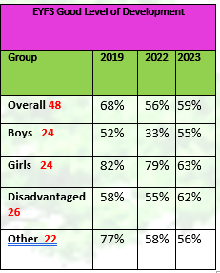
Foundation Stage Data- Good Level of Development

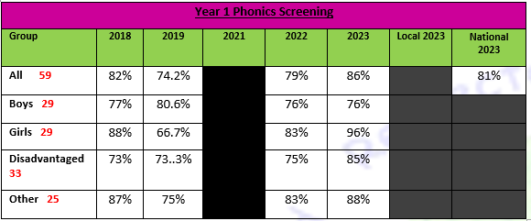
Phonics Screening Y1

Phonics Screening- End of Y2
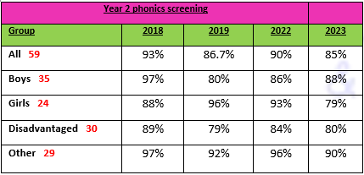
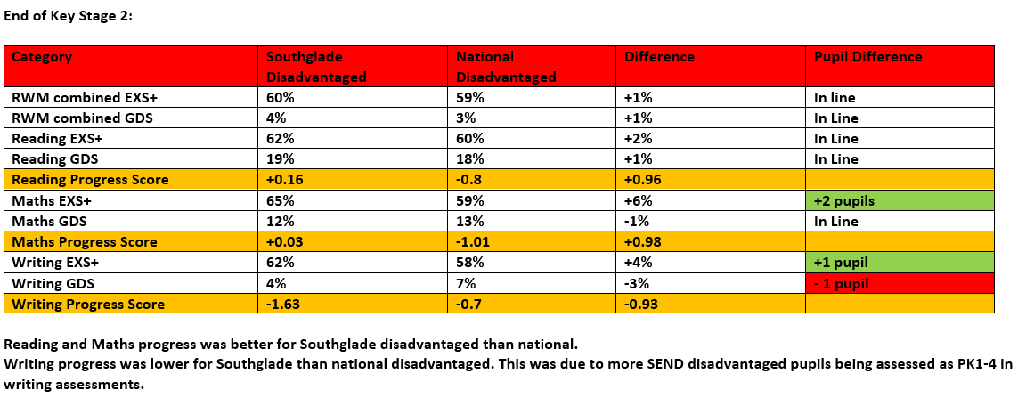
Phonics Y1:
Category | Southglade Disadvantaged | National Disadvantaged | Difference
% passing phonics check | 85% | 67% | +18%
Average number of words | 37.3 | 30 | 7 words

EYFS Data:
Category | Southglade Disadvantaged | National Disadvantaged | Difference
GLD | 58% | 52% | +6.2%
Prime Goals | 63% | 63% | 0%
Specific Goals | 58% | 52% | +6%

Across most areas of statutory data, disadvantaged pupils were inline with their national equivalents.

Externally provided programmes
Please include the names of any non-DfE programmes that you purchased in the previous academic year. This will help the Department for Education identify which ones are popular in England
Programme | Provider
Little Wandle  Letters and sounds | https://www.littlewandlelettersandsounds.org.uk

