Year 6: Summer POST SATS: Design and Technology

Objectives:
Use research to inform the design of functional products that are fit for purpose, aimed at a particular group of individuals.
Generate ideas through annotated sketches and prototypes
Select from a range of materials according to their functional properties and aesthetics.
Investigate a range of existing products
Evaluate the product against their own design criteria and consider the views of others to improve their work.
Understand how key events and individuals in design and technology have helped shape the world.

Key Vocabulary:
textile, material, fabric, CAD (Computer Aided Design), CAM (Computer Aided Manufacture), combine, purpose, inspiration, design, make, evaluate, prototype, Rube Goldberg, contraption, machine, transfer, mechanism
A selection of mini-project ideas for children after SATS to ensure all progression ladder objectives have been met. Can be done in any order.  Project 1  Design and make a T-Shirt for yourself.  Children can use Canva to create a design to go onto a t-shirt. This could be a year 6 leavers t-shirt, a band or musician they like, or any other appropriate design. There are lots of pre-set ideas on Canva to explore.  The design can then be printed onto iron-on transfer paper which is then cut out and ironed onto a cotton t-shirt.  You could either purchase some cheap t-shirts in various sizes for the children to transfer their design onto (from Primark, Shein or similar), OR you could buy a roll of fabric which the children could measure and cut to then sew together and make their own t-shirt.  These could potentially replace the traditional ‘leavers’ hoodies.  From Teach Computing documents:  Students below the age of 13 require parental consent to use Canva for Education. For further details and to download a sample consent template visit: https://www.canva.com/help/invite-teachers-and-students/  To use Canva as a teacher, you will require a Canva for Education account. To learn more and sign up for a FREE Canva teacher account visit: https://www.canva.com/help/about-canva-for-education/.  NB: Due to Canva’s teacher verification process we would recommend signing up prior to teaching the unit to allow time for verification of your teaching status to take place.  Once you have been granted access to Canva you can follow their guide on inviting students and teachers to your class by visiting: https://www.canva.com/help/invite-teachers-and-students/  Things to consider: Read the instructions on the iron-on transfer paper carefully. Check the school printer is compatible with the paper, if not you may need to bring one in from home or see if other staff have one to borrow. Close adult supervision required with iron.  If making the t-shirts from material, stand-alone lessons may be required looking into how clothing is made, how to measure and cut a pattern and how to join fabric. Ensure to allow extra material for seams. Children could design their own shape for their t-shirt (asymmetric, vest, sleeve type).  This could be linked to research on fashion designers who have shaped the world, ethics on fast fashion and sustainability.  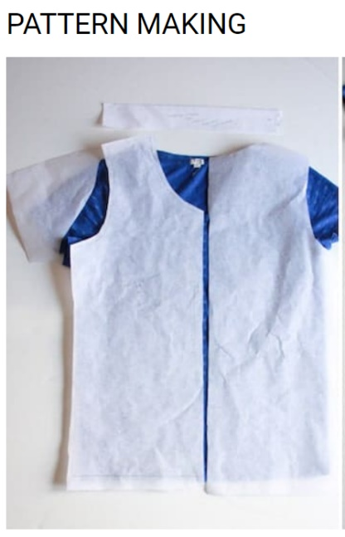  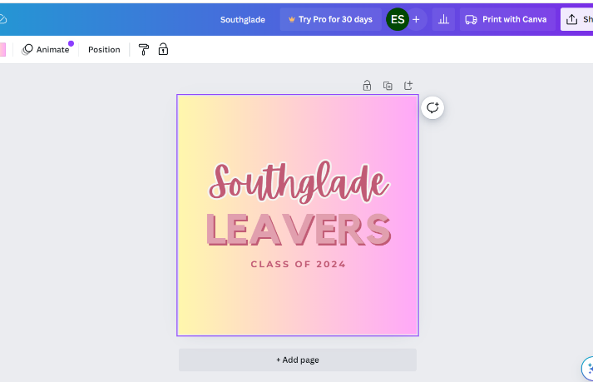  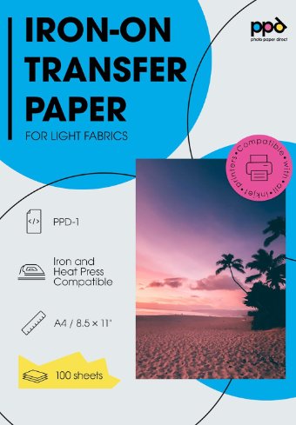  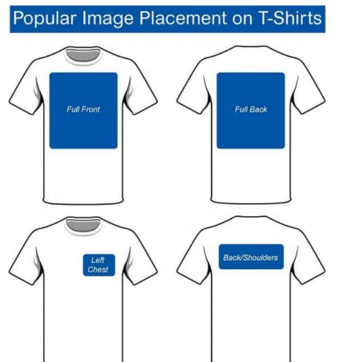  Project 2  Design and make a Rube Goldberg machine (or marble run)  A Rube Goldberg machine is a chain reaction type machine, often an unnecessarily elaborate and complex method of completing a simple task. There are many great examples of these on YouTube. Wallace and Gromit famously use these types of machines. The board game Mouse Trap uses this type of contraption to catch the mouse.  Children can design their machine, starting with no restrictions. The design can then be refined to be realistic, refined again to be able to be made in school.  Equipment required may depend on the designs, however you can guide the children into using materials such as: lolly sticks, toilet roll tubes, elastic bands, wooden dowelling, paper clips and other school based equipment to transport a marble. One idea would be to cut the front panel off a cereal box and create the machine inside, or get some sturdy card to make their contraption on or around. ‘To transport a marble in an elaborate way to entertain’.  They will need to continually evaluate and refine their design as they make it to ensure each section works as intended.  Children can then think of the theming of their contraption and how they could decorate it.  This project links to science and forces, maths and art.  There is a museum in Stratford On Avon called ‘the MAD museum’ (Mechanical Art and Design) which is full of these types of machines. https://themadmuseum.co.uk/about-us/  You could have a go at creating a large scale Rube Goldberg machine that goes around the classroom using things such as books, tables and chairs.  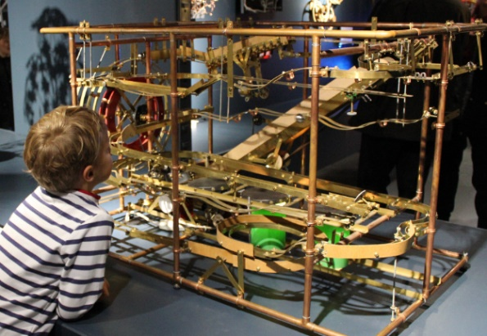  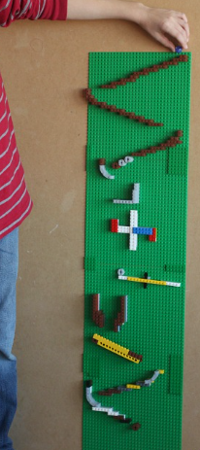  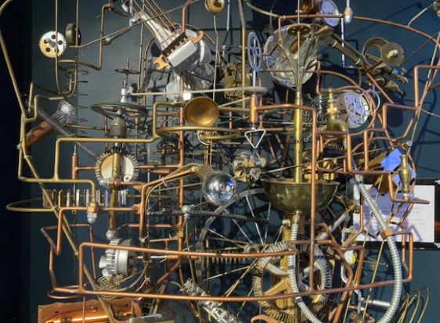  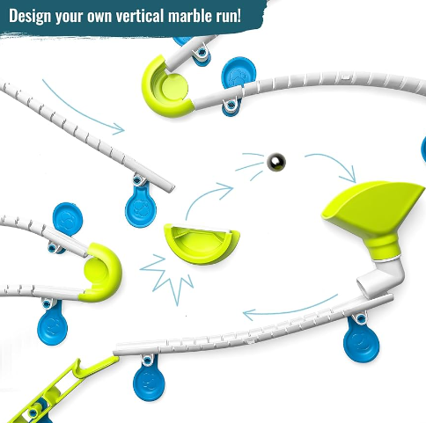  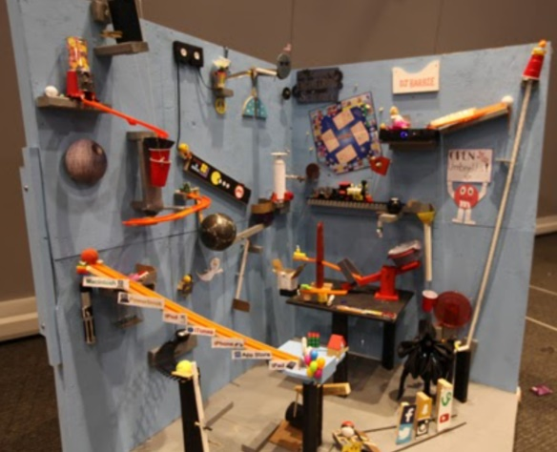  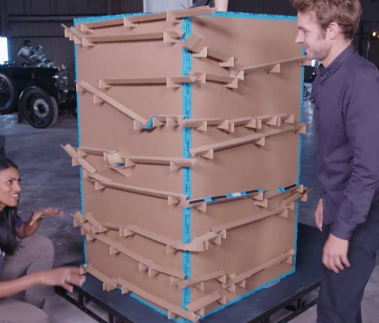  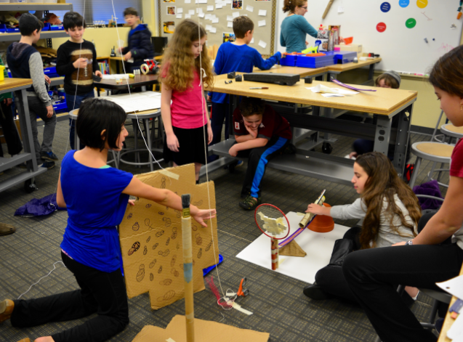  In the MAD museum  Project 3  Design a piece of playground equipment and make a prototype.  Allow chn to design their dream playground with no research to begin with.  Then research existing equipment, look at materials and sustainable equipment. Discuss safety and considerations- will your equipment be for younger children or older children?  They could look at catalogues of products and consider the price. Materials should be suitable; is metal a good idea for sunny days? How will you ensure no one falls from a height?  Refine the design and think about how they would make a small scale prototype. This could be extended to AA to work out dimensions and actually make the prototype to scale.  They could think about theming of the playground- what colours might they use? Will there be any decoration? E.g. rainforest, space, clouds, whimsical, fantasy, industrial etc  Will their playground equipment just be for fun or will there be a secondary purpose? E.g. musical, exercise, educational.  How will they make their equipment inclusive for all- consider disabilities and safety.  children could try to research what their equipment might cost, considering different types of wood or other materials.  You could give the children a budget- can they design a piece of equipment that would be under £500?  Children can design the flooring and fencing around the equipment.  They could make just one element or the whole thing.  It may be necessary to use a small saw to cut the pieces of wood to the correct size. This should be done under close supervision and may need a stand-alone skills lesson or session.  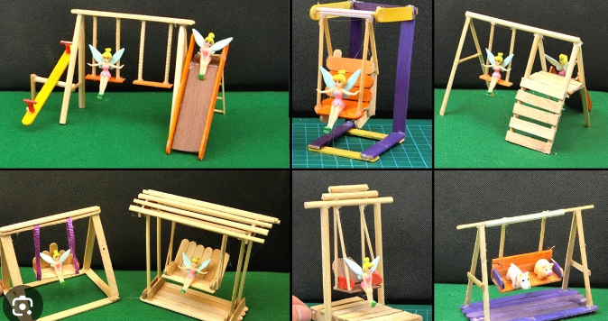  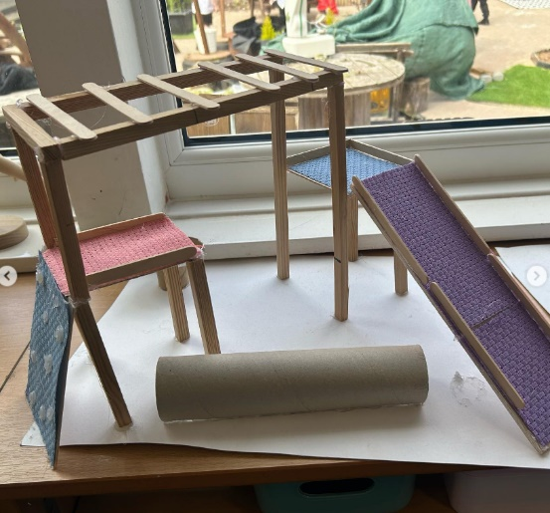  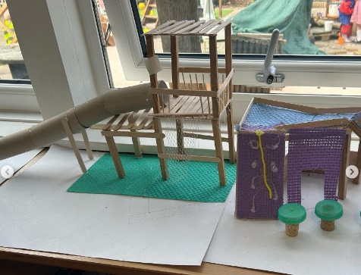  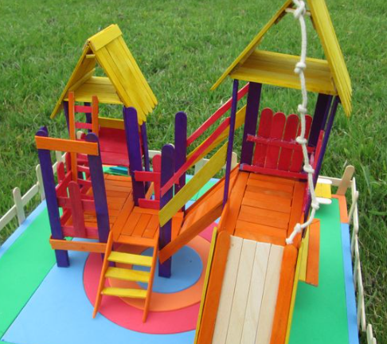  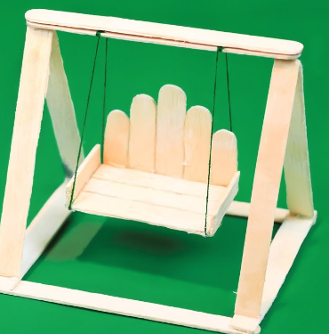  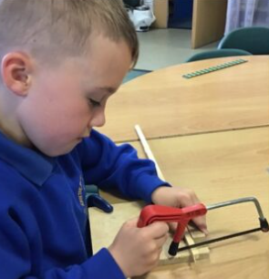 | Practical tasks:  Ideally, children should make an individual product to allow for teacher assessment.  - Design.  Design challenges creating specific products for specific consumers  Children to think about who their product is for- themselves or a family member? They should use colours and patterns accordingly.  - Make.  Give plenty of time to learning the key skills needed before attempting to make the final product. You might want to have an entire day for a project rather than splitting it over a multiple lessons.  - Evaluate.  Chn to think back to the design brief  Answer specific questions- Does it meet the brief? Does it follow the design? How could it be improved with the materials available? How could it be improved with unlimited materials?  Other things to consider  Some children may not be successful! This is okay and expected. Try to only give minimal support.  Resources required (suggested):  Project 1;  iron transfer paper  iron  inkjet printer  t shirts OR material  needles and thread (optional)  large paper to make sewing pattern (optional)  Resources required (suggested)  Project 2;  Cardboard boxes  marbles or small balls  toilet roll tubes  straws  lolly sticks  elastic bands  wooden dowelling  split pins  glue  Resources required (suggested)  Project 3:  lolly sticks  string  wooden dowelling  wool  cardboard  card tubes  fabric  glue (consider using a hot glue gun under adult supervision)
Project 4  A 3D printed keepsake  Children should use Tinkercad to design something with their name on it as a keepsake to remember their time at Southglade.  Possible ideas:  Key ring  Bag charm  Photo frame  Ruler  Ornament  Book mark  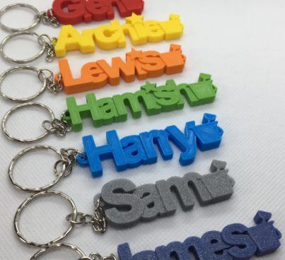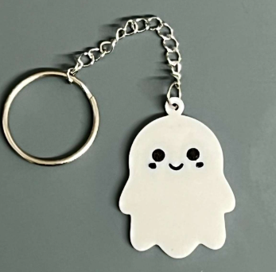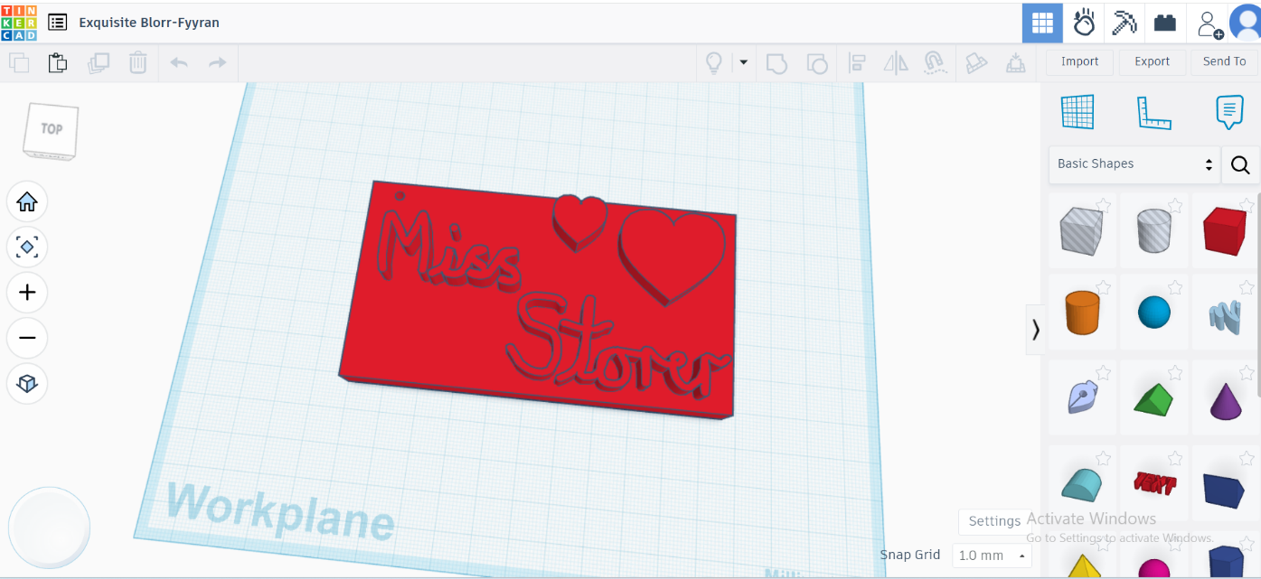 | Resources required  Metal key rings, lanyards, other fastenings (optional)  3D printer filament
Outcome from all 4 projects:
- A personalised t shirt
- A Rube Goldberg inspired marble run machine
- A prototype of a piece of playground equipment
- A 3D designed and printed keepsake

