Year 6 : Summer : Design and Technology
Enquiry Question: I wonder...how cuisine is unique in different countries around the world (making a 3 course meal inspired by Asia)
Objectives:
design purposeful, appealing, innovative products for a particular individual or group based on design criteria
generate, develop and model ideas through discussion, drawing and exploded diagrams.
select from and use a range of tools and equipment to perform practical tasks accurately
select from a range of ingredients according to their characteristics and aesthetic qualities.
investigate and analyse a range of existing products
evaluate ideas and products against design criteria, considering views of others to improve their work
use the basic principles of a healthy diet to prepare dishes
prepare and cook a variety of predominantly savoury dishes using a range of cooking techniques
understand where food comes from including seasonality, how food is grown, reared, caught and processed
Key Vocabulary:
cuisine, recipe, hygiene, safety, ingredients, equipment, mash, cut, grate, melt, bake, measure, combine, drain, mix, spread, heat, presentation, boil, garnish, serve, drizzle, origin, design, make, evaluate, purpose, improve, healthy, consumer, slice, reared, caught, processed, preservatives, marinate, calories
Key factual learning/CPD for staff  World food  Prior learning- Year 1 British afternoon tea, Year 2- Middle Eastern Hummus and Italian Pizza, Year 3- Chocolate, Year 4- Syrian Fattoush salad and kibbeh, Year 5- Greek Gyros and Tzatziki.  Asian cuisine is very varied with most countries in Asia using rice at their main carbohydrate. Indian food is often spicy – you could sample some pre-made curry sauce. They often don’t use utensils to eat with and eat using only their hands.  Chinese food often uses noodles, and a lot of fish and chicken is eaten rather than red meat. They use chopsticks to eat rather than a knife and fork. Children should have a go at using chopsticks to move objects- they can use 2 pencils. They also don’t sit on chairs at tables, they have a low table and sit on the floor. Hong Kong in Southern China has the highest life expectancy in the world at 85 years (UK is 82). This is often attributed to the fact that they do not eat as much processed food as Western countries.  There is a high rate of lactose intolerance in the Chinese community, so dairy products are not as widely used.  Street food is an integral part of Chinese cuisine, with foods being prepped and cooked in very confined spaces ready to consume within minutes. Chinese street food attracts a lot of culinary tourism. Ramen began as a street food. Originally street food catered to the poor, however rich people would send servants out to buy it for them and bring it home!  Stir fry is a type of street food that can be heavily customised- different protein (meat or alternative), different vegetables, different carbohydrate (rice or noodles) and different sauces.  Approx. 3 billion fortune cookies are made each year!  Children will design and make their own stir fry dish. This may need to be over a number of days as there is only one hob area and children will be using different ingredients. They will also follow a recipe to make vegetable spring rolls and fortune cookies, and sample traditional Chinese green tea.  Key cooking concepts to teach:  Kitchen safety. Emphasise the importance of being safe in a kitchen and around food before any food is present or any practical work takes place. This includes hand washing, tying long hair back, staying quiet and calm, taking care when transporting ingredients and equipment, wearing a cooking apron if necessary, food storage and keeping food safe to eat.  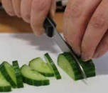  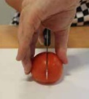  Teach cleaning up as a vital part of cooking.  The EatWell guide should be referred to throughout cooking lessons- They should know it already from previous years.  When discussing food, always talk about where it comes from (a tree, bush, underground, an animal etc, as well as the country of origin)  In years 4 and 5, children will have made dishes using raw meat and cooking it safely. This will need to be reviewed and reinforced- Emphasise the  Bridge hold (left). Claw grip (right).  importance of food safety when handling meat- must wash hands and equipment thoroughly, meat must be cooked through etc.  Discuss why this is especially important with chicken- salmonella risk!  When making the spring rolls, children can work in groups to prepare the filling but should all have a go at rolling their own.  When making the stir fry, due to the risk involved, you may wish to purchase pre cooked chicken. An alternative would be for an adult to prepare raw chicken by cutting it up into small pieces and discussing why the children can’t do this part (the risk of contamination with raw chicken is high). They would then need to ensure it is fully cooked through with close adult supervision. Another alternative would be to buy pre-diced raw chicken and ensure strict rules and procedures are adhered to in the cooking area.  Other protein options could include: sliced beef, quorn or tofu.  When designing their stir fry, the children should think about flavours; spices, herbs, sauces and ingredients such as honey or chili. They can create their own sauce or research to find one that exists and write down the recipe.  When making the fortune cookies, they are shaped while they are still warm from the oven. Consider purchasing cotton gloves for children to wear if they feel the cookie is too hot. An adult should remove the cookies from the baking tray and hand it to the child when it is a safe temperature.  Children should have the opportunity to sample a range of different teas (ensuring the water is not too hot). Tea is an important part of Chinese culture (however it is not the same as our traditional English Breakfast tea!)  Nutritional information should be discussed including calories and how you can use calorie information to make healthy choices. This includes how different foods give us different amounts of energy, and what happens when we give our body too many / not enough caloiries. Discuss portion size.  Food sources and ethical dilemmas should be discussed- should we only buy food grown in the UK despite it being more expensive and the increasing cost of living? Compare the cost of a healthy meal compared to the cost of junk food. Discuss social influence on the foods we eat- social media, Netflix documentaries, videos that show people overeating for entertainment or competitive eating.  Skills for the children to have a go at:  cutting- explicitly recap knife safety and the ‘bridge hold’ and ‘claw grip’ techniques. They should be secure in this already so NOT a full lesson. They should use their skills to finely dice and thinly slice.  mixing- mix a wide variety of both wet and dry ingredients to combine them together in a controlled way.  handle hot food safely- chn should not remove items from the oven themselves but should be able to use oven gloves to handle food that has been removed for them.  measuring- use the digital scales to accurately measure out a pre-determined amount of ingredients, selecting an appropriate utensil to transfer the ingredient (e.g. teaspoon, table spoon, ladle)  frying- use an appropriate utensil to stir fry ingredients in a frying pan- close supervision required.  Skills for the children to observe:  safely transferring food into and out of the oven (spring rolls and fortune cookies)  cutting raw chicken (optional)  Food ideas to make:  Vegetable spring rolls  Custom stir fry  Fortune cookies  Tea  Ingredients to buy:  Vegetable spring rolls: see separate recipe sheet  Stir fry: children will choose from a variety of ingredients to create their own  noodles; egg, vermicelli  vegetables: beansprouts, broccoli, peppers, carrots, mushrooms, baby corn, courgette, green beans.  protein: chicken (either pre-cooked or pre-diced), beef, Quorn  sauce: hoisin, sweet chili, soy, honey, garlic, ginger, sesame oil, sesame seeds, salt, pepper, chili (children can create their own sauce by adding ingredients together)  Fortune cookies: see separate recipe sheet. The recipe calls for an electric mixer however you will have to whisk manually. The recipe also says it is quite tricky and I would recommend reading the comments from the website to get some tips and tricks: https://www.allrecipes.com/recipe/58640/fortune-cookies-so-easy/  Tea: green tea, fruit teas, peppermint, chai  NOTE: Due to space constraints both in the fridge and in the cooking area, each child creating their own stir fry will be time consuming and could be planned to occur over a number of days or even split across multiple weeks. Each child should have the opportunity to design their own, however you may find that some children have created very similar recipes and could work as a group to make one larger portion that is then split. If time constraints prevent each child making their own stir fry, you may need to tell them they will be working in groups, however they should all contribute and use their kitchen skills.  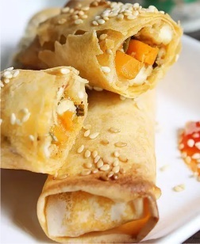  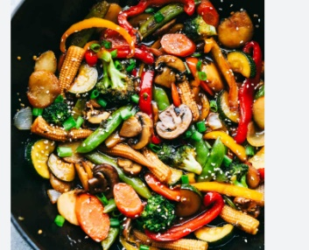  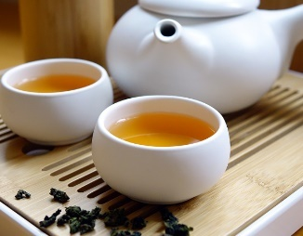  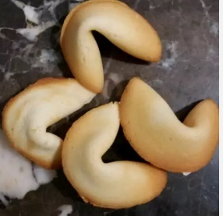 | Practical tasks:  Ideally, children should make an individual product to allow for teacher assessment.  - Design.  lots of design challenges throughout as following a recipe does not allow for much creativity.  - Make.  Starter- Spring roll  Main- Stir fry  Dessert- Fortune cookies  Drink- Chinese tea  - Evaluate.  Chn to think back to the design brief- ‘A 3 course meal inspired by Asia’  Answer specific questions- Does it meet the brief? Does it follow the design? How could it be improved with the materials available? How could it be improved with unlimited materials?  Other things to consider  Some children may not be successful! This is okay and expected. Try to only give minimal support.  With cooking, it is hard to allow children to be creative as the recipe may not work but try to allow as much creativity as possible.  Always try to buy the cheapest ingredients possible from budget supermarkets to make your cooking budget spread further. You have £100 per year group for the whole driver.  Ensure you know whether children in your class have any food allergies before starting, and how many vegetarian alternatives you will need to make!  Some children may not like some of the food, but they should be able to explain if it is healthy or not, or if it would be a good choice. Their specific consumer may be a parent or other family member if not themselves.  Children should be supervised very closely when using the sharp knives.  Refer back to where food items come from regularly throughout the topic, during practical sessions as well as classroom based sessions.  Refer to the EatWell guide regularly when children are making their ingredient choices  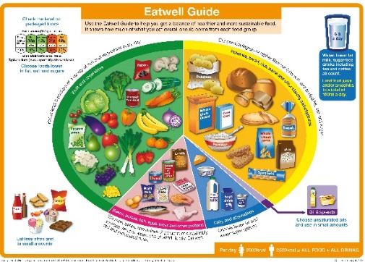
Outcome:
- make a vegetable spring roll
- design and make a custom stir fry inspired by Chinese cuisine, thinking about flavours and ingredients
- write a fortune and encase it within a fortune cookie
- have an understanding of Chinese cuisine as well as important culture traditions surrounding Asian food.
- Leave year 6 at Southglade being able to prepare a range of foods including a 3 course meal.

