Year 5: Spring 2: Design and Technology
Enquiry Question: I wonder… how I can use texture and colour to create a Native American inspired bag.
Objectives:
Use research to inform the design of functional products that are fit for purpose, aimed at a particular group of individuals.
Generate ideas through annotated sketches and prototypes
Select from a range of materials according to their functional properties and aesthetics.
Investigate a range of existing products
Evaluate the product against their own design criteria and consider the views of others to improve their work.
Understand how key events and individuals in design and technology have helped shape the world.

Key Vocabulary:
textiles, materials, design, pattern, needle, thread, yarn, skein, bargello, back stitch, combine, collaborative, purpose, motif
Key factual learning/CPD for staff  History  Textile art is one of the earliest known industries, however most early textiles have been lost or disintegrated. Some examples that have been preserved have survived due to specific environmental conditons- dry deserts in Peru and preservation in peat ponds in Florida for example.  Lots of textile work was done with materials such as llama and alpaca wool, palm leaves, silk and sheep wool. Dog wool was even found to be used in some cases! The yarn was dyed using natural colourings which created a wide variation in colours even across one piece.  Navajo weaving is a great example which is still made today. Fabric is distinctive with geometric designs in red, brown and white. Interestingly the textiles are not planned and the patterns are just made up as they go! They are never perfect and in fact weavers leave one thread undone to ‘allow their soul which they have put into the weaving to escape’ https://www.permanentstyle.com/2021/07/the-craft-history-and-beauty-of-navajo-blankets.html#:~:text=Navajo%20work%20is%20the%20richest,access%20to%20cotton%20and%20wool.  Bargello  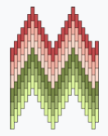  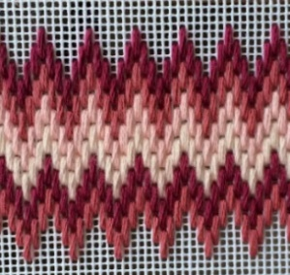  Bargello is a type of embroidery made up of vertical lines only which span 2 or more squares (up to 6) to create a pattern or motif. Patterns that resemble Navajo weaving can be easily made using Bargello. This website has how-to videos and lots of useful tips: https://hellobargello.com/pages/learn-to-bargello . The Bargello technique creates designs by an offset of stitches called the step. Zig-Zag patterns are then made by changing colour. By varying where the step is, more curved zigzags can be formed.  Skills to teach  - Cutting a length of thread- a length should be no longer than the distance from your hand to your elbow for beginners.  - Separating strands- Embroidery thread is made up of 6 strands. Usually you stitch with 2 for cross stitch, Bargello uses 3 or 4.  - Threading the needle- How to use a needle threader as well as threading straight into the needle.  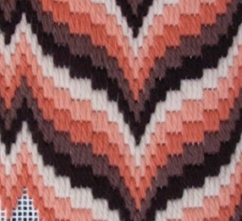  - How to begin stitching with your thread- You should not knot! Leave a tail at the back of the work that you then stitch over to hold in place. (BA may need to knot instead).  - How to follow a pattern- Use a methodical approach rather than stitching randomly. Highlight the pattern as you go to keep track  - How to finish off a thread- On the back of the work, sew under some of your stitches to hold the thread in place, then cut the thread.  Possible errors/misconceptions  - Children don’t pull all of the thread through to the front of their work which creates loops on the back and means their thread runs out very quickly. Ensure stitches are pulled tight.  - Knots form in thread- This is much more common if the piece of thread is too long or they are rushing. If a knot forms, you can often undo it by placing the needle into the loop of the knot and sliding it back and forth.  - Making a mistake when following the pattern- You may need to work backwards to undo stitches; this is known as ‘frogging’ due to having to ‘rip-it’ back (although you should gently undo the stitches and then continue with the same thread where possible.  - Creating stitches that are too long- Bargello stitches should be 2 or 3 squares long, and never more than 6.  Options for end piece:  - Attach completed embroidery onto a pre-purchased bag or pencil case using glue (PVA glue works for fabric)  - Attach with a basic back-stitch, ensuring to only stitch through one side of the bag.  - Attach onto a rectangle of fabric that can then be folded and made into a basic bag or pouch.  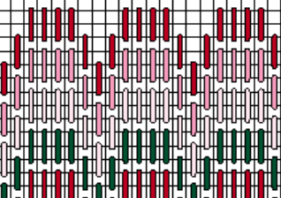  Creating a pattern  A Bargello pattern chart looks like this: Unlike most embroidery charts, the squares represent the holes in the cloth (they would usually represent the s square formed by 4 holes).  A pattern could be made on squared  paper, or you could combine ICT and  create a pattern on a computer.  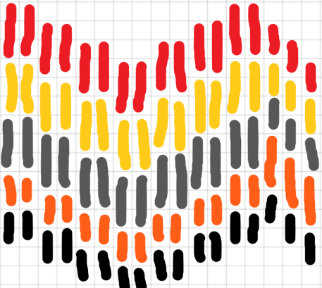  In the left example, I pasted some squared paper from google into Paint3D and used a 25px marker to create a basic design. I only slightly varied my length of stitches.  In the below example, I used PurpleMash 2Paint- the graph paper background is one of the preset options and I used the line tool. I varied my lengths a lot more in this one.  When creating the pattern, start with the top line of one colour (ensuring the colour overlaps by at least one square) all the way across.  Then do the next colour under this one, mostly recreating the same pattern although some changes can be made. Ensure no gaps are left between one colour and the next. My process is below. (This would be the same using squared paper and colours). You would also stitch it following the same steps.  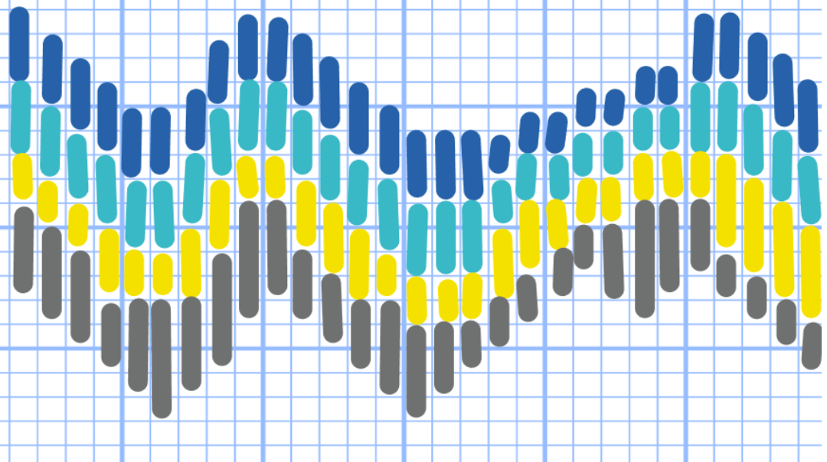  Stitches must overlap by at least one square; this example below is incorrect as the colour touches diagonally but does not overlap  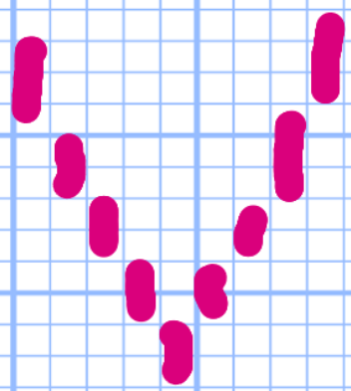  Inspiration photos:  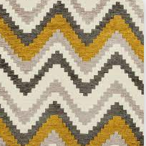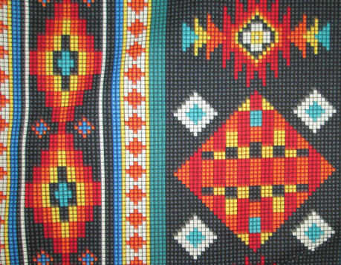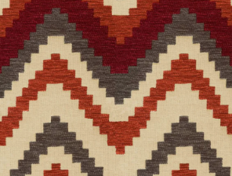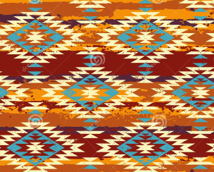  The Bargello embroidery should be done on aida cloth. The finished embroidery should then be attached to a bag or pencil case, either by sewing it on or glueing. | Practical tasks:  Ideally, children should make an individual product to allow for teacher assessment.  - Design.  Design challenges creating specific products for specific consumers  Design the pattern of the Bargello either on a computer or on squared paper. The design could start before you have looked at any inspiration and then be refined as you explore and learn the stitching technique- children will probably start with an elaborate design that they then simplify.  Children to think about who their bag is for- themselves or a family member? They should use colours accordingly.  Design a zip pull or bag charm to attach to their final piece using Tinkercad (CAD)  - Make.  Give plenty of time to learning the key skills needed before attempting to make the final Bargello design. You might want to have an entire day to stitch the embroidery as it takes longer than you might think.  Use the 3D printer to print out the zip pull or bag charm.  - Evaluate.  Chn to think back to the design brief- ‘A bag for [intended user] featuring a Bargello embroidery design inspired by Native America.’  Answer specific questions- Does it meet the brief? Does it follow the design? How could it be improved with the materials available? How could it be improved with unlimited materials?  Other things to consider  Some children may not be successful! This is okay and expected. Try to only give minimal support.  BA children should be encouraged to use less colours and create a smaller design.  Resources required (suggested):  To order:  Aida cloth 14 count, enough for each child to have a 10cmx10cm piece.  Needles  Needle threaders  Embroidery floss  Bags/ pencil cases  Each child to contribute £1 to cover the cost of materials  In school:  Squared paper  PVA glue
Outcome:
- A piece of Bargello embroidery designed and stitched by the child
- A bag or pencil case with the Bargello attached to it
- A zip pull or bag charm made using computer aided design and computer aided manufacturing. (CAD and CAM)

