Year 5 : Summer : Design and Technology
Enquiry Question: I wonder...how I can create a Greek inspired meal for a specific consumer
Objectives:
design purposeful, appealing, innovative products for a particular individual or group based on design criteria
generate, develop and model ideas through discussion, drawing and exploded diagrams.
select from and use a range of tools and equipment to perform practical tasks accurately
select from a range of ingredients according to their characteristics and aesthetic qualities.
investigate and analyse a range of existing products
evaluate ideas and products against design criteria, considering views of others to improve their work
use the basic principles of a healthy diet to prepare dishes
prepare and cook a variety of predominantly savoury dishes using a range of cooking techniques
understand where food comes from including seasonality, how food is grown, reared, caught and processed
Key Vocabulary:
cuisine, recipe, hygiene, safety, ingredients, equipment, mash, cut, grate, melt, bake, measure, combine, drain, mix, spread, heat, presentation, boil, garnish, serve, drizzle, origin, design, make, evaluate, purpose, improve, healthy, consumer, slice, reared, caught, processed, preservatives, marinate, calories, traditional
Key factual learning/CPD for staff  Greek food  Greek cuisine was founded on the triad of wheat, olive oil and wine. These 3 ingredients can be found in many Greek dishes. They use fish more than meat and often create dishes with low cost in mind. The Greek way of cooking spread to ancient Rome and throughout Europe.  Beef dishes are uncommon in Greek cuisine as the climate favours the rearing of goats and sheep over cattle.  In modern times, many Greek restaurants, serve classics such as: gyros, souvlaki, skepasti, moussaka, hummus, tzatziki and desserts including baklava  You will be making Gyros (pronounced yee-row singular or yee-ross plural) and tzatziki dip (sat-zee-key). Gyros are traditionally made from meat cooked on a rotisserie like a donner kebab, but we are using this as inspiration and will be pan frying our meat instead.  Key cooking concepts to teach:  Kitchen safety. Emphasise the importance of being safe in a kitchen and around food before any food is present or any practical work takes place. This includes hand washing, tying long hair back, staying quiet and calm, taking care when transporting ingredients and equipment, wearing a cooking apron if necessary, food storage and keeping food safe to eat.  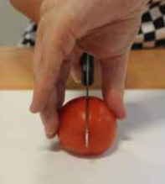  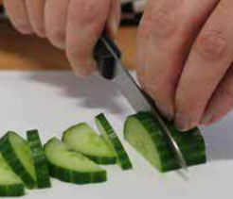  Teach cleaning up as a vital part of cooking.  The EatWell guide should be referred to throughout cooking lessons- They should know it already from previous years.  When discussing food, always talk about where it comes from (a tree, bush, underground, an animal etc, as well as the country of origin)  In year 4, children will have made a dish using raw meat and cooking it safely. This will need to be reviewed and reinforced- Emphasise the  importance of food safety when handling meat- must wash hands and equipment thoroughly, meat must be cooked through etc.  Discuss why this is especially important with chicken- salmonella risk!  Nutritional information should also be discussed including calories and how you can use calorie information to make healthy choices.  Bridge hold (left). Claw grip (right).  Food sources and ethical dilemmas should be discussed- should we only buy food grown in the UK despite it being more expensive? What about  free-range livestock and organic ingredients? Discuss the ethics of veganism and extreme views. Discuss food waste.  Skills for the children to have a go at:  cutting- explicitly recap knife safety and the ‘bridge hold’ and ‘claw grip’ techniques. They should be secure in this already so NOT a full lesson  mixing- mix a wide variety of both wet and dry ingredients to combine them together  draining- use a colander or sieve to rinse salad and drain it  handle hot food safely- chn should not remove items from the oven themselves but should be able to use oven gloves to handle food that has been removed for them.  measuring- use the digital scales to accurately measure out a pre-determined amount of ingredients, selecting an appropriate utensil to transfer the ingredient (e.g. teaspoon, table spoon, ladle)  kneading- dough (if you make your own pittas)  marinade- ensure an even coating of the beef in the marinate, then cover with cling film to safely store and wash hands and equipment thoroughly  Skills for the children to just observe:  frying- fry slices of the beef with small groups of children. They could have a go at moving the meat around the pan. Discuss when we know the meat is cooked. (no pink)  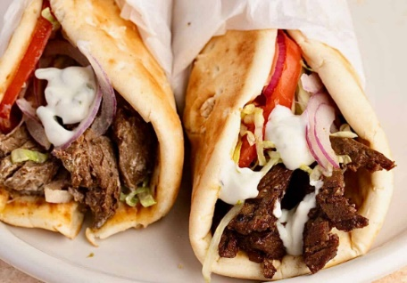  In year 4, children have tried and used different herbs and spices, so ensure to discuss the usage of these in the Greek recipes  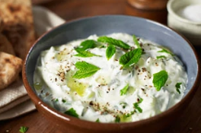  Food ideas to make:  Tzatziki dip https://www.bbcgoodfood.com/recipes/tzatziki  Beef gyros https://www.mygreekdish.com/recipe/easy-beef-gyro-recipe-wrapped-in-pita-bread/  Pitta bread from scratch (optional)  Ingredients to buy:  See separate recipe sheets for beef gyros and tzatziki. Pita bread. Oven chips (optional)  NOTE: Due to space constraints both in the fridge and in the cooking area, it would be wise for each class to cook on different days. The beef is supposed to be marinated overnight in a fridge, however if this is not possible, at least 30 minutes of marinating time should be allowed. You may need to set a whole day aside to create your gyros- some can be doing the tzatziki dip while others are chopping the salad and others are cooking the beef. All children should be allowed to contribute to all 3 elements.  The recipes do not allow for creativity as they should be followed, however the children can then choose what salad they put into their own Gyros. | Practical tasks:  Ideally, children should make an individual product to allow for teacher assessment.  - Design.  lots of design challenges throughout as following a recipe does not allow for much creativity.  - Make.  Tzatziki dip – mixing, grating, crushing garlic  Pitta bread (optional)  Gyro – meat dish; cutting, chopping, assembling, marinating, slicing  - Evaluate.  Chn to think back to the design brief- ‘A Greek inspired dish for a specific consumer’  Answer specific questions- Does it meet the brief? Does it follow the design? How could it be improved with the materials available? How could it be improved with unlimited materials?  Other things to consider  Some children may not be successful! This is okay and expected. Try to only give minimal support.  With cooking, it is hard to allow children to be creative as the recipe may not work but try to allow as much creativity as possible.  Always try to buy the cheapest ingredients possible from budget supermarkets to make your cooking budget spread further. You have £100 per year group for the whole driver. The beef will be your main expense (approx. £50), it may be worth contacting local butchers to see if they would do us a deal.  Ensure you know whether children in your class have any food allergies before starting, and how many vegetarian alternatives you will need to make!  Some children may not like some of the food, but they should be able to explain if it is healthy or not, or if it would be a good choice. Their specific consumer may be a parent or other family member if not themselves.  Children should be supervised very closely when using the sharp knives.  Refer back to where food items come from regularly throughout the topic, during practical sessions as well as classroom based sessions.  Refer to the EatWell guide regularly when children are making their ingredient choices  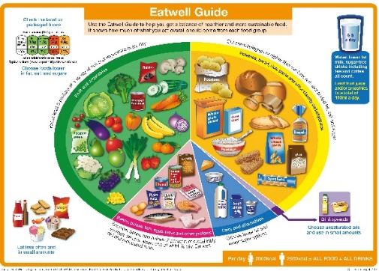
Outcome:
- Each child to have made a gyro and contributed to making tzatziki dip.
- Children will have an understanding of Greek cuisine

