Year 4 : Autumn 2 : Design and Technology
Enquiry Question: I wonder...how I can use electricity to enhance a game?
Objectives:
Use research to inform the design of functional products that are fit for purpose, aimed at a particular group of individuals.
Generate ideas through annotated sketches and prototypes
Select from a range of materials according to their functional properties and aesthetics.
Investigate a range of existing products
Evaluate the product against their own design criteria and consider the views of others to improve their work.
Understand how key events and individuals in design and technology have helped shape the world.
Understand and use electrical systems in their product (circuits, switches, bulbs and buzzers)
Key Vocabulary:
electricity, circuit, switch, current, bulb, buzzer, model, construct, material, design, make, evaluate, sturdy, strengthen, join, flange, L-brace, slot, tabs, split pin, treasury tag, suitable, annotate
Key factual learning/CPD for staff  Electricity in games  The first board game to have an electrical component was made in Germany in 1910 and was called Electro. Players had to connect questions to their answers with a wire. If correct, a bulb would light up.  Since then, hundreds of games have used electric components, games of note are: Operation, Bed Bugs, Wriggly Worms, Bop It, Simon Says, Beat the Buzz.  The first buzz wire game was invented in Yorkshire in 1953 by an electronic engineer called Robert Scrimshaw. They are now widely available and feature at fun fairs (Goose Fair!) where a prize is won.  Circuits  The buzz game works because the circuit is not closed until the wire makes connection with the player’s metal loop. This could trigger a buzzing sound, a lightbulb, or both. The handheld loop acts as a switch. A handle of some kind should be used to avoid holding the wire- this could be a cork with a hole drilled through or it could be layers of electrical tape wrapped around.  Types of join  When making the base for the game, children will need to use a variety of different joins to attach their scenery onto the landscape.  Flange- usually used for connecting a cylinder. Cut slits around the base and splay them out. Stick the splayed out sections to the desired surface.  L-Brace – to join 2 flat pieces together. Tape along the join on both sides to create a hinge style join. Sellotape or masking tape can be used.  Slot- To join 2 flat sections perpendicular to each other. Cut a slit into both pieces, then slot one slit inside the other to make a +  Tabs- To join one flat piece onto the middle of another. Cut a slit in the surface of the base, create a tab on the object to be affixed. Slot the tab into the slit.  Split pins and treasury tags- To allow movement after joining. Hole punch both pieces and put the split pin or treasury tag through both holes.  Examples of product  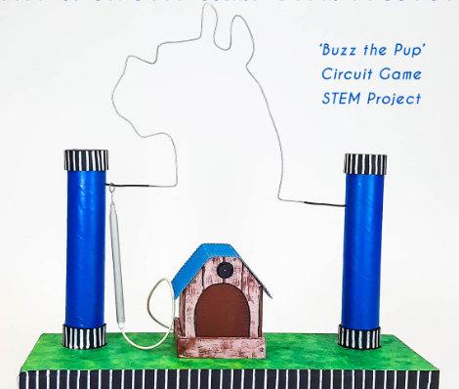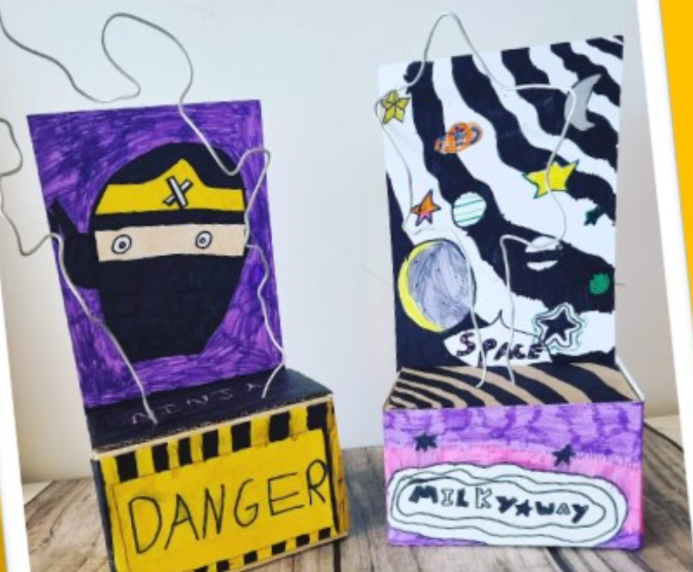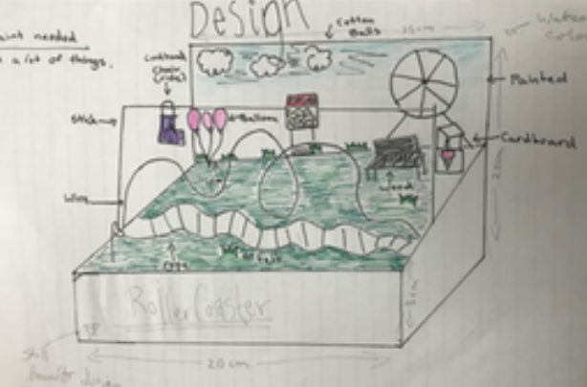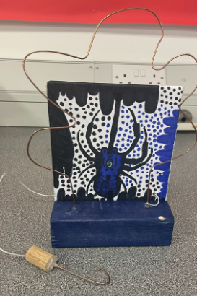  The design of the base should clearly appeal to the intended consumer, research could be carried out to decide what to include.  It is not suggested to try and link the product to another curriculum topic; the children should be able to choose their own consumer and therefore each product should be completely unique.  AA chn should be challenged to use a variety of materials and joining methods whereas BA/SEND chn could make something much simpler. The outcome should be as independent as possible in order to enable teachers to assess each child individually.  Design and print a 3D name for the game using Tinkercad | Practical tasks:  Ideally, children should make an individual product to allow for teacher assessment.  - Design.  Start out with a broad design brief: ‘design a game that uses electricity’  Refine: ‘design a game that uses electrical circuits that we have learnt about in school’  At this stage, show children some examples of buzzer games  Refine: ‘design a buzzer game using electrical circuits we have used in school’  At this stage, discuss a target market and consumer- chn to choose someone specific. Could be a specific person they know or a group of people (e.g. their friend, or ‘people who like football’). Discuss the equipment they will have access to including decorative materials as well as construction materials and show lots of examples from the internet/ previous years work.  Final design: ‘design a buzzer game for your specific consumer using equipment we have in school’  This design should be labelled with details of the materials required as well as the features included.  Use Tinkercad CAD to design the name or logo of the game  - Make.  Ensure chn have an initial ‘dabbling stage’ where they can experiment with different joining methods. This could be a stand-alone lesson to teach the joins.  Also allow them to ‘dabble’ with the electronic circuit equipment to see how it works and decide what they want to include in their game. This could have already been done in a science lesson. A prototype of their wire design could be made.  After ‘dabbling’ show examples and methods- videos, teacher modelling  Children to all make a base that is made to appeal to their target consumer and incorporate their buzz wire to create a game.  Print out the name or logo of the game using the 3D printer  - Evaluate.  Chn to think back to the design brief- ‘design a buzzer game for your specific consumer using equipment we have in school’  Answer specific questions- Does it meet the brief? Does it follow the design? How could it be improved with the materials available? How could it be improved with unlimited materials?  Other things to consider  Some children may not be successful! This is okay and expected. Try to only give minimal support.  Ensure chn are being safe with electrical equipment.  Each child to contribute £2 to cover the cost of the electric equipment so they can take their game home.  The base will need time to dry so ensure enough ‘Make’ lessons are allocated.  Ensure notice is given to children to bring in resources from home.  Use design challenges as starters or warm-ups to get the creative brain engaged.  if using a cork, the wire needs to go all the way through it so consider drilling through them beforehand or buying ready drilled corks.  Resources required (suggested):  cardboard, paper, newspaper, masking tape, Sellotape, glue, toilet roll tubes, paint, mod-roc, paper mâché, clay, string, cork, circuit equipment (wire, batteries, buzzers, bulbs, electrical tape, wire cutters, pliers, crocodile clips)
Outcome:
- A buzzer game with a specified target user, designed to appeal as well as function. (successful or not!). The base should have a well thought out design.
- A comprehensive evaluation of the product.

