Year 4 : Summer : Design and Technology
Enquiry Question: I wonder...how herbs and spices affect the taste of food
Objectives:
design purposeful, appealing products for themselves and others based on design criteria
generate, develop and model ideas through talking and drawing
select from and use a range of tools and equipment to perform practical tasks
select from a range of ingredients according to their characteristics.
explore and evaluate a range of existing products
evaluate ideas and products against design criteria
use the basic principles of a healthy diet to prepare dishes
understand where food comes from
Key Vocabulary:
recipe, hygiene, safety, ingredients, equipment, mash, cut, grate, melt, bake, measure, combine, drain, mix, spread, heat, presentation, boil, garnish, serve, drizzle, origin, design, make, evaluate, purpose, improve, healthy, consumer, slice
Key factual learning/CPD for staff  Herbs and Spices  A herb comes from the green, leafy part of the plant whereas a spice comes from the root, stem, seed, fruit, flower, or bark of the tree or plant.  The earliest known usage of spices is cloves in 1700BC in Southeast Asia (the region was then known as Mesopotamia). The earliest written records of herbs and spices come from ancient Egyptian, Chinese and Indian cultures. They were often used in medicine and religious ceremonies rather than cooking. It is not known when they became commonly used to flavour foods.  Black pepper is the most commonly used spice across the globe today.  Children should be allowed to smell and taste a range of different spices. They should sample unseasoned foods and then have a go at seasoning them with various herbs and spices to see how the flavour is affected. This could be achieved by making some plain pasta with bland tomato sauce, then allowing children to sprinkle different herbs and spices on and critiquing the change.  Key cooking concepts to teach:  Kitchen safety. Emphasise the importance of being safe in a kitchen and around food before any food is present or any practical work takes place. This includes hand washing, tying long hair back, staying quiet and calm, taking care when transporting ingredients and equipment, wearing a cooking apron if necessary, food storage and keeping food safe to eat.  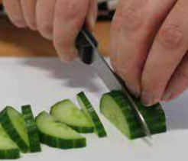  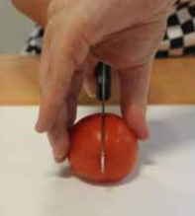  Teach cleaning up as a vital part of cooking.  The EatWell guide should be referred to throughout cooking lessons- They should know it already from KS1 and Y3.  When discussing food, always talk about where it comes from (a tree, bush, underground, an animal etc, as well as the country of origin)  This is the first time children will handle raw meat. Emphasise the importance of food safety surrounding this-  must wash hands and equipment thoroughly, meat must be cooked through etc.  Skills for the children to have a go at:  Bridge hold (left). Claw grip (right).  cutting- explicitly recap knife safety and the ‘bridge hold’ and ‘claw grip’ techniques.  mixing- mix a wide variety of both wet and dry ingredients to combine them together  draining- use a colander or sieve to drain liquid from packaged food such as sweetcorn, tuna and chickpeas  handle hot food safely- chn should not remove items from the oven themselves but should be able to use oven gloves to handle food that has been removed for them.  measuring- use the digital scales to accurately measure out a pre-determined amount of ingredients, selecting an appropriate utensil to transfer the ingredient (e.g. teaspoon, table spoon, ladle)  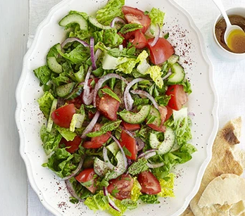  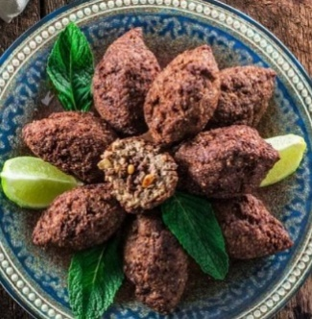  kneading- dough  moulding- meat mixture into patty shapes  Skills for the children to just observe:  baking- pitta bread, kibbeh in the oven  boiling- bulgar wheat needs cooking on the hob  Food ideas to make:  Fattoush salad  Pitta bread from scratch (optional)  Kibbeh (meat patties) https://www.allrecipes.com/recipe/143265/middle-eastern-kibbeh/  Ingredients to buy:  See separate recipe sheets for Fattoush salad and Kibbeh  Herbs and spices- paprika, cumin, ginger, cinnamon, cayenne pepper, black pepper, garlic, parsley, oregano, rosemary, basil, lemongrass, mint  pasta and chopped tomatoes to split into multiple small servings and add different herbs and spices to | Practical tasks:  Ideally, children should make an individual product to allow for teacher assessment.  - Design.  lots of design challenges throughout as following a recipe does not allow for much creativity.  When the children have tried the herbs and spices, they should write down their thoughts as they could alter a recipe based on their preferences- maybe they want to add a different herb or spice to one of the dishes.  - Make.  Fattoush salad- lots of chopping, herbs: mint and parsley  Pitta bread (optional)  Kibbeh- meat dish. Spices: cumin, allspice, black pepper. Herbs: mint  - Evaluate.  Chn to think back to the design brief- ‘A dish using herbs and spices for myself’  Answer specific questions- Does it meet the brief? Does it follow the design? How could it be improved with the materials available? How could it be improved with unlimited materials?  Other things to consider  Some children may not be successful! This is okay and expected. Try to only give minimal support.  With cooking, it is hard to allow children to be creative as the recipe may not work but try to allow as much creativity as possible.  Always try to buy the cheapest ingredients possible from budget supermarkets to make your cooking budget spread further. You have £100 per year group for the whole driver.  Ensure you know whether children in your class have any food allergies before starting!  Some children may not like some of the food, but they should be able to explain if it is healthy or not, or if it would be a good choice.  Children should be supervised very closely when using the sharp knives.  Refer back to where food items come from regularly throughout the topic, during practical sessions as well as classroom based sessions.  Refer to the EatWell guide regularly when children are making their ingredient choices  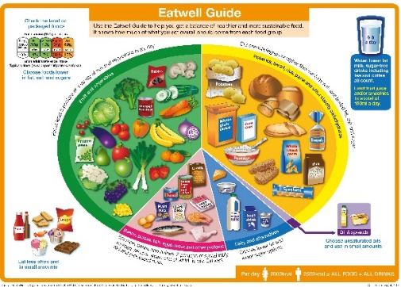
Outcome:
- Each child to have made their own Kibbeh patty flavoured with herbs and spices of their choice
- Each child to have made a Fattoush salad, garnishing with herbs of their choice.
- Children will have an understanding of different herbs and spices, how they affect flavours and will know some that they do and do not like, having tried a wide variety.

