Year 3 : Autumn 2 : Design and Technology
Enquiry Question: I wonder...how did the arrival of the Romans change Britain?
Objectives:
Use research to inform the design of functional products that are fit for purpose, aimed at a particular group of individuals.
Select from a range of materials according to their functional properties and aesthetics.
evaluate the product against their own design criteria and consider the views of others to improve their work.
Understand how key events and individuals in design and technology have helped shape the world.
Understand and use mechanical systems in their product
Key Vocabulary:
lever, fulcrum, load, power, catapult, resistance, launch, design, modify, evaluate, review, target market, consumer, product, warfare, siege weapon, artillery, torsion, tension, sinew
Key factual learning/CPD for staff  Key Technology developed by the Romans  Aqueducts- Roman engineers built aqueducts to bring fresh water into their growing cities for drinking, public baths and farming. They used early cranes in their construction. Some of the aqueducts still provide water to fountains in Rome today.  Roads- Romans understood the importance of drainage in their roads, they dug deep and laid bricks to ensure roads did not flood. They had built over 50,000 roads by 200 A.D. ‘All roads lead to Rome’  Bridges- Romans built a lot of bridges, often semi-circular arches. Stones were made so perfectly shaped that they often didn’t need mortar.  Sewers- They made the first underground pipes to take away waste which vastly improved public health (although majorly polluted the rivers)  Roman concrete- A unique mix of sand, lime and volcanic ash. The Pantheon is built from this and still stands today.  Catapults  Siege weapons and artillery- Romans mostly just adapted existing Greek technology. Most well known weapons include the Ballista, the onager and the scorpio; all types of launch weapon that used a lever and torsion or tension to shoot projectiles (rocks, arrows, spears, fireballs). They were more often used to blast through walls to allow foot soldiers to invade a fortified city, rather than directly killing  Mechanisms  Most Roman siege weapons used a lever mechanism of some kind. A lever has a long arm and a fulcrum where the arm pivots. There are 3 types of lever:  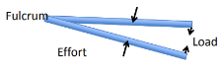  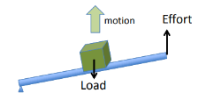  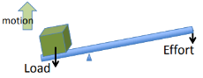  Class 3 lever. The fulcrum joins 2 arms like in tweezers or tongs.  Class 1 lever. The load can be on either end. A heavy item can be easily lifted by putting it on the short end. A lighter item can be launched long distances by putting it on the long end.  Class 2 lever. The fulcrum is on the very end. This is how wheelbarrows and bottle openers work.  Catapults use either Class 1 or Class 3 levers.  The Romans used animal sinew (tendons and ligaments) to create elastic that would be wound tightly to create torsion energy. When released, this would propel the projectile- like a spring. Another method would be to create tension where the sinew or other rope was stretched almost to its limit before being released- like a slingshot.  They were mostly made of wood so they were light enough to transport. They often utilised the wheel for easy transportation. There would be a member of the army whose job it was to ensure the machine was level before it was fired to ensure accuracy.  Examples of finished products  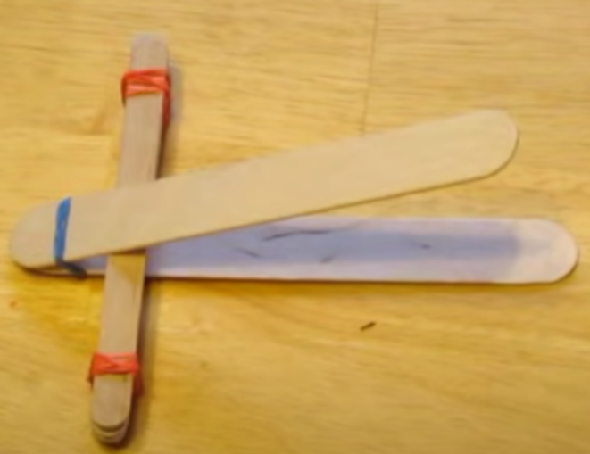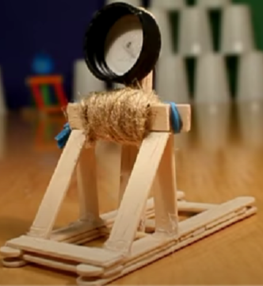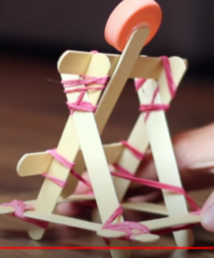 | Practical tasks:  - Design.  Start with a broad brief (design a weapon to invade a city)  Refine the design (design a ROMAN weapon) considering materials and technology available at the time  Refine the design (design a mini version you could make in a classroom) considering available time, resources and skillset  Only then show the chn what resources they will actually have access to  Refine again (only use available materials)  At this stage show children examples with available materials  Final design (using equipment available design a Roman inspired catapult)  - Make.  Ensure chn have an initial ‘dabbling stage’ where they can experiment with different joining methods. Allow them to use glue and Sellotape even though you know it wont work- allow to discover themselves.  After dabbling, show examples and methods- videos, teacher modelling  Chn to then use the advice to make their catapult independently  - Evaluate.  Chn to think back to the design brief- a Roman inspired catapult to invade a city  Answer specific questions- Does it meet the brief? Does it follow the design? How could it be improved with the materials available? How could it be improved with unlimited materials?  Other things to consider  You may need to teach children how to use elastic bands, how to twist them and use them to join 2 lolly sticks.  Ensure they only practice with light objects and do not launch at people  Some children may not be successful! This is okay and expected.Try to only give minimal support.  Ask for plastic bottle tops from home.  Resources required:  lolly sticks, elastic bands, bottle tops, Sellotape, glue, blue tac, string, light objects to launch such as small balls of paper, rubbers, pompoms etc.
Outcome:
- A Roman inspired catapult made from classroom materials (successful or not) with a comprehensive evaluation.

