Year 3: Spring 2 : Design and Technology
Enquiry Question: I wonder... how I can a design a chocolate product that will appeal to a specific consumer
Objectives:
Use research to inform the design of functional products that are fit for purpose, aimed at a particular group of individuals.
Generate ideas through annotated sketches and prototypes
Select from a range of materials according to their functional properties and aesthetics.
Investigate a range of existing products
Evaluate the product against their own design criteria and consider the views of others to improve their work.
Understand how key events and individuals in design and technology have helped shape the world.
Generate ideas through computer aided design
Key Vocabulary:
packaging, product, dietary information, calories, nutrition, brand, logo, tagline, aesthetic, appealing, eye catching, informative, melt, texture, combine, allergens, traffic light system,
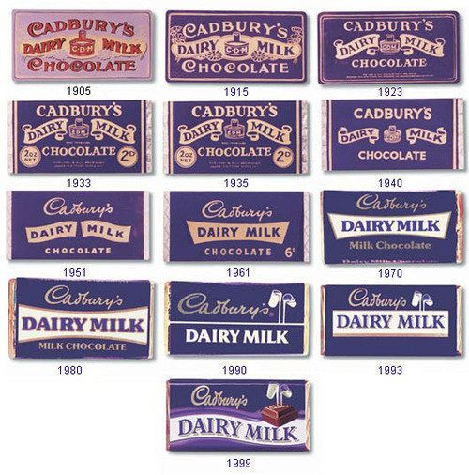  Key factual learning/CPD for staff  This driver should focus on the packaging of the product more than the product itself.  History of packaging:  Paper packaging became widespread in the UK in around the 1850s. They were originally just blank wrappings to keep the food clean. In the 1870s, companies started to use logos and branding on their paper and the packaging we see today began to form.  The oldest logo in the world is from British tea company Twinings which was first designed in 1787.  Logos are an important part of branding – children can complete a logos quiz on Kahoot to see how many they recognise. Discuss colours used- they often use only 2 or 3 and are bold and eye catching rather than intricate designs. Brands are often named after their founders’ surnames.  Brands often use the same types of colours in many of their products- Cadbury’s purple, Coca-Cola red, Barbie pink etc. Children to choose what their brand’s colour(s) will be.  In 1980 it became the law that food should have a ‘use by’ or ‘best before’ date on the packaging. (although many food products had this on already)  In 1984 packaging now had to include a list of ingredients (in order from most abundant to least), the manufacturer and storage guidance.  It was not until very recently (2016) that it became mandatory in the UK to include nutritional information on packaging of food products.  Children should have the opportunity to look at a wide range of different food packaging and come up with a list of what is included on the packaging for themselves. A full list of requirements can be found here: https://en.wikipedia.org/wiki/United_Kingdom_food_information_regulations  Packaging is produced as a net and then folded around the product. Children should look at nets for cubes and cuboids and have a go at cutting them out and folding them to aid in their understanding of how this works.  When designing their own packaging, BA can make more of an envelope/sleeve style package that will just be 2 rectangles. AA should aim for a cuboid and A could do a cube, however if time constraints do not allow, a sleeve style for everyone would work as these are most common for actual chocolate bars (see examples below).  The size of the child’s handwriting may mean they need to make a package that is far larger than the chocolate they will make- perhaps this is the packaging for a multipack of their single bar?  One lesson could be using squared paper to plan out the net for their packaging- how big do all the sides need to be? (use chocolate mould to determine) Links to maths.  Using Tinkercad to design the mold  Children should work through the free tutorial on Tinkercad:  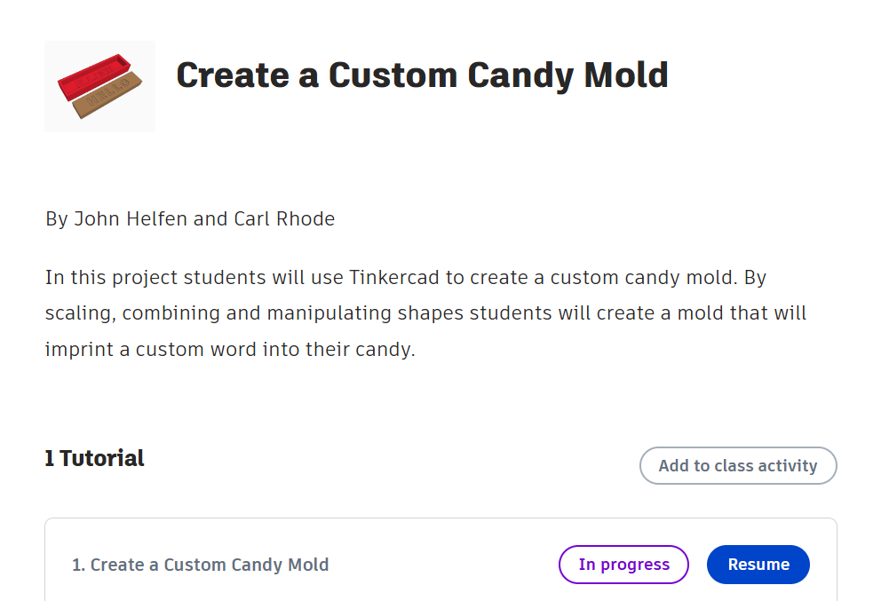  Making the actual chocolate:  Give chn a variety of chocolate bars to sample, thinking about flavours, textures, combination of these. (kit-kat, mars, twix, mint aero, orange club etc)  chn to then choose their base chocolate (white, milk, dark) and choose up to 3 additional toppings they will add to their bar. Their ingredients for their packaging will then be able to be written  toppings could include: different choc chips, broken biscuits of varying flavours, marshmallows, sprinkles, dried fruit.  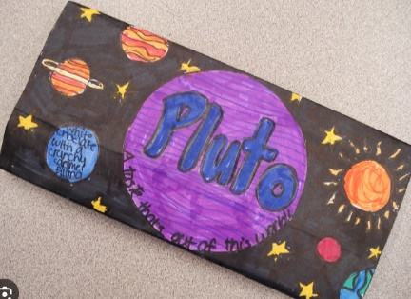  Examples of product  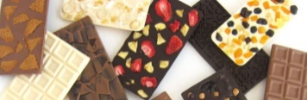  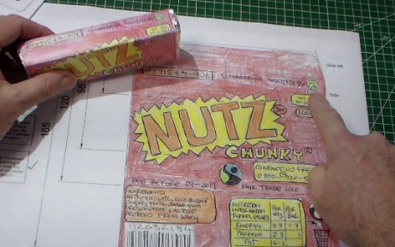  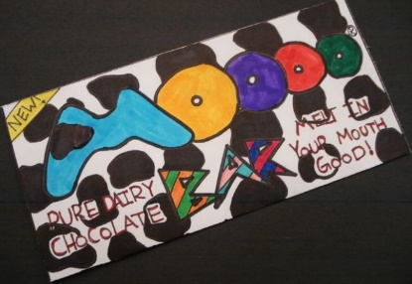  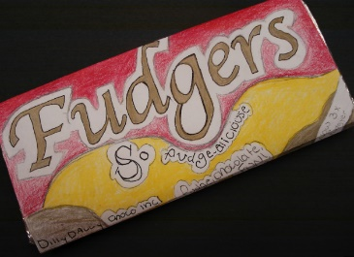 | Practical tasks:  Ideally, children should make an individual product to allow for teacher assessment.  - Design.  - design a logo for their chocolate brand – children could use their name as a basis for a brand name. this could then be made on Paint other laptop programme to be printed and stuck onto their product.  - Design mold for chocolate bar on Tinkercad  - design packaging for a chocolate product,  - refine to have a specific consumer in mind, (either chn or T to decide)  - refine to include features that must be included  - refine to include brand’s colour(s) and logo  - Make.  - Packaging net to be made from scratch for most children but a template could be provided to BA and SEND.  - Features of packaging should be clearly seen; logo, colours, ingredients, manufacture date, use by date etc  - Chocolate product itself- melt chocolate into a mould and chn can choose from a variety of toppings.  - Use 3D printer to print out chocolate mold.  - Evaluate.  Chn to think back to the design brief- ‘to make a chocolate product and packaging to appeal to a specific consumer’  Answer specific questions- Does it meet the brief? Does it follow the design? How could it be improved with the materials available? How could it be improved with unlimited materials?  Other things to consider  Some children may not be successful! This is okay and expected. Try to only give minimal support.  Resources required (suggested):  chocolate bars to cut up and try- variety of flavours and fillings  chocolate to melt into moulds -dark, milk, white  moulds (already ordered)  toppings to sprinkle onto melted chocolate e.g. different choc chips, broken biscuits of varying flavours, marshmallows, sprinkles, dried fruit
Outcome:
- An individual chocolate bar with up to 3 toppings that has been made in a customised 3D printed mold.
- An individual package for the chocolate bar including a brand logo, ingredients list and other features of packaging.

