Year 2 : Spring 2 : Design and Technology
Enquiry Question: I wonder...how I can use mechanisms to protect a castle?
Objectives:
Design purposeful, functional, appealing products for themselves and other users based on design criteria
Generate, develop and model ideas through talking, drawing, templates and mock ups
Select from a range of tools and equipment for cutting, shaping, joining and finishing
Select from a range of materials and components according to their characteristics
Explore and evaluate a range of existing products
Evaluate ideas against design criteria
Build structures exploring how they can be made stronger, stiffer and more stable
Explore and use mechanisms (levers, pulleys, sliders, wheels, axles)
Key Vocabulary:
design, make, evaluate, construct, stable, sturdy, stiff, drawbridge, pulley, lever, force, pivot, mechanism, components, suitable, criteria, purpose, function, dabble, refine
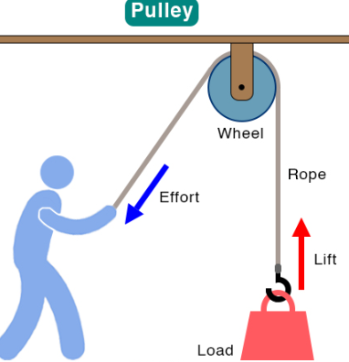  Key factual learning/CPD for staff  A pulley is a mechanism that redirects force. There is at least one wheel and rope. The most common pulley system changes down force into lift force. There is often a winch at the end you pull (a handle and another wheel that the rope winds onto)  Children should have a go at making a simple pulley as in the diagram using a bobbin and string and use it to lift objects so they understand the concept. This video explains a pulley for kids: https://www.youtube.com/watch?v=Nj4J7QNeBNk  Castles used many different types of mechanisms to operate drawbridges. This video explains many of them with lots of good diagrams: https://www.youtube.com/watch?v=ytzNCxTaNxQ  These 2 videos show drawbridges in action in real life: https://www.youtube.com/watch?v=8Ystd_V8tN4 and https://www.youtube.com/watch?v=M635ClShkqc  Historians believe the first drawbridges were actually used by the Ancient Egyptians around 4,000 years ago! However they were much more common in the European Middle Ages.  Modern uses of pulleys include: lifts (elevators), cranes, flagpoles, clothes lines, window blinds. The effects of a pulley can be easily demonstrated in a classroom by pulling down on the blinds rope and seeing the blind go up- the force has been redirected due to the pulley at the top.  Pulley specific things to consider:  - The weight of the load – you don’t want your rope to break if it is too heavy, or you may not be able to provide enough pull force. This is where a counterweight would be needed that is just slightly lighter than the load. This also works the other way- a bridge that has been cut out too small in their castle may not lower by itself and may need weights adding to it (paper clips for example).  - The size of the wheel- for our simple mechanism, the diameter of the wheel won’t affect the pulley much, other than needing to turn a smaller wheel more times to raise the drawbridge.  - Location of the turning wheel – BA children can stick to the simple pulley design and may incorporate a handle on the pulley wheel itself. AA chn may wish to have a second wheel at ground level with a handle attached which acts like a winch and would be more realistic of an actual castle.  This video shows an example that can be simplified: https://www.youtube.com/watch?v=qfz3quQD8gg  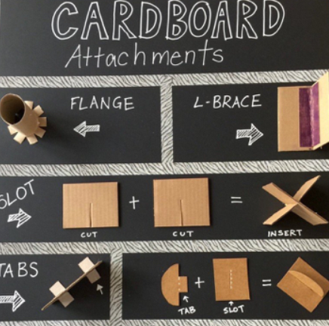  Skills to teach that may need a stand-alone lesson or part of a lesson:  - joining techniques- how will you join a toilet roll tube to a box to make a turret? Flange join is best for this. Joining methods posters in D+T folder. Chn to have a ‘dabbling phase’ to try out different joining methods and materials; pritt stick, sello tape, masking tape, PVA glue etc.  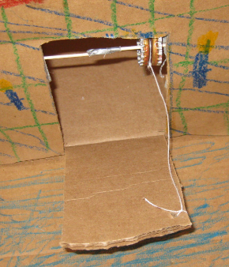  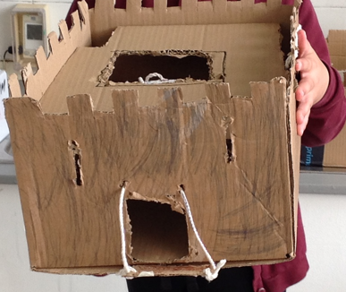  Examples of product  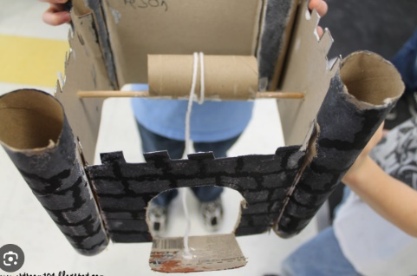  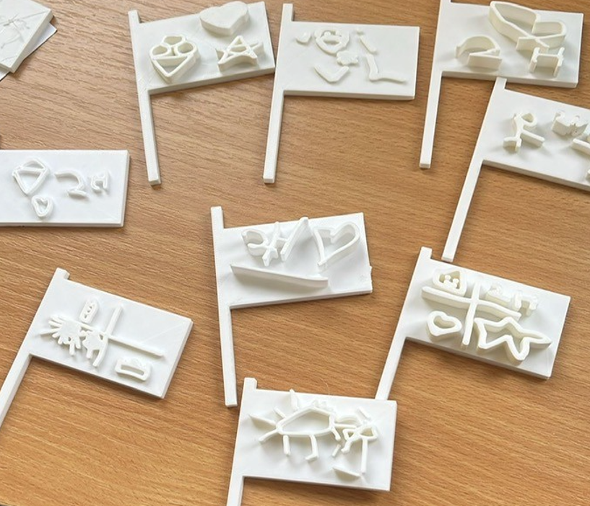 | Practical tasks:  Ideally, children should make an individual product to allow for teacher assessment.  Design.  - Lots of design challenges related to castles; how would you keep your gold safe from enemies? Give more parameters and refine the design.  - design of the castle itself- consider all aspects of castle design and features and their purpose  - design of the pulley system for the drawbridge- the purpose is to raise the bridge when enemies are attacking to stop them from entering, but lower the bridge when there is no danger.  - Lots of encouragement to adapt and refine the design considering available materials, tools and equipment  - Design a 3D flag on Tinkercad and 3D print it  Make.  - A whole day should be used to make the castles.  - All children to have one main box that they will make their castle out of- to be brought from home and collected around school.  - Ensure dabbling phases are allowed so they children can choose their own methods of joining and what components to use.  - Always link back to the purpose- a mechanism to protect a castle. The focus should be on the drawbridge mechanism- consider a whole lesson to just make this part of the castle. Minimal support should be given to ensure products are the child’s own creation.  - For the art links in this topic, printing to be used to create a brick effect on the outside of the castle or a wood effect on the drawbridge.  - Evaluate.  - Chn to think back to the design brief- ‘use a mechanism to protect a castle  - Answer specific questions- Does it meet the brief? Does it follow the design? How could it be improved with the materials available? How could it be improved with unlimited materials?  Other things to consider  Some children may not be successful! This is okay and expected. Try to only give minimal support.  Ensure that the children do not make their drawbridge too small otherwise the mechanism may not work.  As an extra challenge and linked to the art section of this driver, children could put their flag on a pulley too.  Resources required (suggested):  from home or school: boxes, cardboard, toilet roll tubes, string, glue, scissors, sharp pencil, blue tac (for making holes), lollipop sticks,  order online: wooden dowel and bobbins.  You will need to ask parents in advance for resources from home.
Outcome:
- A castle with a drawbridge that uses a pulley mechanism to open and close.
- A 3D printed flag.

