Year 2 : Summer 2 : Design and Technology
Enquiry Question: I wonder...where my food comes from and how I can prepare a range of healthy dishes
Objectives:
design purposeful, appealing products for themselves and others based on design criteria
generate, develop and model ideas through talking and drawing
select from and use a range of tools and equipment to perform practical tasks
select from a range of ingredients according to their characteristics.
explore and evaluate a range of existing products
evaluate ideas and products against design criteria
use the basic principles of a healthy diet to prepare dishes
understand where food comes from
Key Vocabulary:
recipe, hygiene, safety, ingredients, equipment, mash, cut, grate, melt, bake, measure, combine, drain, mix, spread, heat, presentation, boil, garnish, serve, drizzle, origin, design, make, evaluate, purpose, improve, healthy, consumer, slice
Key factual learning/CPD for staff  Key cooking concepts to teach:  Kitchen safety. Emphasise the importance of being safe in a kitchen and around food before any food is present or any practical work takes place. This includes hand washing, tying long hair back, staying quiet and calm, taking care when transporting ingredients and equipment, wearing a cooking apron if necessary, food storage and keeping food safe to eat.  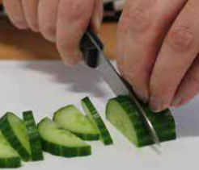  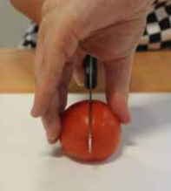  Teach cleaning up as a vital part of cooking.  The EatWell guide should be taught and referred to throughout cooking lessons.  When discussing food, always talk about where it comes from (a tree, bush, underground, an animal etc, as well as the country of origin)  Skills for the children to have a go at:  cutting- explicitly teach knife safety and the ‘bridge hold’ and ‘claw grip’ techniques.  mixing- mix a wide variety of both wet and dry ingredients to combine them together, such as hummus, fruit salad  Bridge hold (left). Claw grip (right).  spreading- use a butter knife to spread butter or other mixtures- pizza sauce  draining- use a colander or sieve to drain liquid from packaged food such as sweetcorn, tuna and chickpeas  beating- beat a pre-cracked egg with a fork or whisk (adult to crack the eggs for them)  measuring- use the digital scales to accurately measure out a pre-determined amount of ingredients, selecting an appropriate utensil to transfer the ingredient (e.g. teaspoon, table spoon, ladle)  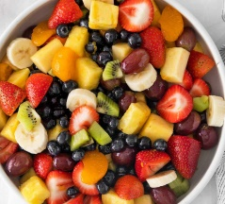  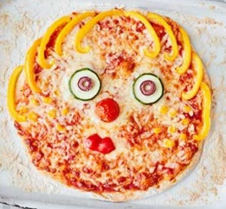  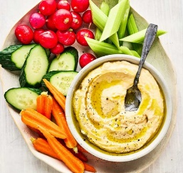  grating- cheese for pizzas  mashing- use a potato masher to mash chickpeas  kneading- dough  Skills for the children to just observe:  cooking- pizzas  Food ideas to make:  Hummus and dips (Middle East origin (Syria) although often linked to Greek food)- Children to follow a recipe to make hummus without the use of a food processor (mashing instead). Chop items to dip into the hummus such as carrots, cucumber and peppers. If feeling adventurous, you could also make pitta bread to dip into the hummus. (see separate recipe in D&T folder)  Pizzas (Italian)- MAIN COOKING ITEM. Children to make a pizza entirely from scratch including making the dough, spreading the sauce, grating the cheese and chopping or preparing any toppings. The Pizza should be designed and be for a specific consumer. (See separate recipe in D&T folder). Children should be encouraged to make healthy choices and consider the EatWell guide when designing.  Fruit salad (also known as Fruit Cocktail in USA) Worldwide food- children could choose a combination of different fruits that they will then chop using the correct techniques. They can then add a juice of their choice and mix.  These 3 items make up a healthy 3 course meal! Depending on the toppings chosen for the pizza, all three could also be vegan which can be discussed.  Ingredients to buy:  Hummus- chickpeas, tahini, garlic, olive oil, lemon juice, paprika, salt  Dipping veg- carrots, cucumber, peppers, celery  Pizza dough- yeast, flour, oil, salt, sugar. The dough can be left in the fridge overnight to rise so consider making the pizzas over 2 days!  Pizza toppings- tomato sauce, bbq sauce, tomatoes, mushrooms, peppers, onion, sweetcorn, spinach, pepperoni, chicken, tuna, low fat cheese  Fruit salad- apples, pears, bananas, oranges, grapes, strawberries, other seasonal fruits, variety of juices e.g. orange, apple, tropical | Practical tasks:  Ideally, children should make an individual product to allow for teacher assessment.  - Design.  lots of design challenges throughout as following a recipe does not allow for much creativity.  Main design for this driver is the pizza. Chn should consider their intended consumer (most likely themselves!) and what ingredients they like. Begin with a broad design- design your dream pizza. Then refine- we will only have these options, this amount of time etc. Do they want to do a pattern with the toppings or make a picture? How could it stand out in a shop? Links to packaging which is studied in year 3.  Fruit salad can also be designed- what fruit to include, what juice.  - Make.  Chn to (as independently as possible) make a 3 course meal:  1. Hummus and dip  2. Pizza  3. Fruit salad  - Evaluate.  Chn to think back to the design brief- ‘design and make a pizza for yourself’ (or other intended consumer)  Answer specific questions- Does it meet the brief? Does it follow the design? How could it be improved with the materials available? How could it be improved with unlimited materials?  Other things to consider  Some children may not be successful! This is okay and expected. Try to only give minimal support.  With cooking, it is hard to allow children to be creative as the recipe may not work but try to allow as much creativity as possible.  Always try to buy the cheapest ingredients possible from budget supermarkets to make your cooking budget spread further. You have £100 per year group for the whole driver.  Ensure you know whether children in your class have any food allergies before starting!  Some children may not like some of the food, but they should be able to explain if it is healthy or not, or if it would be a good choice.  Children should be supervised very closely when using the sharp knives.  Refer back to where food items come from regularly throughout the topic, during practical sessions as well as classroom based sessions.  Refer to the EatWell guide regularly when children are making their ingredient choices  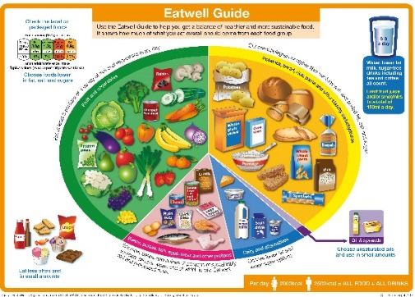
Outcome:
- Each child to have designed and made their own individual Pizza including the dough and preparation of toppings which is then evaluated comparing to the original design.
- Each child to have contributed to (if not made individually) hummus and dipping components and a fruit salad.

