Year 1 : Spring 1 : Design and Technology
Enquiry Question: I wonder...how I can help the penguin get home?
Objectives:
Design purposeful, functional, appealing products for themselves and other users based on design criteria
Generate, develop and model ideas through talking, drawing, templates and mock ups
Select from a range of tools and equipment for cutting, shaping, joining and finishing
Select from a range of materials and components according to their characteristics (waterproof)
Explore and evaluate a range of existing products
Evaluate ideas against design criteria
Key Vocabulary:
design, make, evaluate, construct, stable, sturdy, waterproof, components, suitable, criteria, purpose, function, dabble, refine, axel, wheel, mechanism, joining, hinge
Key factual learning/CPD for staff  The first boats were made in approximately 7600 BC! (almost 10,000 years ago). They were made from a hollowed out tree trunk and were very basic.  The first wheeled vehicle was made in approximately 3500 BC (closer to 5,000 years ago).  Children will have already made a 3D penguin in their art section of this driver. Some D&T objectives will have already been met in the art section- moving parts using a hinge, using and joining a range of materials and using finishing techniques.  This part of the driver will focus on designing and creating a mode of transport to help the penguin get home. Emphasis should be made on material selection and consideration of suitability and function. In science they have studied materials and should know a range of waterproof materials they could use. All children should be taught how wheels and axels work, and that they are used in every day life not just vehicles. They could explore a range of toy vehicles and study their wheels.  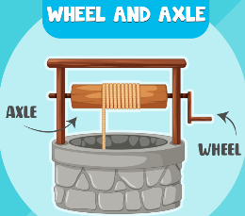  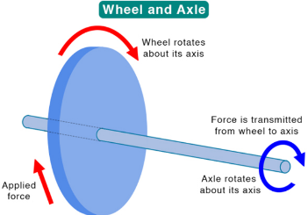  The design process should start broad- ‘design a mode of transport’ and then be refined ‘design a mode of transport for your penguin’ and refined again ‘design a mode of transport for your penguin that you could make in school’  Children could make a variety of transport; boats, cars, planes.  AA and A should be encouraged to make a vehicle with wheels and an axle.  BA/SEND could be encouraged to make a simple boat using waterproof materials.  Children should be allowed to experiment (dabble) with joining methods to see what works best. This includes different types of tape, glue, blue tack, staples etc. Once they have had a go with no input, then it is time to model a WAGOLL and demonstrate the best ways to join and the best materials to use.  Skills to teach that may need a stand-alone lesson or part of a lesson:  joining methods- see posters in D&T folder for methods of joining cardboard  Waterproof materials- this can be taught separately as part of science  Axels and wheels – this can be a lesson exploring all the things that have wheels, not just vehicles. E.g. trolley, mill, Ferris wheel, well, wheelchair. You could discuss the size of wheels and look at images and videos of penny farthings, 3 wheeled cars, unicycles, tractors and other things that have different numbers and different sized wheels.  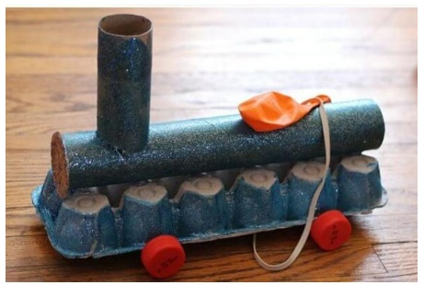  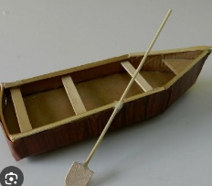  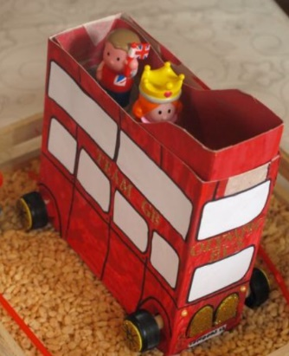  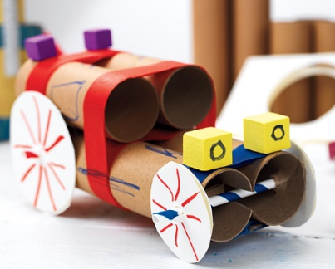  Examples/ideas of end product  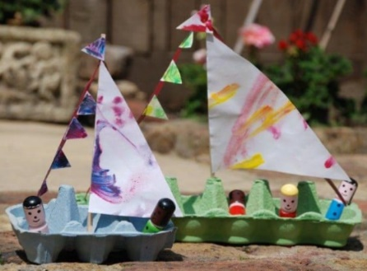  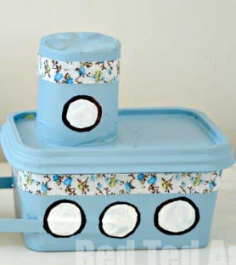 | Practical tasks:  Ideally, children should make an individual product to allow for teacher assessment.  Design.  - Lots of design challenges  - design a mode of transport to get the penguin home- start off with a broad design then discuss suitable methods. Discuss materials available in school and refine again.  - Lots of encouragement to adapt and refine the design considering available materials, tools and equipment.  - Link back to previous learning in science of waterproof materials  Make.  - A whole day could be used to make the vehicles.  - Ensure dabbling phases are allowed so they children can choose their own methods of joining and what components to use.  - Evaluate.  - Chn to think back to the design brief- ‘design a mode of transport to get their penguin home’  - Answer specific questions- Does it meet the brief? Does it follow the design? How could it be improved with the materials available? How could it be improved with unlimited materials?  Other things to consider  Some children may not be successful! This is okay and expected. Try to only give minimal support.  It may be difficult for chn to fully waterproof their design, however if it is mostly waterproof this can be considered a success.  Resources required (suggested):  from home or school: boxes, cardboard, toilet roll tubes, string, glue, scissors, tape, egg boxes, yoghurt pots, butter containers, bottle tops, art straws, toy vehicles to explore  to buy: cling film, foil, other tape such as duct tape, other waterproof fabric/material, wheels (cardboard, plastic, bobbins), Wooden dowelling to use for axels  You will need to ask parents/staff in advance for resources from home.
Outcome:
- A mode of transport for a penguin to get home

