Year 1 : Spring 1 : Design and Technology
Enquiry Question: I wonder...what skills do I need to have to design and make an Afternoon Tea?
Objectives:
design purposeful, appealing products for themselves and others based on design criteria
generate, develop and model ideas through talking and drawing
select from and use a range of tools and equipment to perform practical tasks
select from a range of ingredients according to their characteristics.
explore and evaluate a range of existing products
evaluate ideas and products against design criteria
use the basic principles of a healthy diet to prepare dishes
understand where food comes from
Key Vocabulary:
recipe, hygiene, safety, ingredients, equipment, mash, cut, grate, melt, bake, measure, combine, drain, mix, spread, heat, presentation, boil, garnish, serve, drizzle, origin, deign, make, evaluate, purpose, improve, healthy, bain-marie, consumer
Key factual learning/CPD for staff  Afternoon Tea  The concept of an ‘Afternoon Tea’ was introduced in England by Anna, the 7th Duchess of Bedford in 1840. She was hungry at 4pm but the evening meal wasn’t until 8pm. It then became an upper class tradition to have a pot of tea and a light snack in the mid-afternoon. These days, it is seen as a luxurious treat as originally it was only for the rich and wealthy – the rest of the country were still working! A modern ‘Afternoon Tea’ consists of a variety of finger sandwiches, often with ‘fancy’ fillings, and individually served cakes, usually including a scone with cream and jam, all presented on a tiered cake stand with a pot of English Breakfast tea and a jug of milk.  Key cooking concepts to teach:  Kitchen safety. Emphasise the importance of being safe in a kitchen and around food before any food is present or any practical work takes place. This includes hand washing, tying long hair back, staying quiet and calm, taking care when transporting ingredients and equipment, wearing a cooking apron if necessary, food storage and keeping food safe to eat.  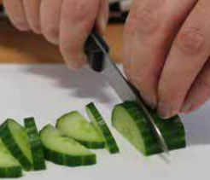  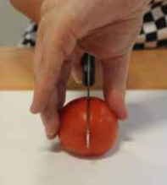  Teach cleaning up as a vital part of cooking.  The EatWell guide should be taught and referred to throughout cooking lessons.  When discussing food, always talk about where it comes from (a tree, bush, underground, an animal etc, as well as the country of origin)  Skills for the children to have a go at:  cutting- explicitly teach knife safety and the ‘bridge hold’ and ‘claw grip’ techniques.  mashing – use a fork to mash soft foods such as egg mayo  Bridge hold (left). Claw grip (right).  mixing- mix a wide variety of both wet and dry ingredients to combine them together, such as cake batter, tuna and mayo  spreading- use a butter knife to spread butter or other mixtures  draining- use a colander or sieve to drain liquid from packaged food such as sweetcorn and tuna  beating- beat a pre-cracked egg with a fork or whisk (adult to crack the eggs for them)  measuring- use the digital scales to accurately measure out a pre-determined amount of ingredients, selecting an appropriate utensil to transfer the ingredient (e.g. teaspoon, table spoon, ladle)  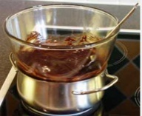  Skills for the children to just observe:  grating- cheese and carrot  boiling- eggs  baking- cake mixture  melting- chocolate on a bain-marie (chocolate in a bowl over another bowl of warm water- image above).  Children should be allowed to sample a wide variety of different sandwiches and cakes to see what flavours go well together and what they like. Pre-made sandwiches and cakes could be bought from the supermarket and chopped into small pieces for them to sample. Consider getting some with ingredients they may have not tried before.  They could follow instructions on how to make a specific sandwich in order to gain the skills. But should be able to design their own sandwich from a selection of fillings.  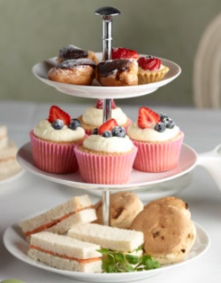  Food ideas to make:  Sandwiches with a variety of bread and fillings to choose from (ham, cheese, tuna, lettuce, cress, baby spinach, tomato, chicken, butter, mayo)  Traybake style cake that they could add their own choice of topping to their segment (berries, sprinkles, choc chips, cinnamon, icing)  Eton mess with a variety of different fruit to add (strawberry, raspberry, banana, apple, pear, orange)  Scones with a variety of fillings and toppings (sultanas, dried fruit, different flavour jam, cream, lemon curd) | Practical tasks:  Ideally, children should make an individual product to allow for teacher assessment.  - Design.  lots of design challenges throughout  design a sandwich for a specific consumer (themselves) with healthy eating in mind  design an afternoon tea for a specific consumer (their family)- thinking about what people in their house like to eat and what flavours will go well together  - Make.  Each child to make their own individual sandwich following their design  Each child to contribute to a group making at least one of the sweet treats, if not more.  - Evaluate.  Chn to think back to the design brief- ‘design and make an afternoon tea for your family’  Answer specific questions- Does it meet the brief? Does it follow the design? How could it be improved with the materials available? How could it be improved with unlimited materials?  Other things to consider  Some children may not be successful! This is okay and expected. Try to only give minimal support.  With cooking, it is hard to allow children to be creative as the recipe may not work but try to allow as much creativity as possible.  Always try to buy the cheapest ingredients possible from budget supermarkets to make your cooking budget spread further. You have £100 per year group for the whole driver.  Ensure you know whether children in your class have any food allergies before starting!  Some children may not like the healthy elements of the sandwich (or other fillings) but they should be able to explain which ingredients are healthier than others.  Children could sample a cup of tea- ensure that it is not too hot!  Children should be supervised very closely when using the sharp knives.  Refer back to where food items come from regularly throughout the topic, during practical sessions as well as classroom based sessions.  Refer to the EatWell guide regularly when children are making their ingredient choices, especially the sandwich  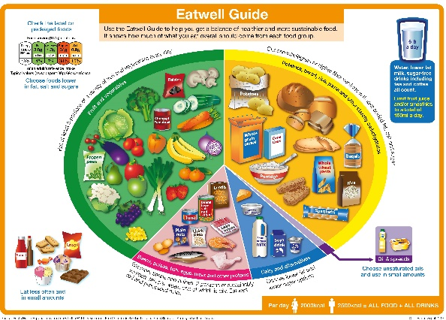
Outcome:
- Each child to have made an individual sandwich and to contribute to a group making at least 1 type of cake/ sweet treat.
- To take home an Afternoon Tea to share with their family

