Year 3
Enquiry Questions: 2.1 What difference does it make to be a Christian? 3.2 How do religious practices and communities practice their faith? 3.3 Where, how and why do people worship? 3.4 What can we learn from inspiring people in sacred texts and in the history of religions?
Key Religions studied: Christianity and Islam
Objectives:
- To learn about the Bible stories that lie behind key Christian celebrations.
- To develop personal ideas about the creation of humanity based on religion and science.
- To learn about the practice of Muslim prayer.
- To learn about the practice of Christian prayer.
- To explore the features of a mosque, mandir and church
- To connect features of religious buildings to beliefs.
- To explore the lives of key religious people in Christian, Jewish and Muslim stories.
- To connect the idea of inspirational leaders to the stories learned.
Christianity Key Vocabulary: religion, Christian, spiritual, Jesus, symbol, God, Bible, Pentecost, commitment, values, Harvest, liturgy, trinity, Exodus, Mesiah, New Testament | Islam Key Vocabulary: Muslim, Islam, mosque, Qur’an, Prophet, ritual, prayer, Allah
Key factual learning/CPD for staff (Christianity)  Pentecost As the second most important festival in the Christian year, Pentecost is often seen as the ‘birthday’ of the Church, since this is when the disciples of Jesus first proclaimed the Gospel after receiving the gift of the Holy Spirit. It is named after the Jewish festival (Shavuot) on which this event happened, which is celebrated 50 days after Passover. The name comes from the Greek pentekoste, “fiftieth”. Pentecost for Christians accordingly falls on the Sunday 50 days after Easter. The alternative name of Whitsuntide comes from the custom of converts presenting themselves for baptism on this day dressed in white. Clergy in church often wear robes with red in their design as a symbol of the flames in which the Bible says the Holy Spirit came to the early disciples. The symbols of Pentecost are those of the Holy Spirit and include the dove, the wind, the breath of God and flames. The Acts of the Apostles tells how the followers of Jesus found themselves speaking in foreign languages, inspired by the Holy Spirit. People passing by at first thought that they must be drunk, but the apostle Peter told the crowd that he and the other apostles were full of the Holy Spirit. Pentecost is a special day for all Christian communities, but it is emphasised particularly by Pentecostal churches, which preach that the Holy Spirit is available to believers during all of their services. The central Christian belief that God is three in one – Father, Son and Holy Spirit – is at the heart of Christian teaching about the nature of God and is central to preaching and teaching both at this time and on the following Sunday, Trinity Sunday. It is the belief in the divinity of Christ and the reality of the Holy Spirit which separates orthodox Christian faith from other monotheistic religions.  Incarnation The incarnation is the Christian belief that God took human form by becoming Jesus. Incarnation literally means ‘to take on flesh’. For Christians, the incarnation shows that Jesus was fully God and fully human. It is an essential part of belief in the Trinity, and in many ways it forms the basis of Christianity.  The ‘fruit of the spirit’ (Galatians 5:22) Christians generally believe that they cannot live in the way Jesus commands by their own efforts,because human beings are sinful and always tend to put themselves first.But the Bible says that if they allow God into their lives, they may grow the ‘Fruit of the Spirit’, and their character may gradually grow more loving, joyful, peaceful, and so on. This is not an easy process, and Christians may say that they fail many times, ask forgiveness, and continue to try to live ‘according to the Spirit’.  The church and its role in the teachings of Jesus: Each church must commit to teach and preach the Bible, each church must commit to equip their people to serve in the church, each church must commit to fulfilling the great commission to make disciples and each church must commit to helping people apply God’s word to their daily lives.  Creation and Science There are many interpretations of the biblical accounts of creation among Christians today.  Many believe that God brought the universe into being from nothing. This is sometimes referred to as ex nihilo. Some believe that it was created from matter that already existed. This is sometimes referred to as ex materia.  Some Christians take the biblical accounts of creation literally, believing that they describe exactly how the universe and human beings were created.  Other Christians regard these accounts as more like parables or symbolic accounts that tell, in story form, the profound truth that God brought the universe and all that is in it into being, and sustains his creation. These Christians might look to science to help them understand how God did this.  Cosmology is the study of the universe, and humanity's place in it.  One of the theories put forward by cosmologists is the Big-Bang theory. This suggests that about 15 billion years ago there was a massive explosion. This was the point at which all matter in the universe began. Space and time began then too. Over time, the universe that we know, and human and animal life, emerged.  This theory is generally accepted by scientists as being the best theory they have to explain the origins of the universe. If the Big-Bang theory is true, then it could mean that the universe 'just happened' and that it did not emerge as a result of the activity of a creator God. Many Christians have no problem in accepting the Big-Bang theory. They see the cosmologists helping them to understand how God brought the world into being - the Big Bang could have been the mechanism God used. And there is nothing in the theory itself which proves that there is no such being as God.  Christian prayer Christians believe that God is all-knowing, as well as always being present and all-powerful. So if God knows and sees it all why pray? Knowing that God already knows is a great place to start because you don't have to explain or put on a show for God; He is there for someone just as they are. Christians believe that prayer changes them and that it is about listening as well as talking. They also believe that God has given people free will, but that God loves people and wants to be involved in their lives. By inviting God into their lives, Christians believe He can support people through struggles, comfort people with His presence and bless their lives. Christians believe that God should be involved in every aspect of life and celebrates with people in their joys and draws close to them in their sadnesses. Christians also believe that they are family together. When they pray they are joining with many others around the world who are doing the same. WHAT HAPPENS WHEN CHRISTIANS PRAY?  Christians believe that as they spend time with God, they grow in love more. That helps them to understand God's will better and creates a greater awareness of what is going on and situations and people they should care about. Christians believe that it's important to be thankful when they pray and to have an attitude of thankfulness, remembering all the good things in their lives and in the world. Christians believe that it's still important to be thankful even when things are difficult. Sometimes Christians find it helpful to praise God in prayer; it reminds them of how powerful He is and how they need to trust Him. Praying is an act of faith and believing that God can change a situation is an important reason Christians talk directly to God.  The Lord’s Prayer is the prayer that Jesus taught his disciples when they asked him how to pray.  Churches and chapels have many different internal features, which are designed to help people worship. The features and layout of different denominations can differ somewhat.  Catholic churches  Catholic churches are traditionally built in the shape of a cross with the top of the cross facing Jerusalem.  The east end of the church is called the sanctuary and contains:  the altar – a table where the bread and wine are blessed during the Eucharist  the lectern – a stand where the Bible is read frm  the pulpit – where the priest delivers sermons  a crucifix – a cross with Jesus on  There is a rail which acts to separate the sanctuary from the place where the congregations sits, known as the nave. In the nave there are often rows of pews where the congregation sit in rows on benches.  Around the church there are 14 framed pictures, known as the Stations of the Cross, which show the events of Jesus’ crucifixion.  Other features that can be found in the Catholic Church include:  a font – a large stone bowl containing holy water used to baptise babies  a stoup – usually a small basin containing holy water, which Catholics dip their hand in to make the sign of the cross to renew their baptism promises  statues of religious figures, e.g. Christ, Mary or saints  stained glass windows – often depicting biblical stories or religious teachings  candles – often lit by Catholics when they are praying  an organ to be played during hymn singing  a confessional – a small enclosed cupboard or cabinet, where Catholics can confess their sins to the priest  Anglican churches  The inside of Anglican churches can be similar in appearance to Catholic churches. Anglican churches are also often in the shape of a cross, with a sanctuary at the east end.  Anglican churches are often a lot plainer than Catholic churches, and have fewer statues and candles.  An Anglican church will usually have a simple cross displayed rather than a crucifix. Although there may be a font, there won't be a stoup containing holy water.  Esther (Jewish and Christian Bible) Read the story of Esther in Esther 2:19-23, Esther 3:8-14, Esther 8:15 17 and point out that she was a queen, a leader of her time. She saved Mordecai from Haman. It was risky but she did it to get justice for her people. Ask pupils such questions as:  - What do you think being a Queen would have involved in her situation?  - What qualities were needed for her role?  - What qualities do female leaders need to have today? Do you think female leaders today need to have different qualities to male leaders? Why / Why not?  - What do you think you would you have done in Esther’s situation?  Provide small groups of pupils with information sheets about women who changed the world  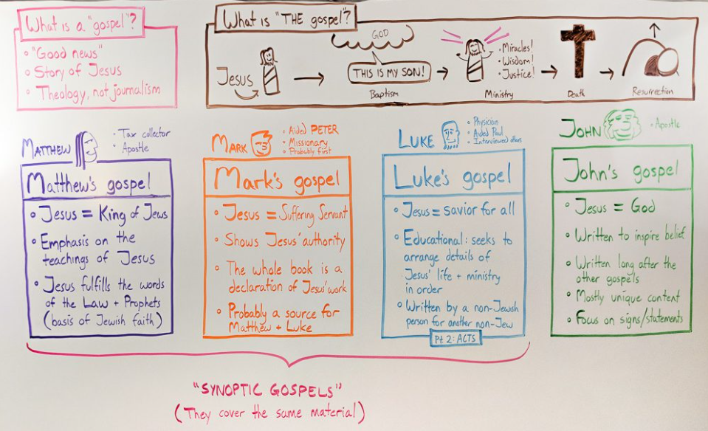  The four gospels  Christmas celebration day: Why is Mary such an important part of the story?  Easter celebration day: How are the events of Easter remembered by Christians? | Key factual learning/CPD for staff (Islam)  Islamic prayers -The Holy Qur’an teaches that Muslims should pray five times a day (Salat) at certain time, roughly dawn, midday, late afternoon, sunset and between sunset and midnight. It is a time to remind themselves of their willing submission to Allah and to remind themselves of unity with their sisters and brothers in Islam. Prayer involves ritual movements which include standing up, kneeling down and bowing the head towards the floor. Prayer can be done anywhere but it is good to be done in the Mosque. Men and women pray separately to avoid distraction. They stand shoulder to shoulder on a level floor to remind them that they are all equal to Allah. They face the same way towards Makkah, Saudi Arabia, which is the site of the Ka’aba (cube), the holiest site for Muslims. They use prayer mats, often with the images of Ka’aba on and sometimes a compass. Muslims never attempt to depict any representation or image of Allah as well as their prophets or companions.  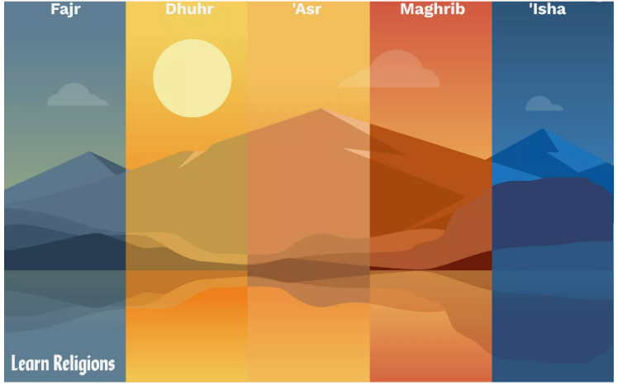  - Fajr: This prayer starts the day with the remembrance of God; it is performed before sunrise.  - Dhuhr: After the day's work has begun, one breaks shortly after noon to again remember God and seek His guidance.  - 'Asr: In the late afternoon, people take a few minutes to remember God and the greater meaning of their lives.  - Maghrib: Just after the sun goes down, Muslims remember God again as the day begins to come to a close.  - 'Isha: Before retiring for the night, Muslims again take the time to remember God's presence, guidance, mercy, and forgiveness.  Prayer is one of Islam's Five Pillars, the guiding tenets that all observant Muslims must follow:  - Hajj: Pilgrimage to Mecca, Islam's most holy site, that all Muslims must make at least once in their lifetime.  - Sawm: Ritual fasting observed during Ramadan.  - Shahadah: Reciting the Islamic profession of faith, called the Kalimah ("There is no God but Allah, and Muhammad is his messenger").  - Salat: Daily prayers, properly observed.  - Zakat: Giving to charity and aiding the poor.  Muslims demonstrate their faithfulness by actively honoring the Five Pillars of Islam in their everyday lives. Daily prayer is the most visible means of doing so.  Mosques The word ‘mosque’ means 'place of prostration'. Generally, a mosque is any place where a Muslim prays and worships Allah. Prostration shows the dedication of one’s life to Allah and the features of a mosque reinforce this submission to him.  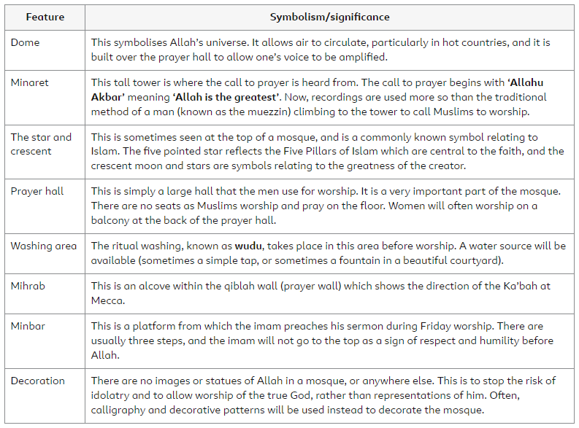  Prophet Muhammad - Before the dawn of Islam, Prophet Muhammad (pbuh) was someone who attracted many people towards him. He was known as the trustworthy (al-aman) and to be very truthful (sadiq). Prior to the announcement of Islam and his Prophethood, there is a famous story about a Christian monk who saw the sign of prophecy in him and informed his uncle that he must look after him as he was destined for greatness. The migration (hijrah) from Makkah to al-Madinah is another notable event in the history of Islam as well as the night of ascension (mi’raj) where the Qur’an states that he was taken up to the heavens and travelled on a mystical and spiritual journey. There are many more stories about the Prophet and his mission in his biography (sarah). There are numerous stories about the way in which the Prophet interacted with people prior to and after the birth of Islam. He treated all people equally, male or female, prince or pauper, black or white, rich or poor. He never discriminated against anyone and everything he did was for the sake of God and for His pleasure. The Prophet Muhammad (pbuh) is the best example of spiritual and moral values. The Qur’an states: ‘Indeed you have in the Messenger of Allah an excellent exemplar (of moral conduct) for he whose hope is in Allah and the Final Day and who (frequently) engages in the remembrance of Allah’ (Surah 33:21). God tells Muslims that Prophet Muhammad (pbuh) is the most perfect example of moral conduct and who possesses sublime ethics. He is seen as the epitome of perfection in morals, conduct and in his very being as a human, he is the manifestation of the Beautiful Names of God on earth. According to some Muslims, Imam Khomeini is an example of someone who in modern times showed something similar to the Prophet Muhammad (pbuh) as he was a charismatic leader. His teaching and humble way of life influenced and attracted hundreds of thousands of Muslims to re-evaluate their Islam in this day and age. Although the Prophet Muhammad (pbuh) passed away more than 14 centuries ago, his teachings are still leading Muslims today. Islam is a universal religion that caters for all people of all times. Muslims believe that the Qur’an is the eternal word of God and therefore Islam and its teaching are able to accommodate any society and any people, it should be adapted to cater for the society in which someone lives. For all Muslims, Prophet Muhammad (pbuh) is the very person who gives a meaning to their lives, it is he who sets the standards of human behaviour and it is he whose message is the very key to salvation in this temporal world and the eternal next.  P  • The Holy Qur’an teaches that Muslims should pray five times a day  at certain times (roughly: dawn, midday, late afternoon, sunset and  between sunset and midnight).  • It is a time to remind themselves of their willing submission to Allah,  take time out of the busy day to focus on what really matters, and  remind themselves of unity with their sisters and brothers in Islam –  the ‘Ummah’, or ‘community’.  • Prayer involves ritual movements, which include standing up, kneeling  down and bowing foreheads to the floor.  • Muslims pray anywhere, but it’s good for them to pray together in  the mosque.  • When they pray, men and women pray separately (to avoid  distraction). Muslims will stand shoulder-to-shoulder, on a level floor,  to remind them
Hinduism Key Vocabulary:
Hindu, mandir, gods and goddesses, sacred
Mandir - A Hindu temple is called a mandir. It is a sacred place for Hindu worship. There are hundreds of mandirs in the UK. In India, where most Hindus live, there are temples in almost every village. Temples often honour the gods and goddesses whose murtis live inside them with beautiful decoration, sculpture and lighting. Hindu worship can also happen in open-air shrines, which are more common in India than in the UK.  Historically in India, mandirs were devoted to only one Hindu god or goddess. Vaishnavite temples housed a central image of Vishnu and murtis of associated gods and goddesses, such as Rama, Sita or Krishna. Shaivite temples housed images of Shiva and murtis of the goddesses associated with Shiva, including Parvati, Shakti, Durga and Kali.  In India, where there are many Hindus, it is often still the case that mandirs are devoted to only one god or goddess. However, in the UK, many mandirs include lots of different shrines to all the gods and goddesses worshipped in the local community.  When they enter a mandir, a Hindu worshipper typically removes their shoes as a sign of respect and cleanliness in the house of the deities. The worshipper then enters the shrine room and rings a bell at the shrine of one of the gods or goddesses. This is a symbol of awakening the deity but it also acts to focus the worshipper’s mind. They may then walk around the shrine while singing, chanting or praying. They may also present an offering, such as fruit, milk or money.  The purpose of worship in the mandir is to ‘have darshan’ of (or see) the gods and goddesses. Worship enables the devotee to clearly see – and be seen by – the divine. Prayers and hymns (such as bhajans) help the devotee to experience the divine presence. Hindu teaching says that worship comes from human hearts and minds, and is expressed in actions.  The daily services of the mandir usually include morning and evening arati ceremonies led by a Brahmin priest. The priest’s role is to look after the murtis of the gods and goddesses in the temple by washing them and clothing them each day. The priest also feeds the gods by placing blessed food, called prashad at their feet. This food is then shared out with worshippers in the temple or given to people in need.  Moses Pupils will have learned about the story of Moses in Y2. Look at his life in further detail, this time describing the challenges he faced and his values and commitments. | Practical tasks:  Retell and sequence Christian and Islamic stories through drama/writing/art  Visit to a local church – what does the church do to support Christians in their way of life?  Investigate the meaning of Muslim and Christian prayers and how/where/why they pray  Visit a mosque/visitor/video  Identify features of religious buildings  Design a religious building  Investigate an inspirational religious leader  Write a person specification for a female Queen leader today (based on the story of Esther)  Science vs religion debate about creation (oracy)
Outcome:
- Connect Christian celebrations to Bible texts and belief about God
- Understand the significance of Muslim and Christian prayer
- Describe the key features of a church, mosque and mandir connecting these to the religious beliefs expressed.
- To relate the idea of inspirational leaders to the stories learned.

