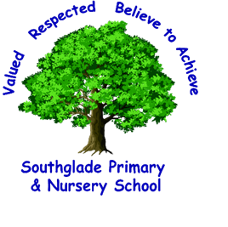 Valued, Respected. Believe to achieve! Y2 reading

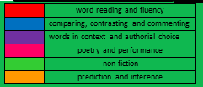
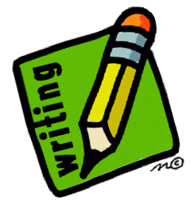
Greater Depth
In a book they are reading, independently
- make inferences
- make a plausible prediction about what might happen on the basis of what has been read so far
- make links between the book they are reading and others they have read

word reading and fluency
comparing, contrasting and commenting
words in context and authorial choice
poetry and performance
non-fiction
prediction and inference

I can make inference, answer questions and make predictions on the basis of what has been read so far in the text.
Statements in grey are expected standard in reading in Year 2
I can recognise that non-fiction books are often structured in a different way.

I can discuss and clarify the meanings of words, linking new meanings to known vocabulary.

I can continue to build up a repertoire of poems learnt by heart.

I can participate in discussions about books that I have read and have been read to me.

I can discuss the sequence of events in books.

I can explain my understanding of texts and express my views.

I can read most words containing common suffixes.
I can reread books to build up confidence in word reading and fluency.

I am becoming increasingly familiar with a range of stories, which I am able to retell.
I can recognise recurring language and answer questions about a text I am familiar with.
I can sound out most unfamiliar words accurately, without undue hesitation
Check my reading makes sense and correct inaccurate reading
I can continue to apply phonic knowledge to decode words until automatic decoding has become imbedded and reading is fluent.

I can read accurately by blending the sounds in words that contain graphemes I have been taught.
I can read most words of two or more syllables.
I can read words with contractions
You should be able to show a knowledge of a range of texts and enjoy both reading and being read to with an increasing familiarity of some well-known poems and stories. You should be able to use your phonic skills in order to read fluently and begin to make inferences and predictions about what you have read. 2022/2023

I can read most year 2 common exception words.

