Valued, Respected. Believe to achieve! Y1 Reading

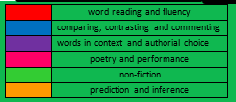
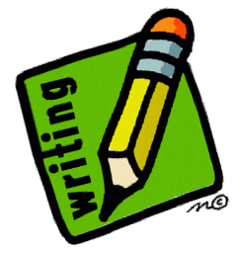
Statements in the yellow boxes are working towards statements for Year 2 reading exemplification overview
word reading and fluency
comparing, contrasting and commenting
words in context and authorial choice
poetry and performance
non-fiction
prediction and inference

I can begin to make some simple inferences and predict what might happen on the basis of what I have read so far.
I can join in with discussions about a text, taking turns and listening to others.

I can recite simple poems by heart.
I can listen to and discuss a wide range of texts at a level beyond my own independent reading.

I can link what I have read, or what has been read to me, to my own experiences.

I can retell familiar stories in increasing detail.

I can blend sounds in unfamiliar words using the GPCs that I have been taught.
I can read year 1 common exception words.

I can accurately read and then reread texts that are consistent with my developing phonic knowledge.
I can check that a text makes sense to me as I read it and self-correct.

I can apply phonic knowledge and skills as the route to decode words.

I can respond quickly, giving the correct sound to graphemes for all of the 40+ phonemes.
Early Learning Goals 2022/2023
Comprehension
- Demonstrate understanding of what has been read to them by retelling stories and narratives using their own words and recently introduced vocabulary
- Anticipate (where appropriate) key events in stories
- Use and understand recently introduced vocabulary during discussions about stories, non-fiction, rhymes and poems and during role play

Word Reading
- Say a sound for each letter in the alphabet and at least 10 digraphs
- Read words consistent with their phonics knowledge by sound blending
- Read aloud simple sentences and books that are consistent with their phonic knowledge, including some common exception words.
I can read words containing -s, -es, -ing, -ed and –est endings.

