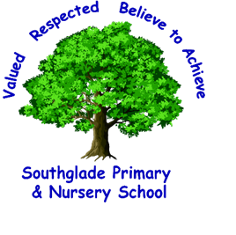 Valued, Respected. Believe to achieve!

+
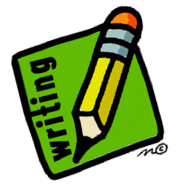
word reading and fluency
comparing, contrasting and commenting
words in context and authorial choice
poetry and performance
non-fiction
prediction and inference

I can use knowledge of texts and organisation devices to retrieve, record and discuss information from fiction and non-fiction texts.
I can make predictions based on details stated and implied, justifying them with evidence from the text.

I can draw inferences from characters’ feelings, thoughts and motives.

I can understand the meaning of words based on their context.

I can discuss the vocabulary used by the author to create effect.

I can evaluate the use of the authors’ language and explain its impact on the reader.

I can continually show an awareness of audience when reading out loud, using intonation, tone and volume.

I can read a wide range of genres, identifying and comparing the characteristics of each text type.
I can identify the main ideas in more than one paragraph.
I can summarise ideas from more than one paragraph.

I can recommend texts to my peers based on personal choice.

I can read most words fluently and attempt to decode with speed and accuracy.
I can read most year 5/6 exception words.

E - You should be able to read aloud with increasing fluency and confidence. You should be reading a range of age appropriate texts in and out of school. You should be able to answer questions accurately to demonstrate that you have understood the meaning of what you have read, discussing inferences and predictions with evidence to support your answers. 2021/22

I can participate in discussions about books, building on my own and others’ ideas.

