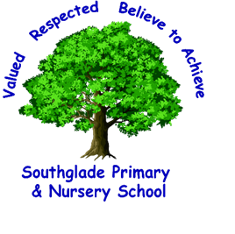 Valued, Respected. Believe to achieve!

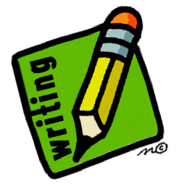
word reading and fluency
comparing, contrasting and commenting
words in context and authorial choice
poetry and performance
non-fiction
prediction and inference

I can analyse and evaluate the use of language, including figurative language and how it is used for effect.
I can consider different accounts of the same event and discuss viewpoints of authors and of fictional characters.

I can discuss how characters change and develop through texts by drawing inferences based on indirect clues.
I can retrieve, record and present information from non-fiction texts.

I use non-fiction materials for purposeful information retrieval, for example reading in History and Geography.

I can distinguish independently between statements of fact and opinion.

I can compare characters, settings and themes within a text and across more than one text.
I can confidently perform texts using a wide range of devices to engage the audience.

I read for pleasure, discussing, comparing and evaluating in depth across a wide range of genres.
I can explain and discuss my understanding of what I have read, including through formal presentations and debates.
I can draw out key information and summarise the main ideas in a text.

I can provide reasoned justification for my views.

I can decode unfamiliar words with increasing speed and skill.
I can read fluently with a knowledge of all year 5/6 exception words.

F - You should be able to display a positive attitude to reading and show an understanding of what you have read with the confidence to justify your answers using evidence from a range of texts. You should be able to read texts fluently, showing an evaluation of how authors use a variety of language choices and how this can impact the reader. 2021/22

I can recognise more complex themes in what I have read such as loss or heroism.

