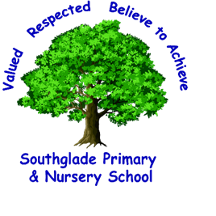Valued, Respected. Believe to achieve!

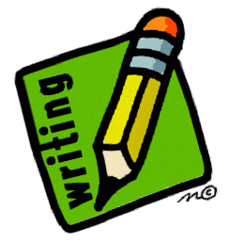
word reading and fluency
comparing, contrasting and commenting
words in context and authorial choice
poetry and performance
non-fiction
prediction and inference

I can ask and answer questions appropriately, including some simple inference questions based on characters’ feelings, thoughts and motives.
I can justify my predictions using evidence from the text.

I can retrieve and record some information from non-fiction texts.

I can prepare and perform poems and play scripts showing some awareness of the audience.

I am beginning to use appropriate intonation and volume when reading aloud.

I can discuss the authors’ choice of words and phrases for effect.

.

I can recognise, listen to and discuss a wide range of genres.
I can use appropriate terminology when discussing texts including plot, characters and setting.

I can check that a text makes sense to me and discuss my understanding.

I can explain the meaning of words in context.

I can use my phonic knowledge to decode quickly and accurately.

I can apply my growing knowledge of root words, prefixes and suffixes.
I can begin to read the year 3/4 exception words.

C - You should be able to read age appropriate books accurately and at a speed that is sufficient for you to understand what you have read. You should be able to demonstrate that you are a fluent, independent and enthusiastic reader who reads widely and frequently. You should also be able to show that you are beginning to respond to questions about a text with confidence. 2021/22

