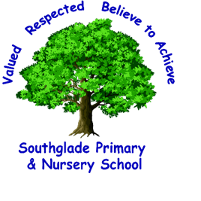 Valued, Respected. Believe to achieve!

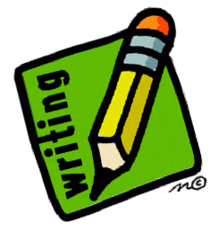
word reading and fluency
comparing, contrasting and commenting
words in context and authorial choice
poetry and performance
non-fiction
prediction and inference

I can begin to justify my responses with evidence from the text.
I can draw inferences from characters’ feelings, thoughts and motives.

I can justify predictions that I have made from details stated or implied.

I can use the organisational devices of a non- fiction text to retrieve, record and discuss information.

I can use a dictionary to check the meaning of words I have read.

I can discuss vocabulary used to capture the readers’ interest and imagination.

I can prepare and perform poetry and play scripts showing an awareness of the audience.
I can recognise and discuss some different forms of poetry such as free verse or narrative poetry.

I can discuss and compare texts from a wide variety of genres and authors.
I can identify themes and conventions in a wide range of books.
I can refer to the authorial style, themes and features in a range of texts.

I can identify main ideas drawn from more than one paragraph and summarise these.

I can read most words fluently and attempt to decode unfamiliar words with speed.
I can apply my knowledge of root words, prefixes and suffixes to read fluently.
I can read all year 3/4 exception words.

D - You should be able to read books at an age appropriate level and be an independent, fluent and enthusiastic reader. You should be able to read stories, poetry, plays and non-fiction with interest. You should be developing your knowledge and skills in reading non-fiction while learning to justify your views about what you have read across all genres. 2021/22

I can identify how language, structure and presentation contribute to meaning.

