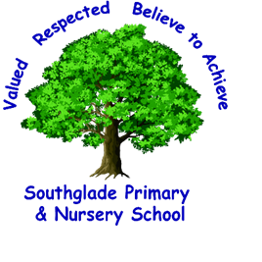 Valued, Respected. Believe to achieve!

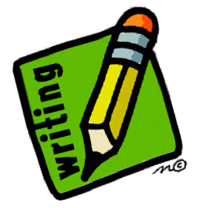
The highlighted objectives provide a guide as to what should be included in Secure writing.
I can use inverted commas mostly correctly including correct punctuation of dialogue in a narrative.

I can write in the appropriate form for audience and purpose and organise my ideas into paragraphs.

I can maintain legibility, fluency and speed with my handwriting.

I can use expanded noun phrases to add detail, clarity and precision.

I can use inverted commas, commas for clarity and brackets, dashes and commas for parenthesis, mostly correctly.

I can use commas for clarity.

I can try to use semi-colons and colons in a list and dashes, colons and semi colons to separate clauses.

I can use multi-clause sentences.
I can make some use of hyphens in my independent writing.

I can use a range of cohesive devices including pronouns, conjunctions and synonyms.

I can use relative clauses within my sentences starting with who, which, where, when, whose and that.

I can use prepositional phrases to add detail, qualification and precision.

I can use adverbial phrases to add detail and use to link between sentences and paragraphs with precision.

I can use the active and passive voice.

I can use the correct tense consistently.
I can select vocabulary and sentence structures that match the formality of the text type.

I can use modal verbs.

F. You should already be able:
To make writing match an audience and purpose. To use dialogue to move a narrative forward.
To use organisational and presentational devices for non-fiction texts. To use the correct level of formality in writing.
To use paragraphs to organise ideas. To attempt adverbials between sentences and paragraphs as well as repetition and ellipsis.
To use relative clauses beginning with a relative pronoun. To use coordinating and subordinating conjunctions.
To use joined handwriting.

I can use subordinate conjunctions and clauses- front, embedded etc.

I can use the correct homophones within my writing and spell most words with silent letters.

I can spell within my own writing most, or all, of the words within the statutory word lists.

I can use a thesaurus and dictionary independently to edit and improve a piece of writing.

