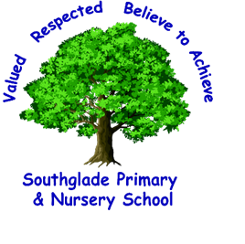 Valued, Respected. Believe to achieve!

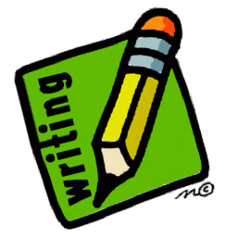
I can use relative clauses beginning with who, which, where, when, whose, that or with an implied (ie omitted) relative pronoun.

I can use complex sentence structures appropriately which are correctly marked with commas.

I can make some use of brackets, dashes or commas to indicate parenthesis and a colon to introduce a list.

I can correctly use dialogue to develop character and action and move a narrative forward.

I can use commas to clarify meaning or avoid ambiguity in writing.

I can edit my work and the work of others and improve.

I can use semi-colons, colons or dashed to mark boundaries between independent clauses.
I can use a range of adjectives, appropriate adverbs and adverbials to link ideas and develop cohesion.

I can use capital letter, full stops, question marks, exclamation marks, commas in lists and apostrophes for contraction and possession.

I can use co-ordinating (and, but, so) and subordinating conjunctions (after, although, since, despite, consequently, therefore).

I can use a confident and established voice in my writing and describe character and setting in narratives.

I can write in the correct tense and maintain consistency throughout.

I can use paragraphs and build cohesion by linking words/phrases, including adverbials. E.g. Firstly, then, after, while, significantly, likewise, for instance.
I can link adverbials of time, place and number e.g later, nearby, secondly.
I can make some use of hyphen to avoid ambiguity.
I can use features to create effect (alliteration, similes and metaphors as well as repetition and ellipsis.).
I can use modal verbs to indicate degrees of possibility e.g. should, would, could, shan’t, might and shall.

I can use organisational devices bullet points, colons and semi- colons in lists.

E. You should already be able:
To organise writing into paragraphs. To develop a plot in narrative and describe settings and characters.
To use the correct tense consistently. To choose nouns and pronouns appropriately.
To use ‘a’ or ‘an’ correctly. To use a wide range of conjunctions to join clauses together and to show time and cause. To use a range of adverbs to describe verbs. To use prepositions to show place. To use a range of adjectives and expanded noun phrases. To use a possessive apostrophe accurately in plurals. To use simple layout devices in non-fiction. To use joined handwriting. To use inverted commas in direct speech.

I can use the correct features of writing to match the audience and purpose of the piece.
The highlighted objectives provide a guide as to what should be included in Secure writing.
I can use a Thesaurus successfully to improve my word choices and a dictionary to check the spelling of a word independently.

I can spell most words correctly including words taken from the Year 3,4 and 5 statutory word list.

I can write neatly, legibly and accurately in a flowing style.

