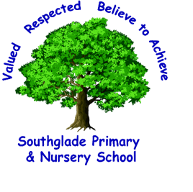 Valued, Respected. Believe to achieve!


I can spell words with suffixes correctly and include these in my writing.

The highlighted objectives provide a guide as to what should be included in Secure writing.
I can use the homophones on the Y3/4 word list within my own writing.

I can create more detailed settings, characters and plot in narratives to engage the reader.

I can spell words with prefixes correctly and include these in my writing.

I can consistently use a neat, joined handwriting style.

I can use knowledge of word families to help with my spelling.
I can use adverbials and prepositional phrases to express time, place and cause.

I can use a wider range of conjunctions to join clauses together including; when, if, because, although, and, but, so.

I can use all punctuation in direct speech mostly accurately.

I can choose nouns and pronouns appropriately to aid cohesion and avoid repetition and use ‘a’ or ‘an’ correctly.

I can use fronted adverbials and demarcate correctly using commas.

I can use apostrophes for contracted words, singular and plural possession.

I can use a range of sentence types with more than one clause eg main and subordinate clauses.

I can use conjunctions to show time, place and cause. E.g. when, before, after, while, so, because.
I can use standard English verb inflections accurately e.g. ‘we were’ rather than ‘we was,’ ‘I did’ rather than ‘I done.’

I can expand noun phrases with the addition of modifying adjectives and prepositional phrases.

I can consistently organise my writing into paragraphs around a theme.

I can maintain an accurate tense throughout a piece of writing.

I can use the correct features for non-fiction pieces including genre-specific layout devices.

I can choose the correct punctuation and use full range of punctuation from previous years.

I can edit my writing for spelling and punctuation errors and make improvements.

D. You should already be able:
To organise writing into paragraphs around a theme. To develop a plot in narrative and describe settings and characters.
To use the correct tense consistently. To use nouns/pronouns appropriately.
To use ‘a’ or ‘an’ correctly. To use a range of conjunctions to join clauses together.
To use conjunctions to show time and cause. To use a range of adverbs to describe verbs.
To use prepositions to show place. To use a range of adjectives and expanded noun phrases.

I can spell most or all of the Year 3 and 4 statutory words.

