Valued, Respected. Believe to achieve! Y2 writing

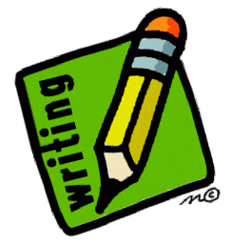
I can edit my work to improve it and make it better.

I can spell many common exception words correctly.

I can write about real events.

I can join some of my writing and use some diagonal and horizontal join.

I can use neat handwriting with suitable sized finger spaces.
I can use commas in a list.

I can write simple, coherent narratives (real or fictional).

I can use the correct size and spacing for letters and words.

I can use my phonics to sound out words and spell them correctly.

I can add adjectives to my writing.
I can use different sentence types (statements, commands, exclamations and questions).

I can use co-ordinating conjunctions.
‘or’, ‘and’, ‘but’

I can use some subordinating conjunctions to join clauses.
‘when’, ‘ if’ , ‘that’, ‘because’

I can use present and past tense mostly correctly and consistently.

I can use capital letters and full stops in my sentences.

I can use ? and ! in some of my sentences.

B. You should already be able:
To form lower-case letters in the correct direction. To form capital letters and use full stops. To write sentences in order to make a short story or non-fiction text. To use adjectives. To use finger spaces. To use the conjunction ‘and’ to join sentences together. To use capital letters for names, places, days of the week and personal pronoun ‘I’.

I can use apostrophes to mark singular possession.

The highlighted objectives provide a guide as to what should be included in Secure writing.
I can use expanded noun phrases.

I can use some suffixes
-ment, -ness, -ful, -less, -ly.

I can use an apostrophe to spell some contracted words. E.g. can’t, don’t, wouldn’t

