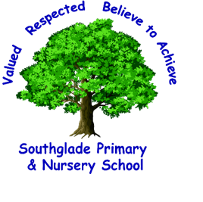 Valued, Respected. Believe to achieve!


I can spell common exception words.
I can use my phonics to help with my spelling.

I can add these suffixes mostly accurately:
-ing, -ed, -er, -est

I can form my lower-case letters correctly, starting and finishing in the right place.

I can use a capital letter for the personal pronoun ‘I’.

I can use capital letters for people, places and days of the week.

I can add adjectives to describe.
We had a wonderful time.
I can write a sequence of sentences.

I can sometimes use present and past tense verbs correctly.

I can use full stops.

I can use the conjunction ‘and’ to join clauses together. E.g. It was raining and the boy was scared.

I can sometimes use ? and !

I can use spaces between
words.

I can re-read my writing to check it makes sense.

- You should already be able: Year 1 Writing
To use phonic knowledge to write words in ways which match their spoken sounds.
To write some irregular common words.
To write simple sentences which can be read by themselves and others.
Some words are spelt correctly and others are phonetically plausible.

I can form capital letters.

I can use some conjunctions (and/because).

I can add -s or -es to spell plurals correctly. E.g. dogs, boxes

I can use and spell compound words.
E.g. sunflower, cowboy

The highlighted objectives provide a guide as to what should be included in Secure writing.

