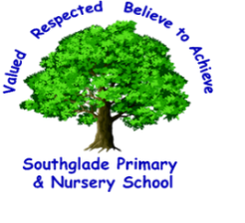

Southglade Primary and Nursery School

EYFS PSHE and Wellbeing Progression Ladder 2024-2025
Responsibility
Empowerment
Safe
Perseverance
Empathy
Collaboration
Tolerance
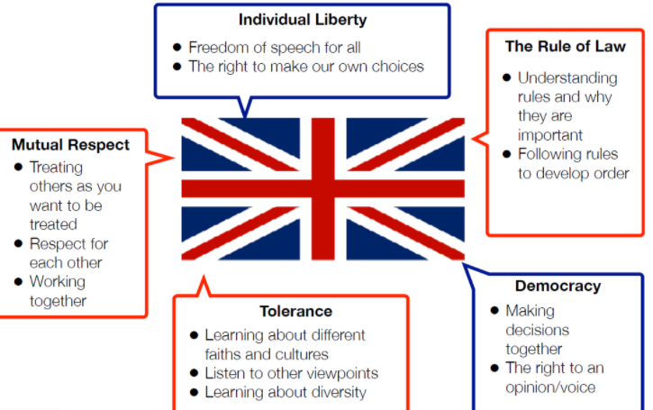
Autumn Term – Friendship
- I know why we have school rules
- I can say what friendship means
- I know what makes a good and bad friend
- I understand that bullying is something that happens several times on purpose
Autumn Term Wellbeing Day (Emotions)
- I can identify and understand a simple range of feelings in myself and others, eg. happiness, sadness, anger, fear
- I know who to talk to if I need help with my feelings
Spring Term – Jed and Ted (Drug Education)
- To know some of the risks and effects on body of medicines and household substances
- To be able to identify helpful and harmful substances in the home
- To be able to recognise when something is not safe or information may be untrue
Spring Term – Safer Internet Day
- I understand some basic technology including iPads, Computers and other technology in the environment
- I can describe some ways to use the internet and how it is useful to my life and learning
- I know some basic safety rules for keeping safe online when using the internet in school and at home
Summer Term Wellbeing Day (Aspirations)
- I can identify a range of different jobs
- I can identify gender stereotypes in relation to different jobs
- I can verbally say what I would like to do or be when I am older
- I can explore and learn about different jobs

Summer Term - Safety
- I know what happens in my body and mind when I feel unsafe
- I can describe feelings of being unsafe
- I can identify who I could tell if I feel unsafe
Summer Term – Christopher Winter Project
- To consider the routines and patterns of a typical day
- To understand why hygiene is important
- To recognise that all families are different
Summer Term Wellbeing Day (Health)
- I understand how special my body is
- I know that there are lots of things I can do to keep my body healthy
- I can identify a range of fruits and vegetables
- I understand that fruits and vegetables are one thing I can eat to keep my body healthy
- I know why it is important to wash my hands well
- I can demonstrate how to wash my hands well
- I can recognise that all families are different

