Year 6 : Autumn 2
Enquiry Question: I wonder how the weather differs across the UK.
Objectives: Name and locate counties and cities of the United Kingdom, geographical regions and their identifying human and physical characteristics, key topographical features (including hills, mountains, coasts and rivers), and land-use patterns; and understand how some of these aspects have changed over time
To identify the position and significance of latitude, longitude, Equator, Northern Hemisphere, Southern Hemisphere, the Tropics of Cancer and Capricorn, Arctic and Antarctic Circle. (Find the exact latitude for each.)
Key Vocabulary: Island, equator, continent. Longitude, latitude, climate, weather, Physical Geography, Human Geography, Beaufort Scale, Tropic of Cancer, Tropic of Capricorn
Key factual learning/CPD for staff  The UKThe UK is an island nation in Western Europe just off the coast of France. The mainland areas lie between latitudes 49°N and 59°N and longitudes 8°W to 2°E. The United Kingdom is made up of England, Scotland, Wales and Northern Ireland (beginning 1801). Below are the longitudes and latitudes of our local area and the capitals of each country in the UK. Longitudes and latitudes tell us the exact location of a place. Longitude- position north or south, latitude- the position east or west.  - Nottingham ( 52.9540° N, 1.1550° W)  - -Dover (51.1279° N, 1.3134° E)  - London ( 51.5072° N, 0.1276° W)  - Edinburgh ( 55.9533° N, 3.1883° W)  - Belfast ( 54.5973° N, 5.9301° W)  - Cardiff ( 51.4837° N, 3.1681° W)  Longitude and Latitude- Tropics of Cancer and Capricorn. Arctic circle and Antarctic Circle.  The Tropic of Cancer and Tropic of Capricorn are latitudes to the north and south of the Equator. There are five main latitudes that are given specific names ( aside from their degree locations). These are the Equator, Tropic of Cancer, Tropic of Capricorn, Arctic Circle, and Antarctic Circle.  The Equator runs around the very middle of the Earth, at zero degrees, and cuts the Earth evenly into a 'top' northern half and 'bottom' southern half. These halves are known as hemispheres. The Tropic of Cancer is located at 23.5 degrees north and the Tropic of Capricorn is at 23.5 degrees south. The Arctic and Antarctic Circles are at 66.5 degrees north and 66.5 degrees south, respectively.  Topography -the arrangement of the natural and artificial physical features of an area  The Highest Peaks in the UK  Ben Nevis, 1344 metres, Scotland  Snowdon, 1085 metres, Wales  Scafell Pike, 987 metres, England  Slieve Donard, 850 metres, Northern Ireland  Clouds  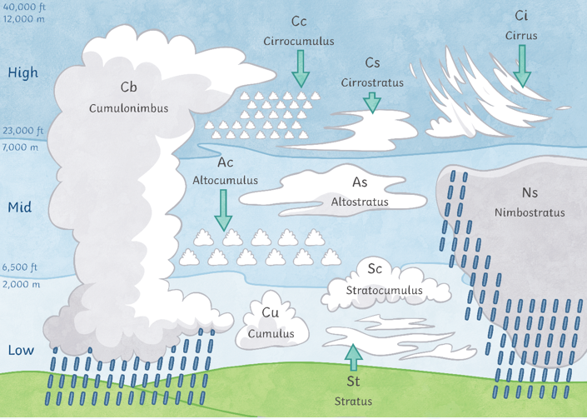 | Position and significance  Climate Zones  Climate in the UK is called temperate maritime. This means that it is mild with temperatures not much lower than 0 degrees Celsius in the winter and not much higher than 32 degrees Celsius in the summer.  Why do places have different climates?  A prevailing wind is the direction the wind blows from most of the time. Prevailing winds can bring warm or cool air to an area, depending on where they have come from.  In the UK, the prevailing wind direction is from the south-west (the Atlantic Ocean), so it brings warmer, moist air  or rain!  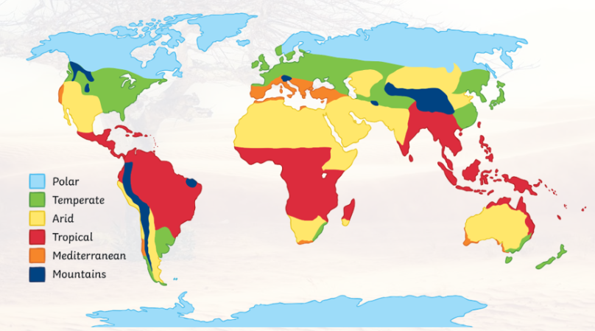  Northern and Southern hemisphere  The seasons in the Northern Hemisphere are the opposite of those in the Southern Hemisphere. | Practical tasks:  - Colour/ label a blank world map with the different types of climate zones.  -Use OS maps and digimaps to compare areas of the Uk looking at their key topographical features e.g Nottingham and Dover (look at current issues e.g coastal erosion and flooding)  - Children to use digimaps to find the exact logitude and latitude of capital cities in the UK.  - identify constituent countries of UK, capital cities, seas and islands, mountains and rivers using Toporopa Geography Games| Learn the map of Europe  -When comparing the geographical regions of the UK- play the game happy families in groups of 3 or 4- (resource folder)  -Pupils complete the UK trail map activity using an atlas and internet searches, pupils identify the iconic UK locations/landmarks and place the number of each in the correct place on the UK Trail Map (resource folder)  Fieldwork opportunities  -Use digimaps to create a map of the local area. Children to walk around Bestwood noting what different types of buildings/ resources there are. They can use a key to record what they find. In the classroom compare this to a previous land use map on digimaps. What has changed? Why do you think these changes have happened?  Observe clouds. Create a padlet (https://padlet.com/) for pupils to upload the different types of clouds they spot.  Create a wind gage or weather vane to support the observations of weather patterns. Children to record what they find.
Compare land- use over time (Bestwood)
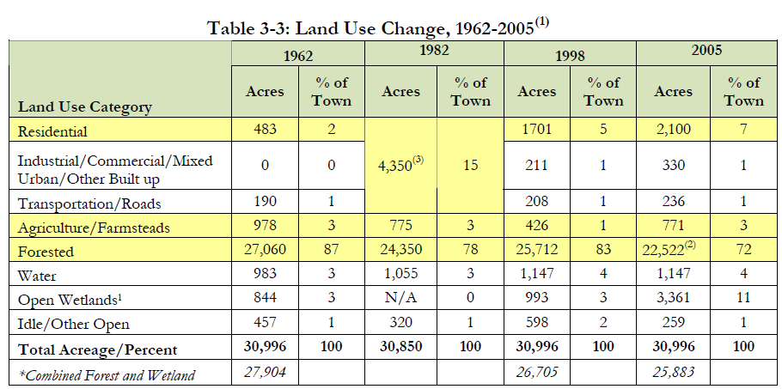
Over the past 50 years there has been a shift in land use from primarily agricultural and forest use to more developed land, primarily residential. Most of this shift was due to residential development which increased in acreage from 483 to 2,100. By contrast, combined forested lands and wetlands lost over 2,000 acres during this period. With an influx of residential buildings, comes a need for shops, schools, medical resources etc.

Outcome:
- Weather report (using green screen)
- Create a map showcasing where a journey from one part of the UK to another.

