Year 1 : Autumn 2
Enquiry Question: I wonder what I can create to help the whale find its way home?
Objectives:
- To find information on aerial photos.
- I can follow a route on a prepared map, e.g journey to school, where I live.
- I can recognise simple features on maps such as buildings, roads and fields.
- To look down on objects and make a plan. e.g a desk.
- To draw a simple map (real or imaginary) including route maps.
To use symbols on maps and understand that they mean something.
Key Vocabulary:
Key physical features, including: beach, cliff, coast, forest, hill, mountain, sea, ocean, river, soil, valley, vegetation, season and weather.
key human features, including: city, town, village, factory, farm, house, office, port, harbour and shop
Key factual learning/CPD for staff  Advice before teaching this unit: Take a short walk in the surrounding areas around the school. Look at where the local parks are (The Ridge, Southglade Park). Look at where the local library and the local leisure centre is. Observe places of worship.  Aerial view- birds eye view of a thing, place, city or country.  Physical features  The study of the Earth's natural features, such as mountains, rivers, deserts and oceans.  Human features  The study of man-made features like houses, roads and bridges.  Local churches  -Bestwood Park Church (Beckhampton Road), Infant of Prague Catholic Church (Cherry Orchard Mount), and The Peoples Church (Gladehill Road).  Green spaces  Sandy banks,  Southglade park,  Little woods  The Ridge  Bestwood Country Park | Practical tasks:  Introduce maps through the story book – Martha Maps it Out by Leigh Hodgkinson  Fieldwork ideas  - Fieldwork in the classroom- Begin by making a large map of the classroom with the pupils. Use pictures of different areas in the classroom so pupils can place where things are. Explore the compass together (powerpoint in resources). Can the children explain where items are in the classroom? Eg the table is west of the chair? Expand this by hiding a toy in the classroom when one child is waiting outside. Call the child back and ask the children to explain where the toy is using compass directions.  -Fieldwork in the playground- Children to have a map of the playground. They follow the map to find different points chosen by the teacher. When they get to that place they write their name on the whiteboard.  Fieldwork outside of school- Children to go on a walk up to the shops. Using ipads and padlet- children to upload pictures of things that they see on route. Children can create pictograms of what they see. Eg, flats, houses, cars, buses, shops, trees…  Recreate your walk around Bestwood by creating a 3D map;  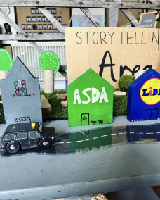  Look at maps of Bestwood- what physical and human features can you find? Use bluetac, cocktail sticks and white labels to mark what you can see.  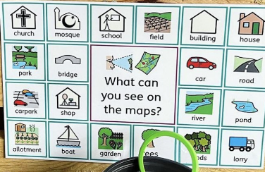  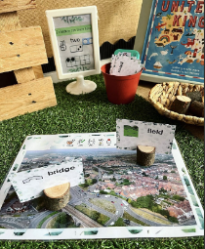  Exploring aerial photos- ask children to take a picture from a birds eye view and a bugs eye view- upload to padlet to look through together.  Chalk maps on the playground to map our places of interest. Children can create a story using the map to explain what they have seen.
Outcome:
- Create a map of a local area walk.
- Re-create their walk using small word/ pictures/ chalk maps.

