Year 5 : Spring 1
Enquiry Question: I wonder how the geographical features of North America compare to the United Kingdom
Objectives:
- I can follow routes on maps.
- I can use thematic maps for specific purposes.
- I can interpret distribution and thematic maps for information.
- I can follow a route on 1:50000 ordinance survey map.
- I can make sketch maps of an area using symbols and a key.
- I can use a scale bar on all maps.
- I can read and compare map scales.

Key Vocabulary:
derelict GMT grid reference scale
Countries of North America, Names of states of the USA, Capital cities, Oceans,

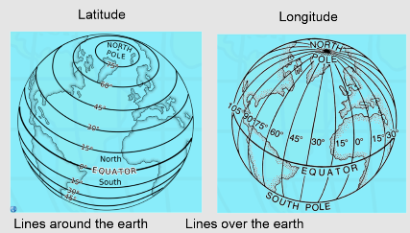  Key factual learning/CPD for staff  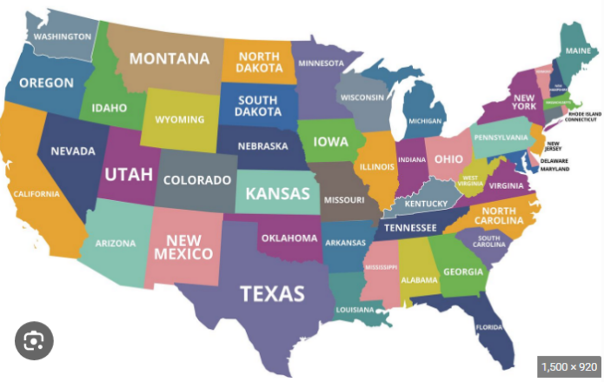  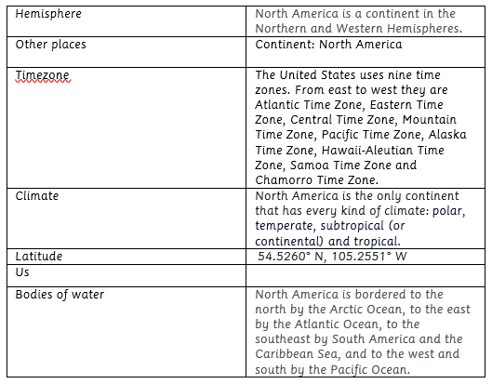  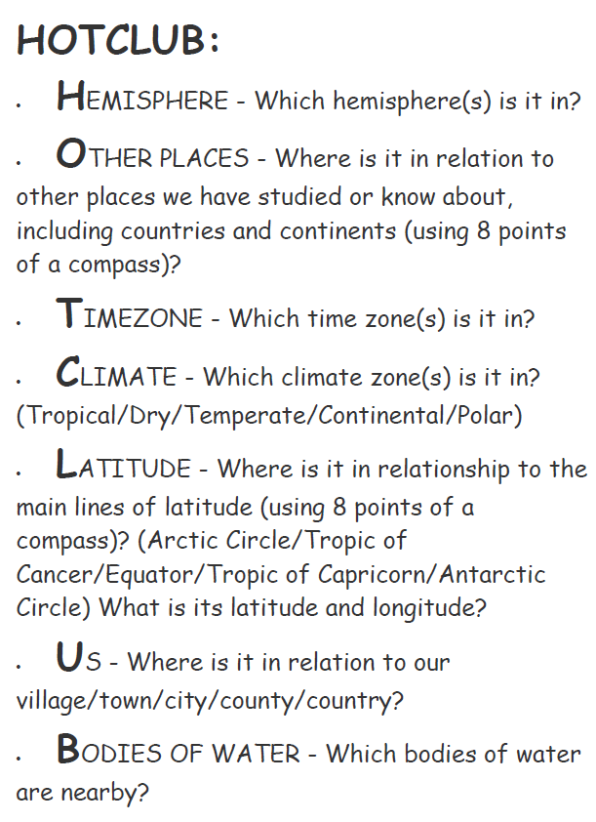  Complete a HOTCLUB to describe a place.  Yosemite National Park  Yosemite National Park is an American national park in California. It is best known for its waterfalls, towering granite monoliths, deep valleys and ancient giant sequoias.  Compare to another area of N.America such as Los Angeles.  Los Angeles (LA) is the largest city in the state of California and the second most populous city in the United States. | Practical tasks:  - Use the historical maps on Digimaps to see how areas of the United Kingdom have changed over time. E.g River Severn and the sand dunes.  Login details:  Username: NG55NE  Password: glurbs6270  PIN number: 0197  - Create a HOTCLUB for the United Kingdom and North America.  - Sort Physical and Human features of the UK and North America. What do you notice?  - Use Padlet to record climate changes in North America, what do you notice?  - Locate landmarks of the UK/ North American and place onto a scaled map.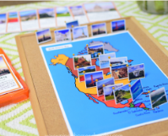  Fieldwork:  Orienteering (when new build and grounds have been built)  - Use the eight points of a compass, four figure grid references, symbols and key (including the use of Ordnance Survey maps) to build their knowledge of the United Kingdom and the wider world  - Use fieldwork to observe, measure, record and present the human and physical features in the local area using a range of methods, including sketch maps, plans and graphs, and digital technologies.  Mini project:  PSHE links  To use the school and its grounds as a site for studying aspects of physical and human geography by investigating questions such as ‘How can our school reduce its plastic waste?’ and ‘How can we make our school grounds more bee friendly?’  - collecting, analysing and presenting quantitative data in charts and graphs.  - designing and using a questionnaire to collect qualitative data (e.g. to find out and compare pupils’ views on plastic waste).
  United Kingdom
  Hemisphere | Northern Hemisphere
  Other places | Continent: Europe  The United Kingdom consists of the four geographical and historical parts of England, Scotland, Wales and Northern Ireland, located in the British Isles
  Timezone | United Kingdom is within just one time zone. London Greenwich is located on the prime meridian and is officially the zero point of reference for time zones.
  Climate | The climate of United Kingdom is temperate oceanic, mild and humid (more humid in Northern Ireland, and Scotland, colder and drier). The weather is mainly influenced by the warm oceanic current of the Gulf Stream. The sea, surrounding the country from all sides, does not allow the air over land to heat up or cool too much.
  Latitude | 55.3781° N, 3.4360° W
  Us
  Bodies of water | Irish Sea, Celtic Sea, Atlantic Ocean, North Sea English Channel.  The longest rivers in each of the four UK countries are:  River Severn in England  River Tay in Scotland  River Bann in Northern Ireland  River Tywi in Wales  What is Topography?  Topography describes the physical features of an area of land. These features typically include natural formations such as mountains, rivers, lakes, and valleys. Manmade features such as roads, dams, and cities may also be included.
Outcome:
- Tourist brochure of an area of interest in the UK/ N.America. Focussing on HOTCLUB factors.
- Create a comparison magazine article about tourist reasons to visit Uk or N.America.

