Year 4 : Spring 1
Enquiry Question: I wonder why the Ancient Egyptian civilisation was able to last a thousand years?
Objectives:
- Locate the world’s countries, using maps to focus on Egypt, concentrating on their environmental regions, key physical and human characteristics, countries, and major cities
- Compare Nile region of Egypt to the Trent or Thames region of the UK.

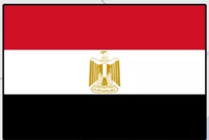
Key Vocabulary:
)

Key factual learning/CPD for staff  Egypt Facts:  - Capital: Cairo  - Area: 1,010,408 sq km  - Population: 107.7 million  - Language: Arabic  Egypt  Location:  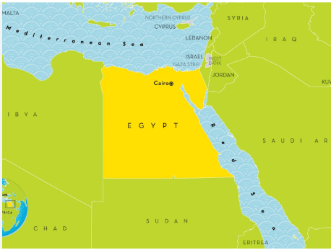 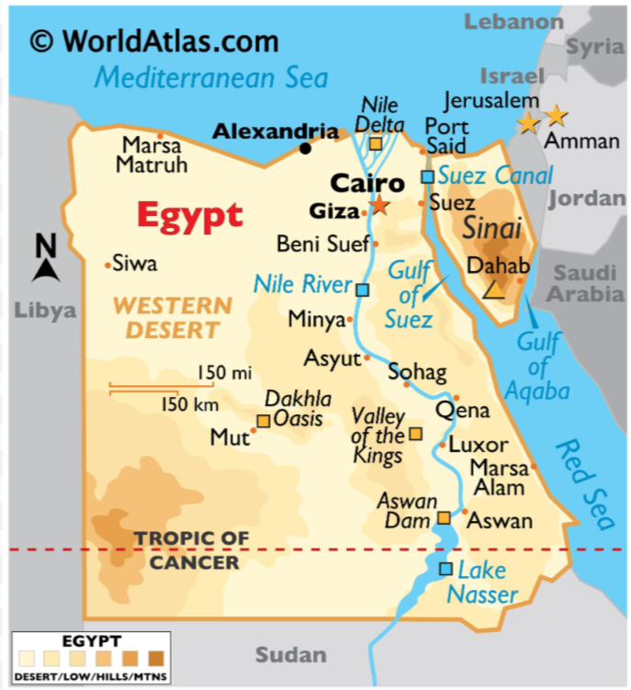  Egypt is located in northern Africa and shares borders with Gaza Strip, Israel, Libya, and Sudan. Egypt's boundaries also include the Sinai Peninsula. Its topography consists mainly of desert plateau but the eastern part is cut by the Nile River valley.  Egypt’s heartland, the Nile River valley and delta, was the home of one of the principal civilizations of the ancient Middle East and, like Mesopotamia farther east, was the site of one of the world’s earliest urban and literate societies. Pharaonic Egypt thrived for some 3,000 years through a series of native dynasties that were interspersed with brief periods of foreign rule.  Physical and Human features  Egypt is unequally split by the Nile. The Nile (the longest river on Earth) divides the country into the Eastern Desert and Western Desert. The eastern side has some hills and mountains and the western side is very flat. The Sinai Peninsula in the north-east is a strip of land divided from the main area of Egypt by the Suez Canal.  Egypt’s major cities:  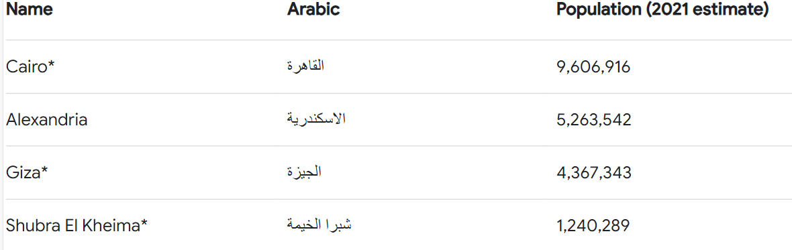  Climate:  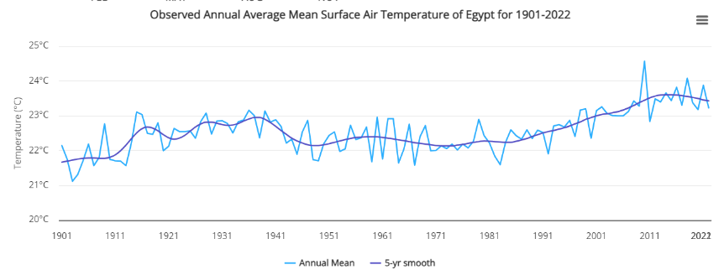  Egypt’s climate is dry, hot, and dominated by desert. It has a mild winter season with rain falling along coastal areas, and a hot and dry summer season (May to September). Daytime temperatures vary by season and change with the prevailing winds. In the coastal regions, temperatures range between average winter minimums of 14°C (November to April) and average summer maximums of 30°C (May to October). Temperatures vary widely in the inland desert areas, especially during the summer, where they range from 7°C at night to 43°C during the day.  The River Nile compared to the River Thames  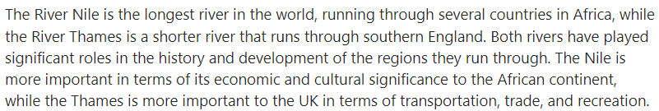 | Practical learning:  - Locate the world countries on a map. Label them and their continents.  - Play map detectives: Give each pair a set of true or false questions such as ‘The River Nile is the only river in Egypt’. Children should use the maps on digimaps to locate and find the answer.  Login details:  Username: NG55NE  Password: glurbs6270  - Complete a comparison table of the River Nile and The River Thames. Consider:  Length, depth, mouth of the river, functions of the river, trade, historical significance.  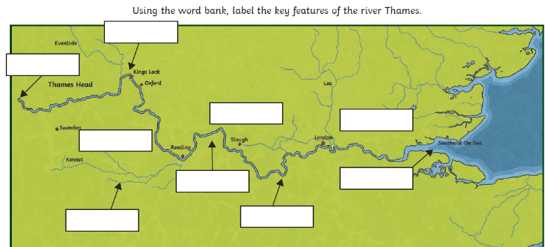  - Complete a features of the River Thames activity and a features of the River Nile.
Outcome:
- Create a factfile comparing the River Nile and the River Thames

