Year 3: Summer 1
Enquiry Question: I wonder where earthquakes and volcanoes are located and the impact of this on the local area?
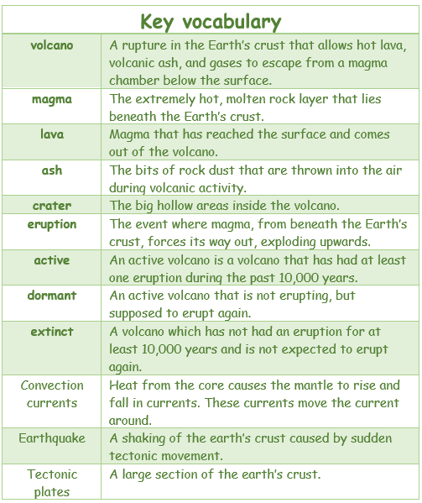
Objectives:
Describe and understand key aspects of:
- Physical geography including: volcanoes, earthquakes, (Linking to Science: rock types)
- Human geography including how volcanoes can impact the local area (Tourism, money, fertile soil, thermal power stations, resources)
Map skills
- I can use thematic maps (in an atlas).
- I can explain what places are like using maps at a local scale.
Compare Vesuvius region of Italy to a region of the UK.
- Understand geographical similarities and differences through the study of human and physical geography of a region of the United Kingdom, a region in a European country.
Compare Vesuvius region of Italy to a region of the UK Arthur's Seat in Edinburgh.
- use maps, atlases, globes and digital/computer mapping to locate countries and describe features studied
- use the eight points of a compass, 2 figure grid references, symbols and key (including the use of Ordnance Survey maps) to build their knowledge of the United Kingdom and the wider world
- use fieldwork to observe, measure, record and present the human and physical features in the local area using a range of methods, including sketch maps, plans and graphs, and digital technologies.
Key Vocabulary: Volcano, earthquake, Europe, fault mantle, ring of fire, active, dormant, crust, core, sill, lava, extinct, vent, eruption, magma, ash, crater
Key factual learning/CPD for staff  How does an earthquake happen?  How does a volcano erupt?  Earths layers- How do these relate to volcanoes and earthquakes?  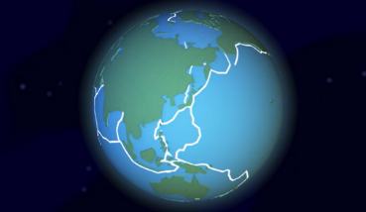  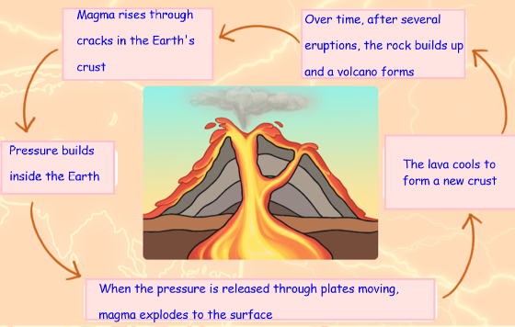  The earth is made up of 3 layers.  The crust (together with the upper layer of the mantle) is made up of different pieces, called tectonic plates. These plates fit together like a jigsaw and are moving at a rate of a few centimetres a year, in different directions and at different speeds.  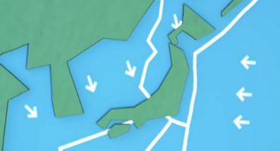  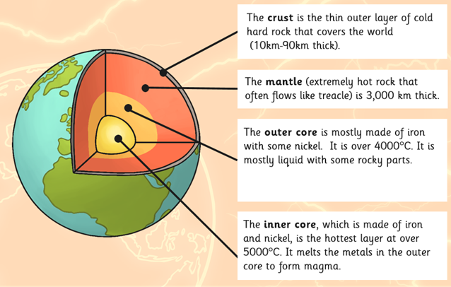  Some plates slide past each other, others move away from each other and some bump into each other. Sometimes these plates lock together when they meet. This is called a plate boundary or a fault line.  Explore earthquakes - BBC Bitesize- A simple video  explaining how earthquakes happen.  Earthquakes  The Earth’s surface is called the crust. It is made up of different rocky sections called tectonic plates. Tectonic plates can move about  on the softer mantle underneath them. Watch: https://www.youtube.com/watch?app=desktop&v=j7To56VsunE A great visual  representation of what happens when the tectonics plates moves away from each other (divergent) and when they are pushed back together (convergent).  If an earthquake is beneath the ocean it can create a series of huge waves, called a tsunami. There are thousands of earthquakes across the world each day.  Volcanoes  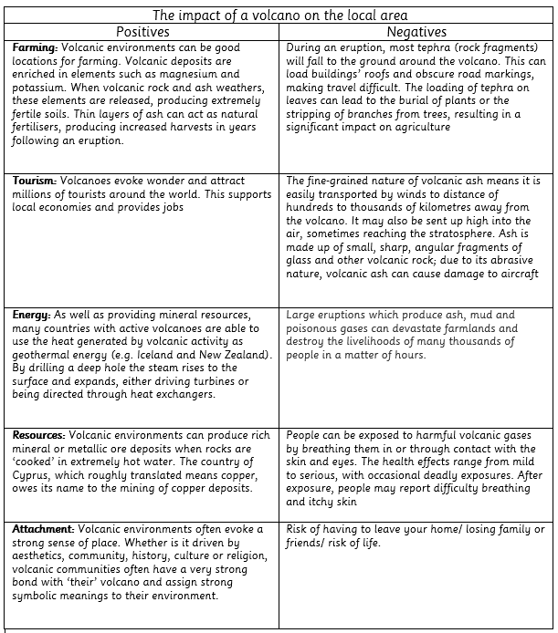  - Volcanic eruptions can be explosive, sending ash, gas and lava high up into the atmosphere, or the magma can form lava flows, as effusive eruptions. Whether an eruption is explosive or effusive largely depends upon the amount of gas in the magma. If a lot of gas is trapped within magma, pressure will build and build until eventually the magma erupts explosively out of the volcano. It’s a bit like a bottle of fizzy pop: gas is trapped in the liquid but if you shake the bottle the gas wants to escape.  This builds pressure inside the bottle and when you release the pressure by opening the bottle, the gas rushes out of the top carrying some of the liquid with it. (Link with bicarbonate soda and vinegar investigation)  - There are volcanoes on every continent, even Antarctica.  - Watch: Experience: Ashfall - "An Eclipse" (youtube.com). It shows what the local area around some volcanoes are like after the volcanic ash starts to fall down. | Retrieval activities  -Seven continents (label a map/ picture prompt)  -Link with prior learning of Mount Vesuvius and the impact of this on Pompeii.  Practical tasks:  Conduct a case study of naples and mount Vesuvius.  Link to recent Earthquakes e.g Turkey and Syria (2023)  - Look on a map. Where are most volcanoes found?  - Mr P ICT links- VR, Animations, Labelling, comprehension and green screen Extreme Earth - MR P ICT ONLINE CPD  -label the 3 layers of the earths crust  Crust mantle outer core inner core  -Label the parts of a volcano on a diagram (examples in resource folder. Use key terminology-  -Living in Peril | Key Stage 2 | Geography in the News a great link to recent volcanoes and the impact of their eruptions on the local area.  -  -Create an erupting volcano by using bicarbonate of soda and vinegar.  -Digimaps Map bingo. http://osric.com/bingo-card-generator/ use this link to create your own bingo word cards using key vocabulary from driver.  Fieldwork opportunity-  - Explore gradients on a map by looking at mountain ranges and then comparing to our locality and how flat it is. Go into locality and see areas of low gradient, for example around Southglade park. Use this to show the incline and height of the mountains and volcanoes we study  - Annotate a daring/ diagram of the earths core and the parts of a volcano.  - Label a map showing tectonic plates around the world.
  ash cloud | magma chamber | main vent
  lava flow | conduit | crater
Outcome:
- Debate (oracy)
- Create a new story based on a volcano erupting- interview people. How are you feeling? What are the consequences?

