Year 1 : Summer 1
Enquiry Question: What I can create for Paddington to tell him all about the UK?
Objectives:
.Naming and locating the four countries and capital cities of the United Kingdom and its surrounding seas.
.Identify seasonal and daily weather patterns in the United Kingdom and the location of hot and cold areas of the world in relation to the Equator and the North and South Poles

Key Vocabulary:
United Kingdom, Wales, Scotland, England, Nothern Ireland, London, Belfast, Cardiff, Edinburgh, City, Capital, Weather, Equator, North Pole, South Pole, hot, cold, flag
Key factual learning/CPD for staff  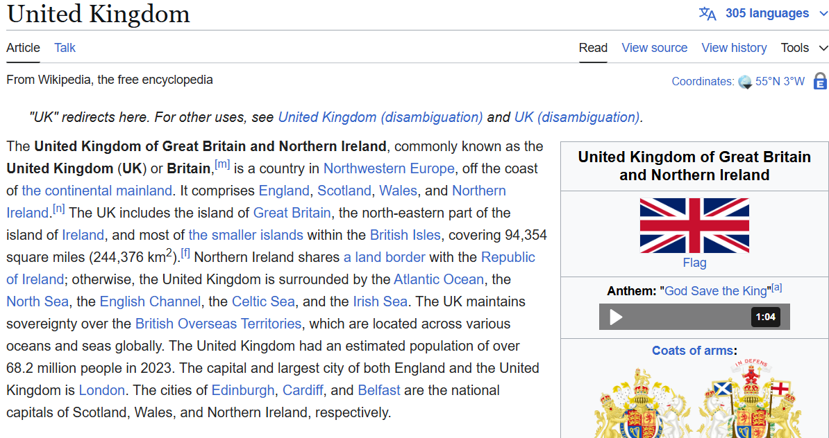  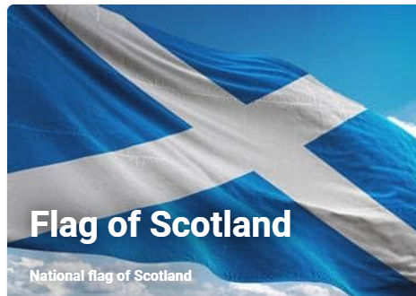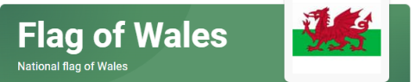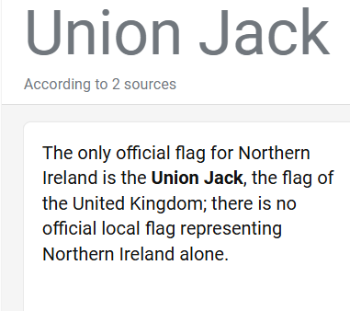 | Practical tasks:  Introduce children to a map of the Uk. Go through the 4 different countries. Give them a cut up UK ‘jigsaw puzzle’ for them to assemble in pairs.  Children to explore the UK map through digimaps and/or google aerial view.  Have a cultural tasting session of each of the 4 countries in the UK with traditional food for the children to taste e.g. haggis, welsh cakes, scones, etc..., traditional music e.g. bagpipes for the children to listen to and traditional dress e.g kilts, mayday clothes etc...  Expose children to the four flags of the countries of the UK. Share the union Jack with the children. Compare and contrast with the children.  Locate the UK on a globe. Share where the equator is. Share where the North and South Pole is on the globe in relation the UK. Explain how our position in relation to the equator affects weather patterns in the UK. E.g. UK is colder than Peru where Paddington is from originally.  Create Talking tin weather reports for each of the 4 capital cities of the UK for Paddington to listen to and help him pack for his time in the UK.
Outcome: UK museum of the four key
Countries.

